

**Server & Cloud Security**

**SCHOOL OF INFOCOMM TECHNOLOGY**

Diploma in Cyber Security & Forensics

Diploma in Information Technology

**INDIVIDUAL ASSIGNMENT**

**Duration:** Weeks 5 -17

**Weightage:** 15% out of Total 30%

**Tutorial Group: P03 Team Number:_____**

|  |  |
| --- | --- |
| **Student Name** | **Student Number** |
| Neo Rei Siang Edward | S10204829 |

# SCS Individual Assignment

**SCS Individual Assignment** **1**

4.6 Encryption 42

4.6.1 Installing Bitlocker 43

4.6.2 Testing of BitLocker Encryption 50

4.6.3 Setting Up 7-Zip Encryption 52

4.6.4 Testing of 7-Zip Encryption 54

4.7 Configure Access Control List 61

4.7.1 Configure Access Control List 61

4.7.2 Testing Access With Created Users 72

4.8 Server Backup 74

4.8.1 Server Backup Implementation 74

4.8.2 Testing Server Backup 83

4.9 Account Lockout Policy 84

4.9.1 Implementation of Account Lockout Policy 84

4.9.2 Testing of Account lockout Policy 88

4.10 Logging 89

4.10.1 Implementation of Logging on Shared Folder 89

4.10.2 Testing of Implemented Logging 92

4.10.2.1 Accessing Network Shared Object 92

4.10.2.2 Opening of File in Shared Folder 93

4.10.2.3 Deleting of File in Shared Folder 94

4.10.2.4 Modification of File in Shared Folder 95

4.10.2.5 Closing of File in Shared Folder 96

4.11 Ensuring OS is the latest version 98

4.12 Changing of Default User Account Names and Passwords 99

4.12.1 Implementing Change of Default User Account Names and Passwords 99

4.12.2 Testing of Changed Default Name 103

## **5. Conclusion** **105**

## 4.6 Encryption

Encryption is a good way to protect the shared folder. Encryption can prevent any unauthorised users from reading the data stored on the shared folder and prevents data loss from occurring. It helps protect private information, sensitive data and can enhance the security of the shared folder. For full-disk encryption, I will be using bitlocker and as an additional security feature, I will use 7-zip to password protect folders stored on the shared folder.

### 4.6.1 Installing Bitlocker

Bitlocker integrates with the operating system and addresses issues such as data theft or data exposure. In order to use Bitlocker, I first had to install the “Bitlocker” feature by going to the server manager and clicking on add roles and features. I went to the “Features” section and selected “BitLocker Drive Encryption”. After clicking Next, a pop up will appear, recommending for other features to be added for the usage of “BitLocker Drive Encryption”.

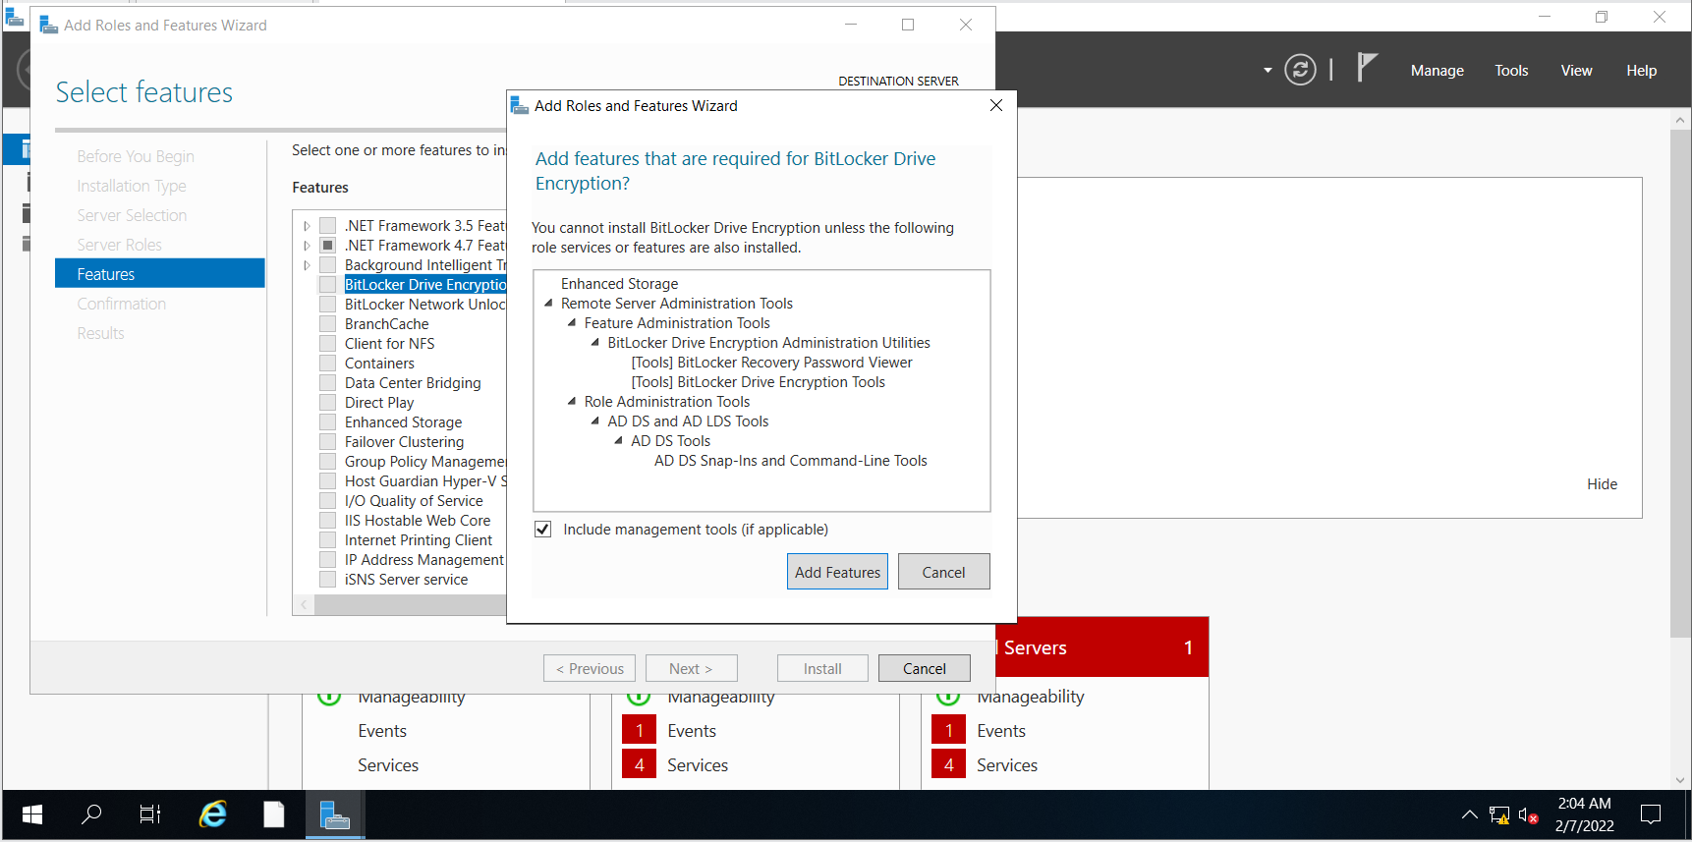

I clicked on “Add Features” and continued with the installation. I then confirmed all the features that are to be installed and once everything was checked to be correct, I clicked on “Install”.

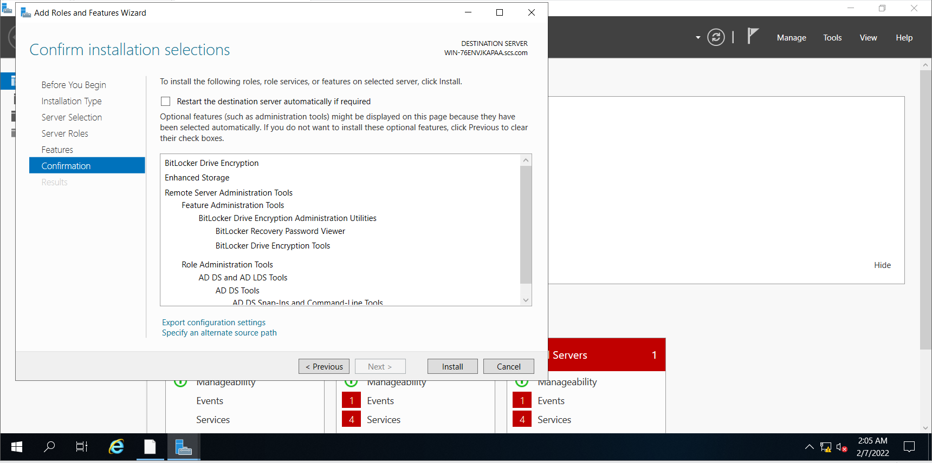

I then restarted the virtual machine to ensure that the features had been installed on the file server. I then opened “BitLocker Drive Encryption” to turn on Bitlocker for the C:/ Drive.

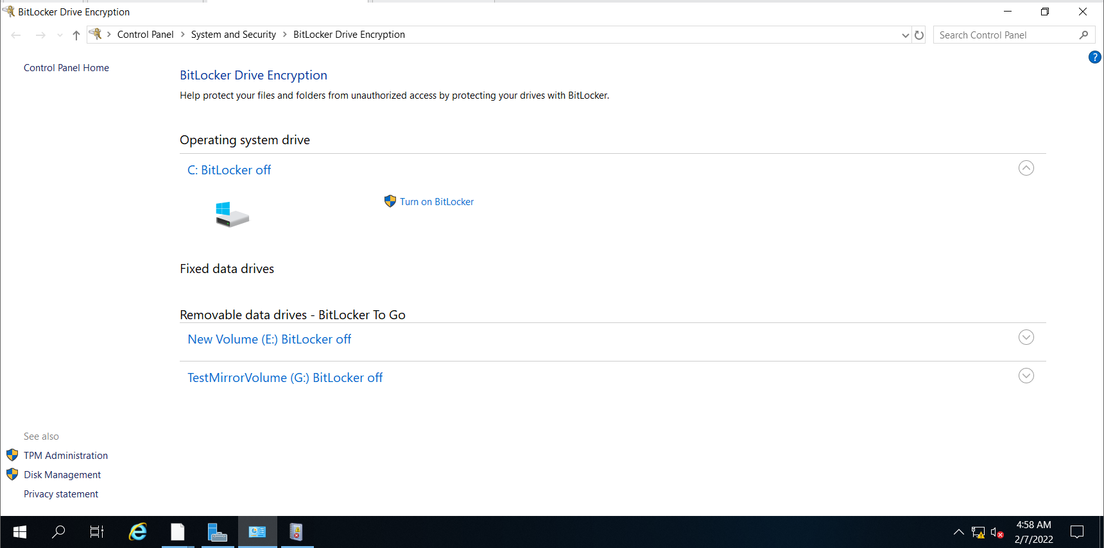

However, when I tried to turn on bitlocker, I received an error message stating, “Your administrator must set the “Allow BitLocker without a compatible TPM” option in the “Require additional authentication at startup” policy for OS volumes. “

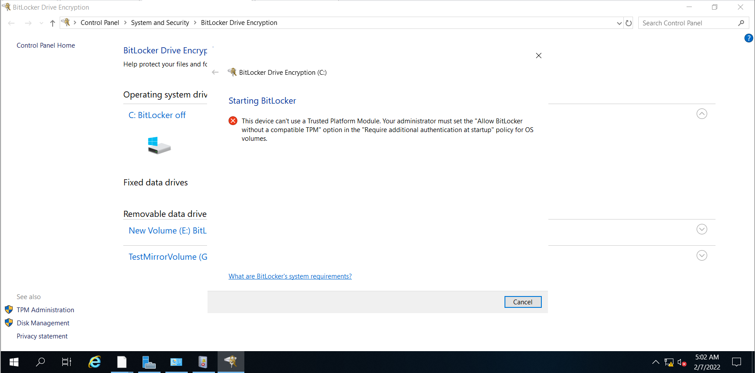

In order to fix this error, I went to “Local Group Policy Editor”. I had to navigate to “Computer Configuration”, “Administrative Templates”, “Windows Components”, “BitLocker Drive Encryption” and “Operating System Drives”.

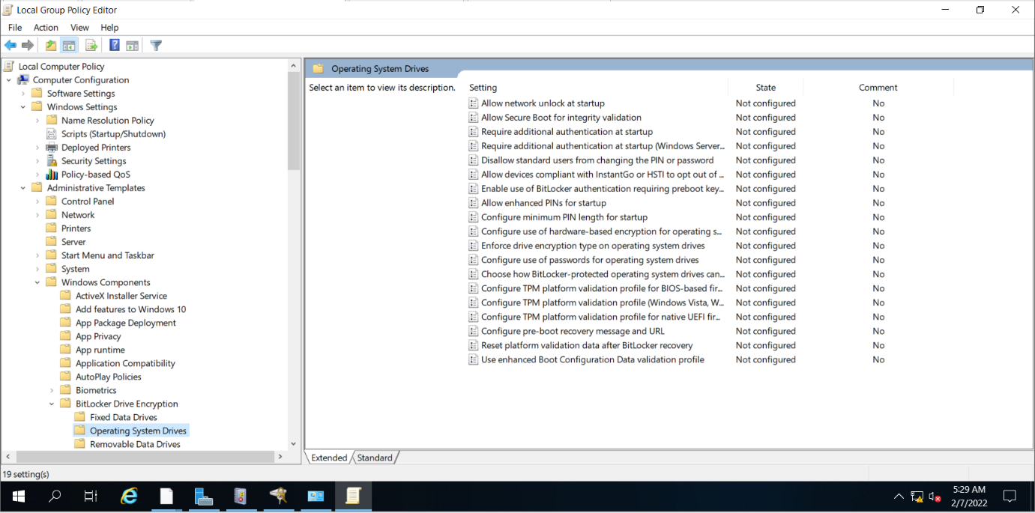

In “Operating System Drives”, I had to click on the third option, “Requires additional authentication at startup” and click on the underlined “policy setting”.

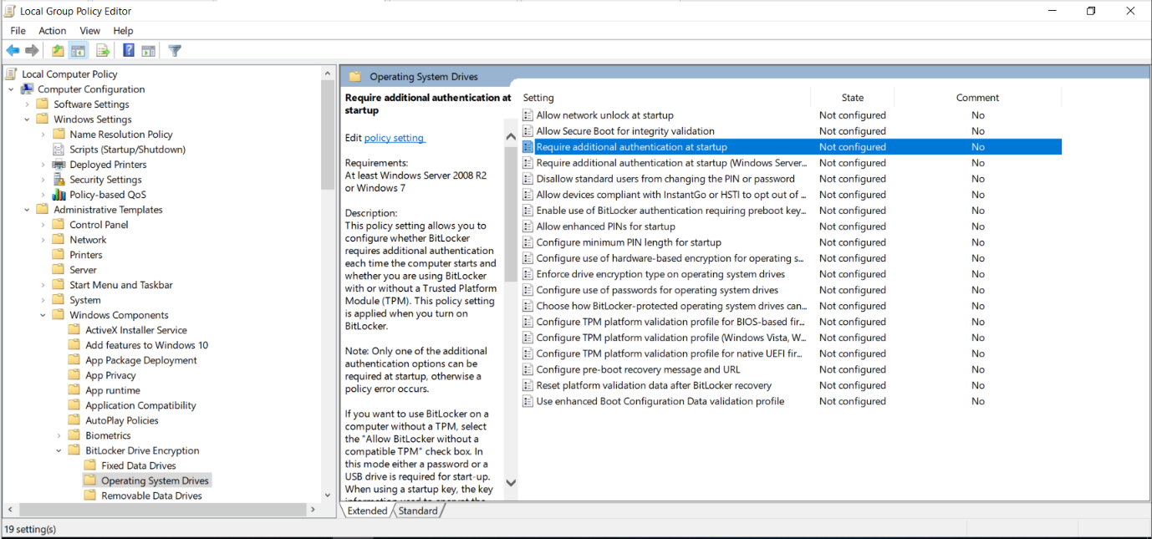

A pop up will appear and in this pop up, I had to click on the radio button “Enabled” and also tick the box that “Allows BitLocker without a compatible (TPM)”. Then, I clicked on “Ok” to apply the settings.

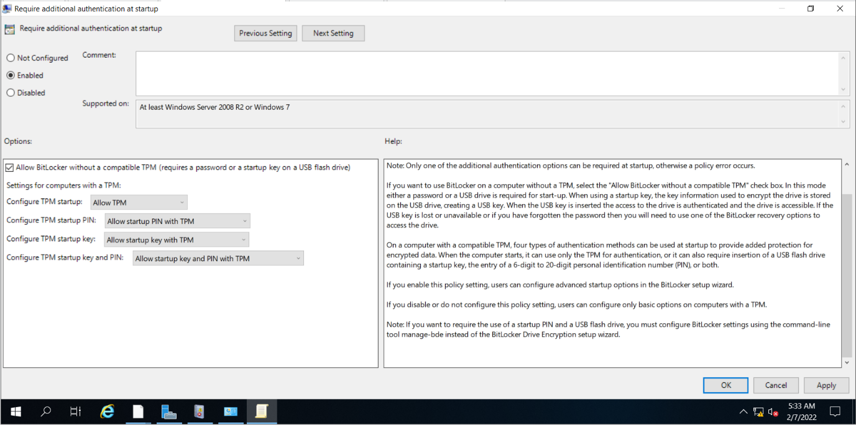

I then opened a command prompt and typed in the command, “gpupdate /force” to ensure that the changes made to the settings has been applied and ensured that the drive can be encrypted.

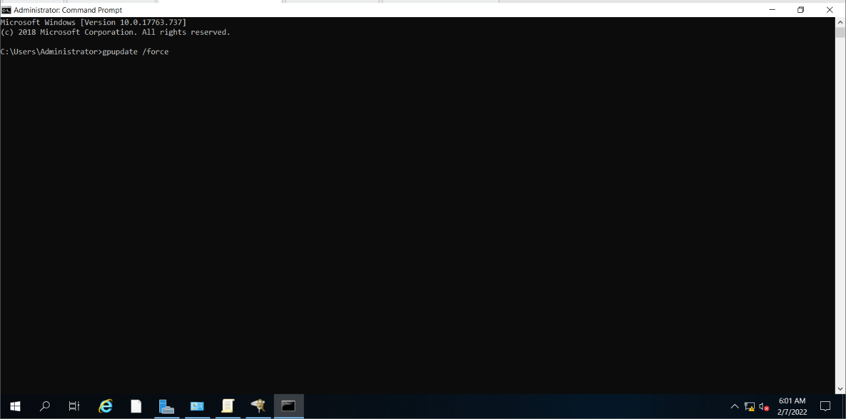

Unfortunately, I faced another error that stated, “The processing of Group Policy failed because of lack of network connectivity to a domain controller”.

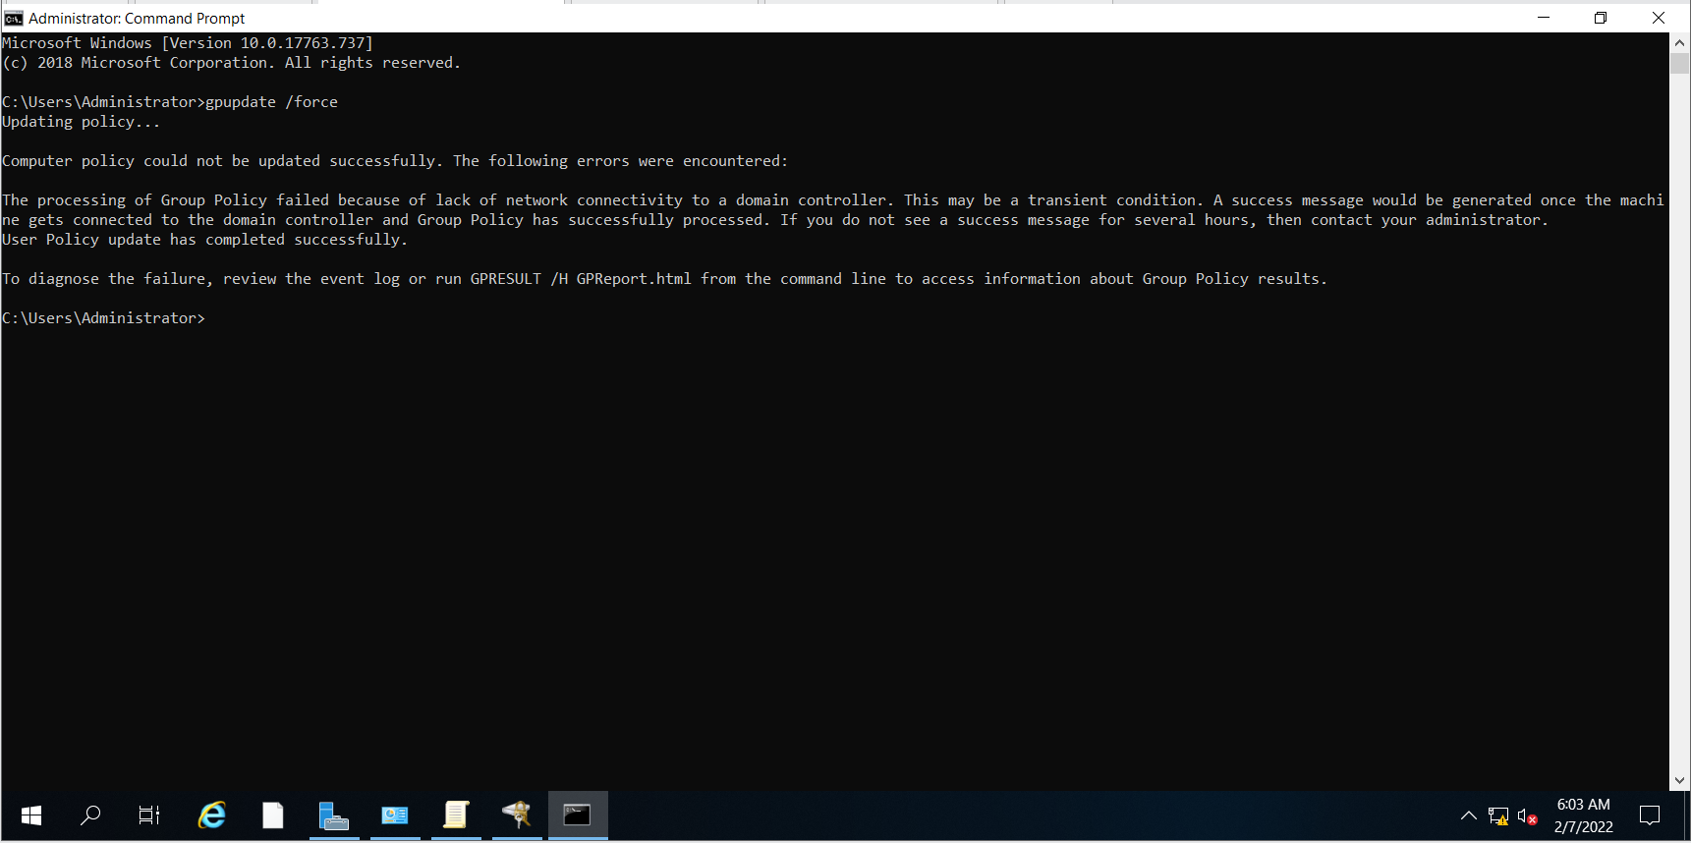

Thus, I repeated the command after ensuring that the file server is connected to the domain controller.

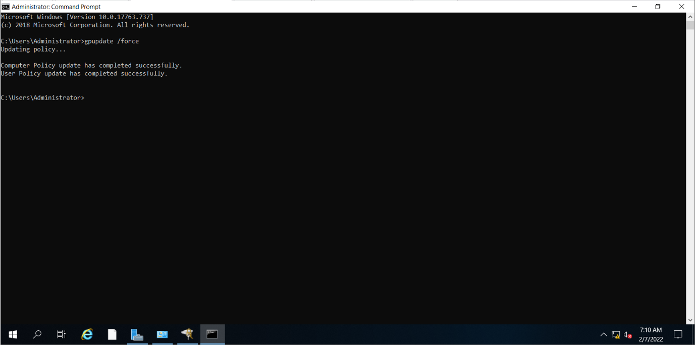

It was a success, and the computer policy was updated successfully.

I then went back to “BitLocker Drive Encryption” and turned on BitLocker. It then opened a pop up asking for the method to unlock the drive at startup. I chose the option, “Enter a password”. I then set the password to be “Pw123456”.

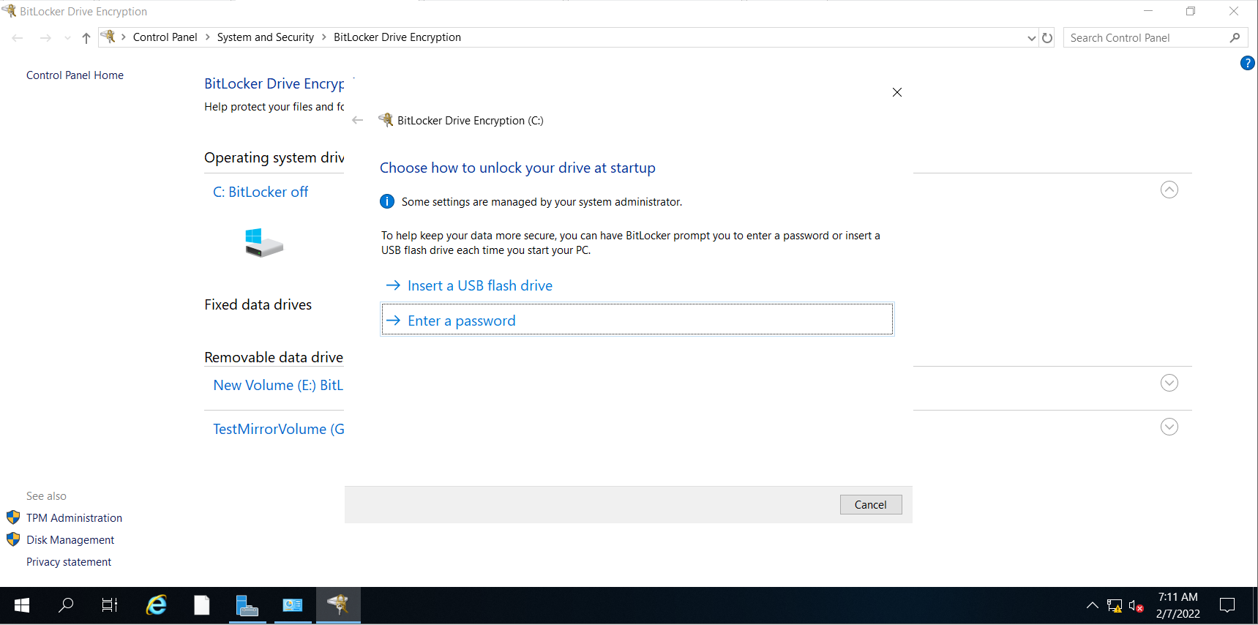

I then chose to encrypt the entire drive because it is much more secure and is one of the main features of using bitlocker.

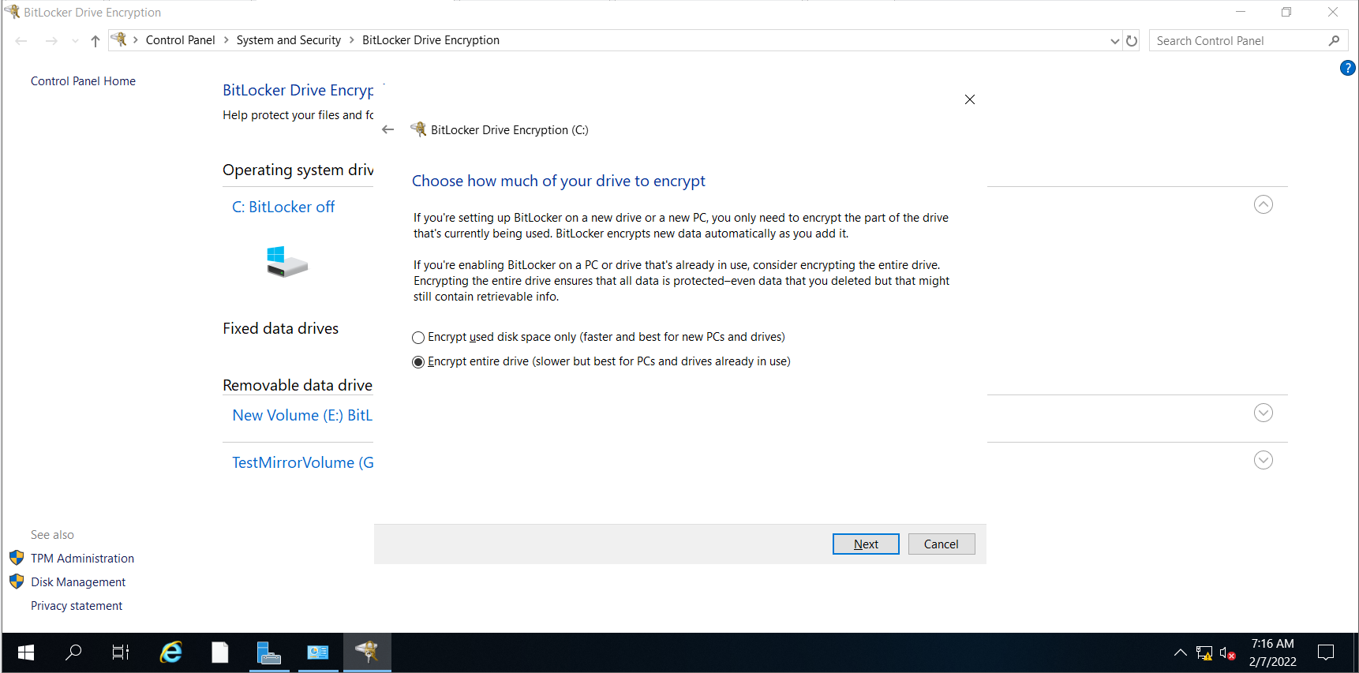

I then selected “New encryption mode” because it is a fixed drive on the system and an older version of Windows is not being used.

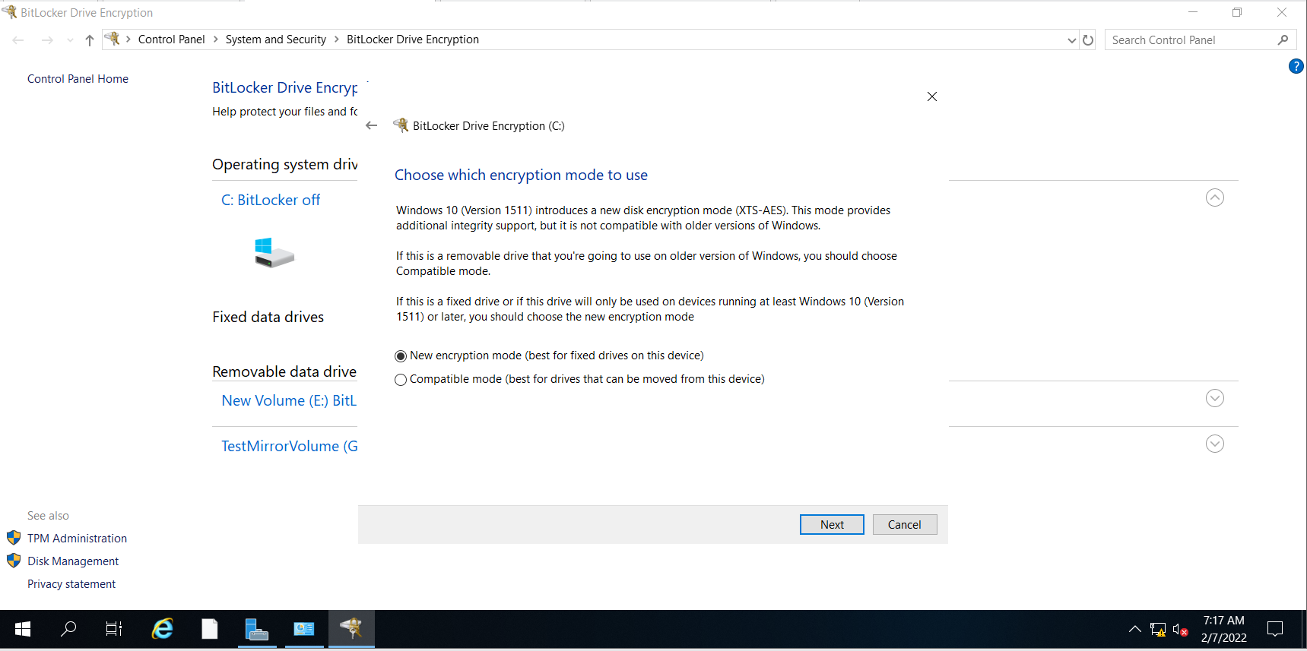

I then tick the option “Run BitLocker system check” so as to ensure that everything is working as intended and that BitLocker can read the recovery and encryption keys correctly before

encrypting the drive. I clicked on “Continue” to start the encryption process.

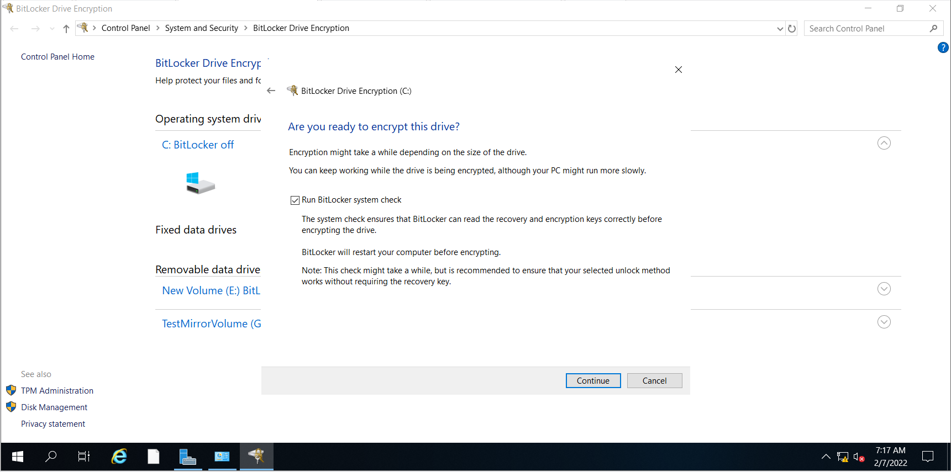

I was then prompted to restart the computer to initiate the encryption process.

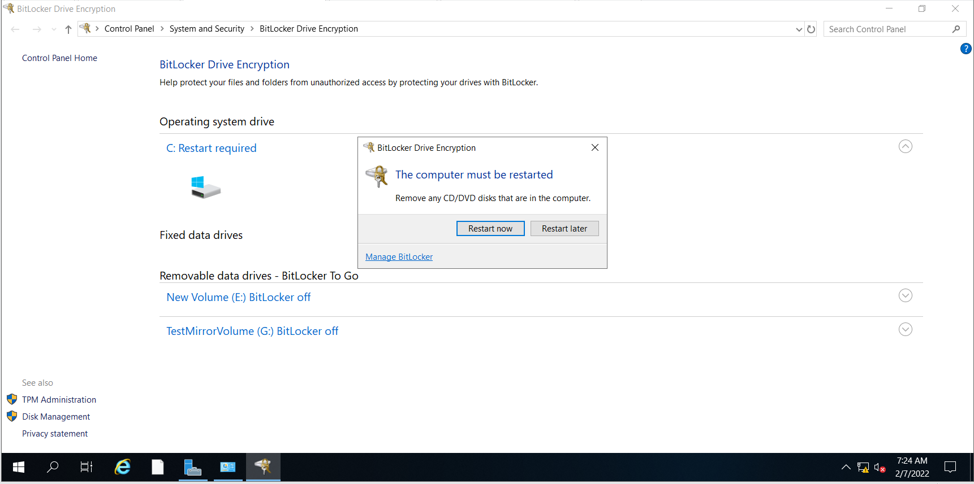

After restarting, this is the screen I saw and we have to key in the password so as to enter windows.

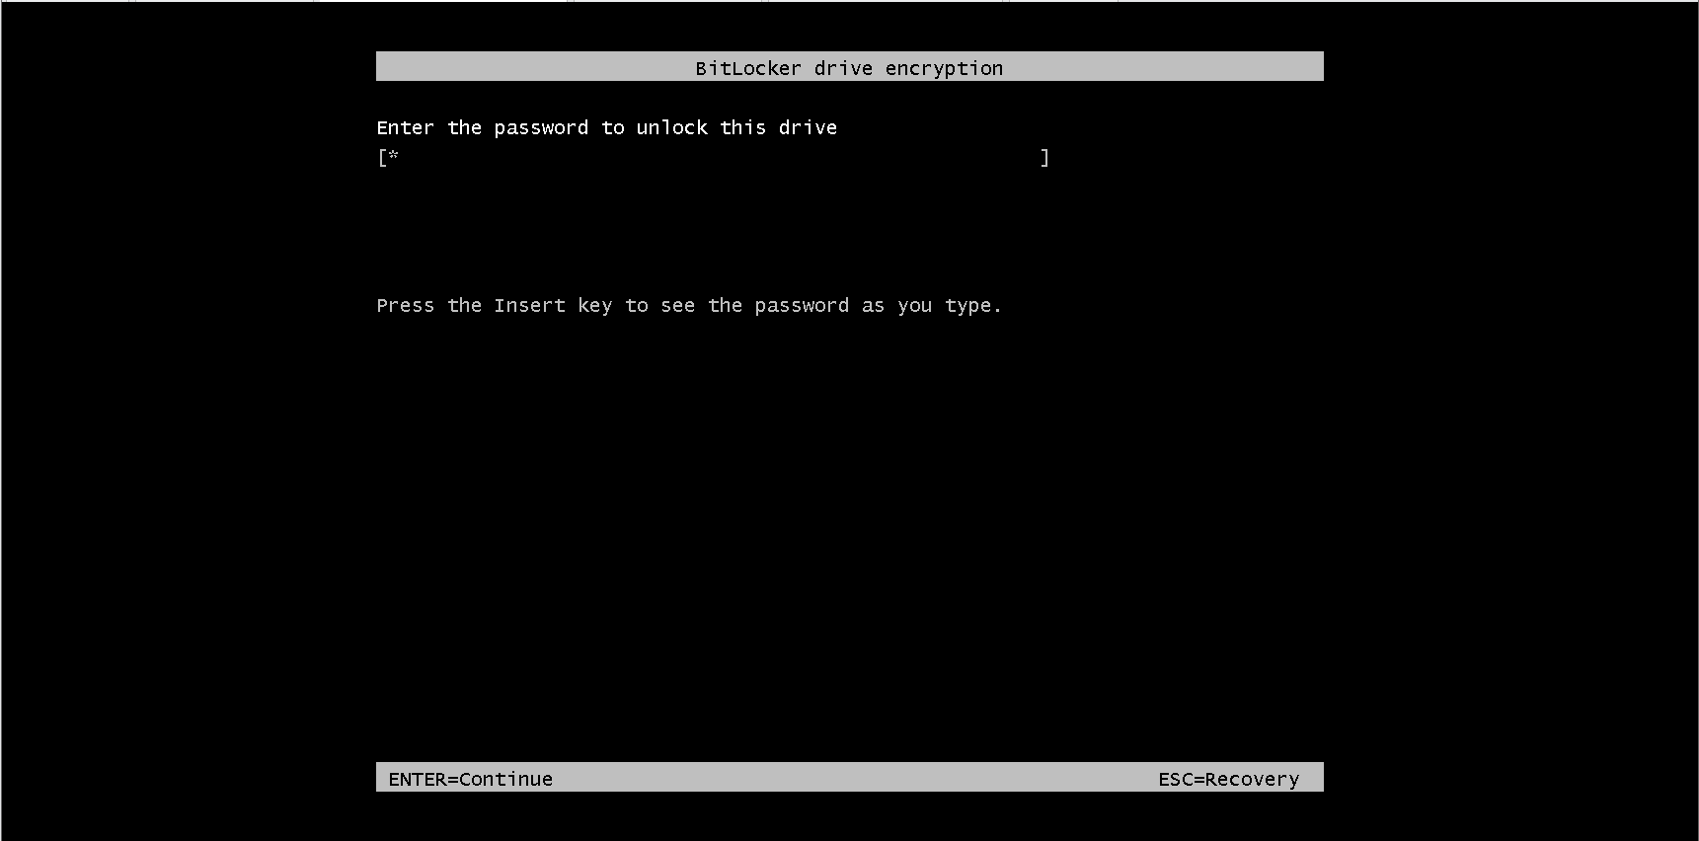

### 4.6.2 Testing of BitLocker Encryption

“Incorrect password” will be displayed if the wrong password was used.

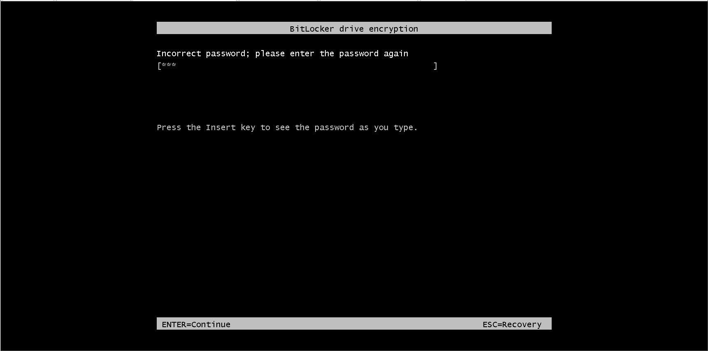

Although there is a recovery key option, the user still needs to enter the recovery key for the drive in order to recover the disk.

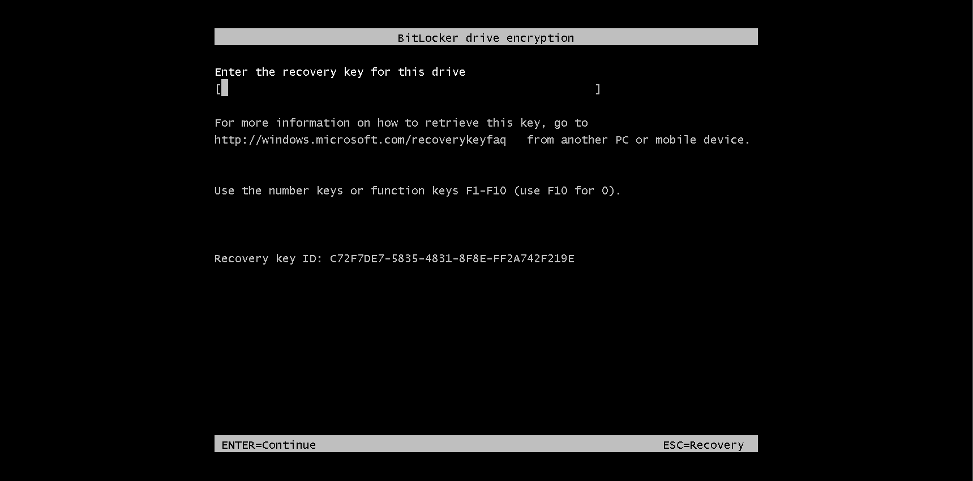

If the user presses “Recovery” again, Windows again prompts for the recovery key and provides the option to skip the current drive. However, since the windows boot up files are in the C:/ drive, Windows will not be able to boot if users choose to skip this drive.

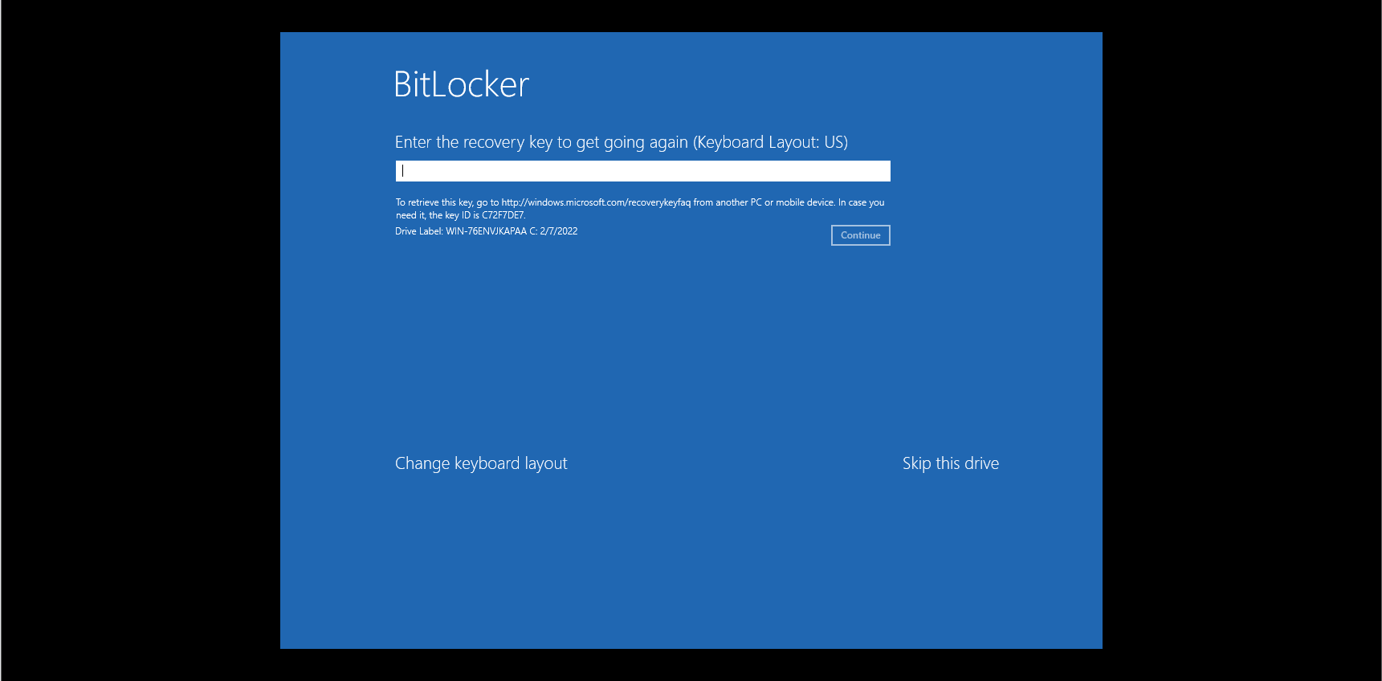

If the user manages to key in the correct password for the bitlocker, windows will start to boot.

### 4.6.3 Setting Up 7-Zip Encryption

As an additional act of security, I have decided to use 7-Zip encryption to “encrypt” the shared folder. 7-zip does not really encrypt the shared folder but it can protect the folder with a password, protecting the contents. In order to set up the encryption of the shared folder, I have to go to the shared folder locally which is located on the File Server VM. Since 7-Zip cannot encrypt the share folder, I can only encrypt folders inside the shared folder. Thus, one way of making the shared folder completely encrypted is to store all items in another folder in the shared folder. Then, encrypt the folder inside the shared folder with 7-Zip. This will make it such that people can only view the contents of the folder if they know the password. Thus, I created a folder inside the shared folder and moved all items to it. Then, I started the encryption process by right clicking the created folder, clicking on “7-Zip”, and clicking on “Add to Archive”.

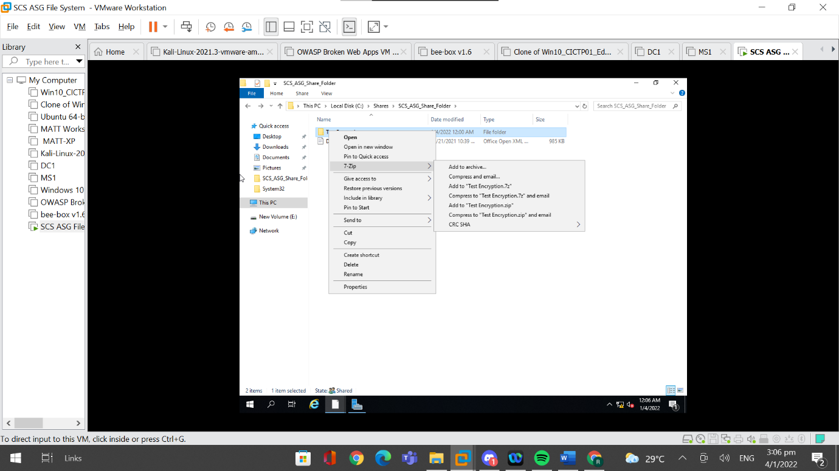

I had to change the archive format to “.zip” and change the encryption method to “AES-256”. Then I had to enter a password for the encrypted folder. After setting up a password, I had to click on “Ok” and the folder would be encrypted.

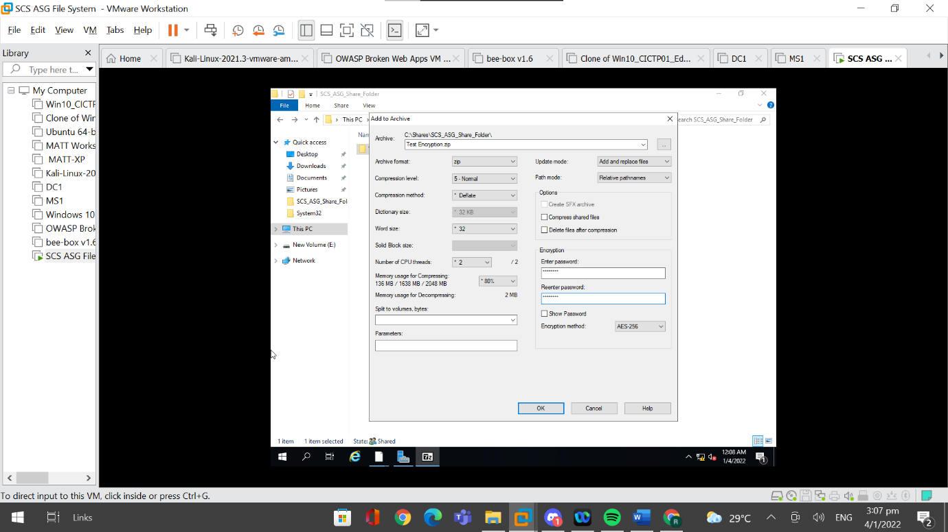

A zipped folder was created, and I deleted the original folder.

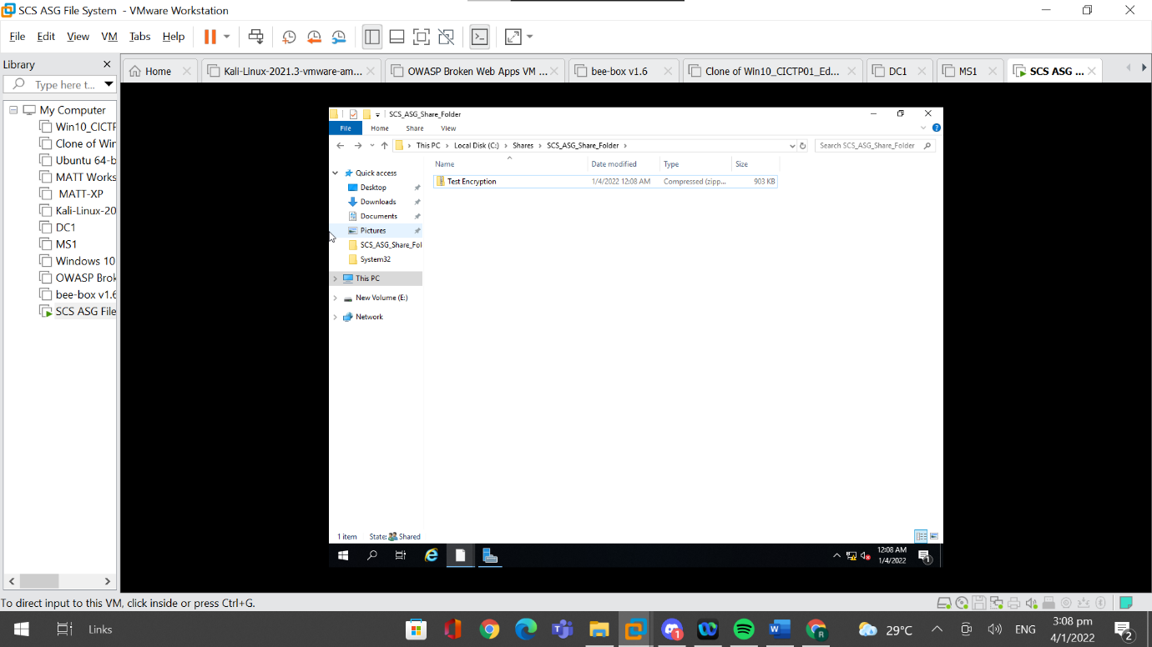

### 4.6.4 Testing of 7-Zip Encryption

Although I can view these files inside the encrypted folder, I cannot access these files because they are in the zipped folder and thus need to be extracted.

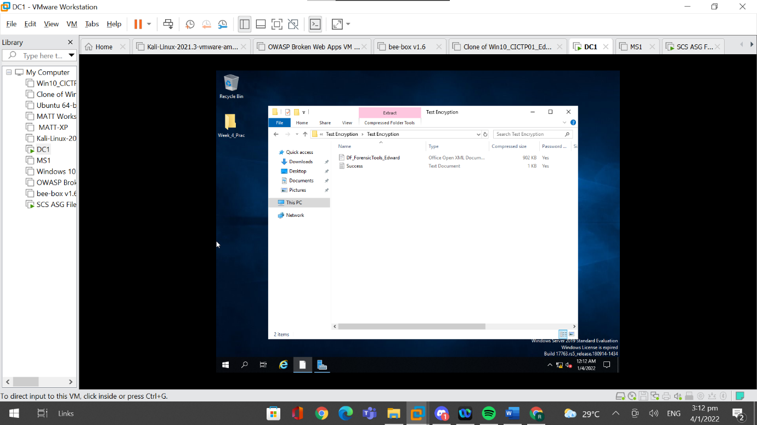

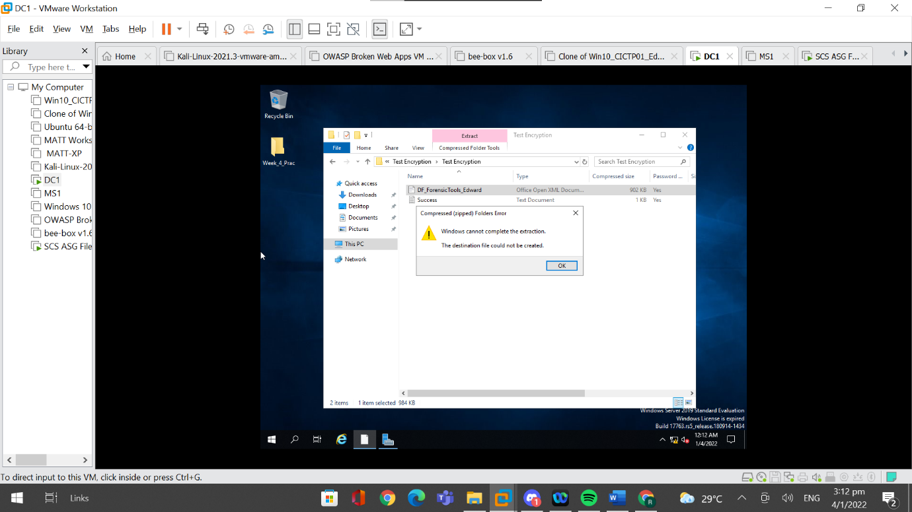

Windows has its own extraction feature but when I tried it, it showed an error message stating “An unexpected error is keeping you from copying the file.” Thus, the files cannot be extracted out using the default extract feature.

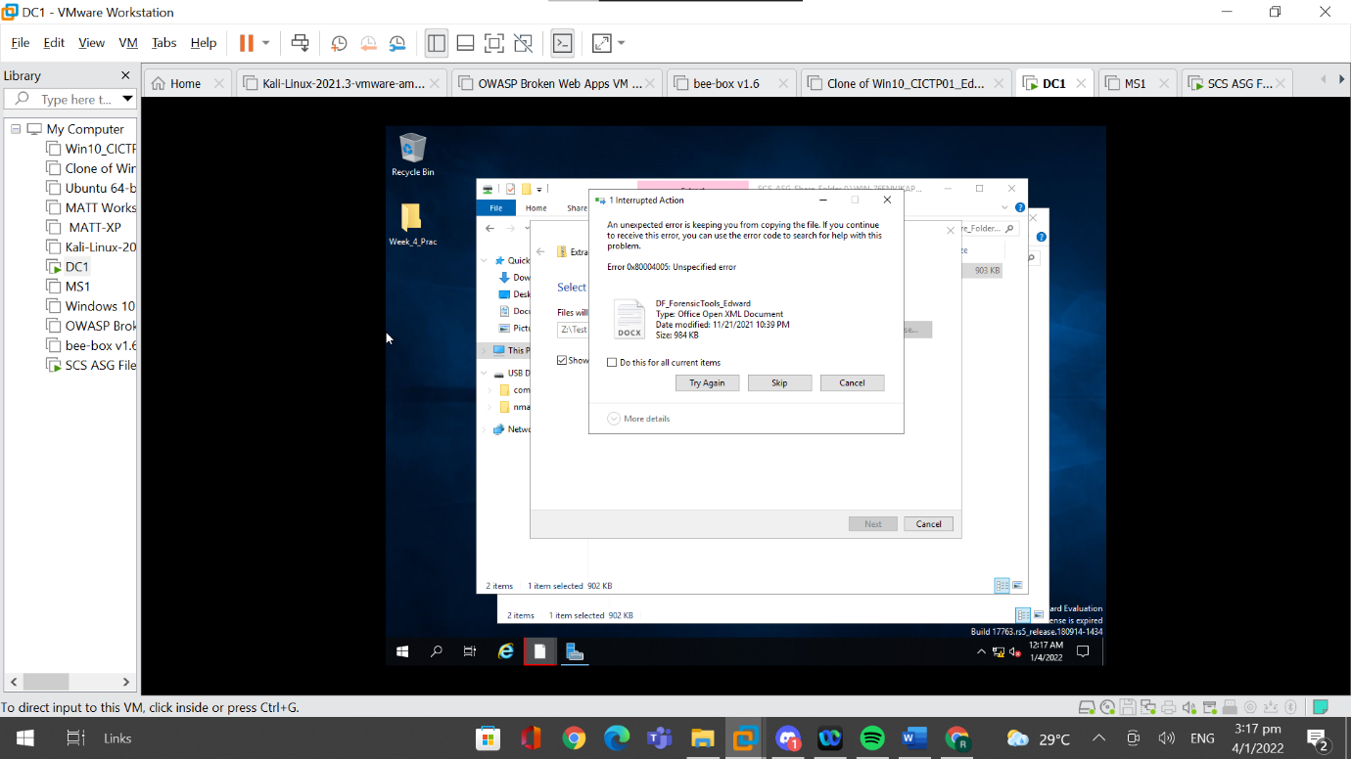

Instead, 7-Zip has to be used to extract files from the encrypted folder. In order to extract, I have to right click on the encrypted folder, go to “7-Zip” and click “Extract Files”.

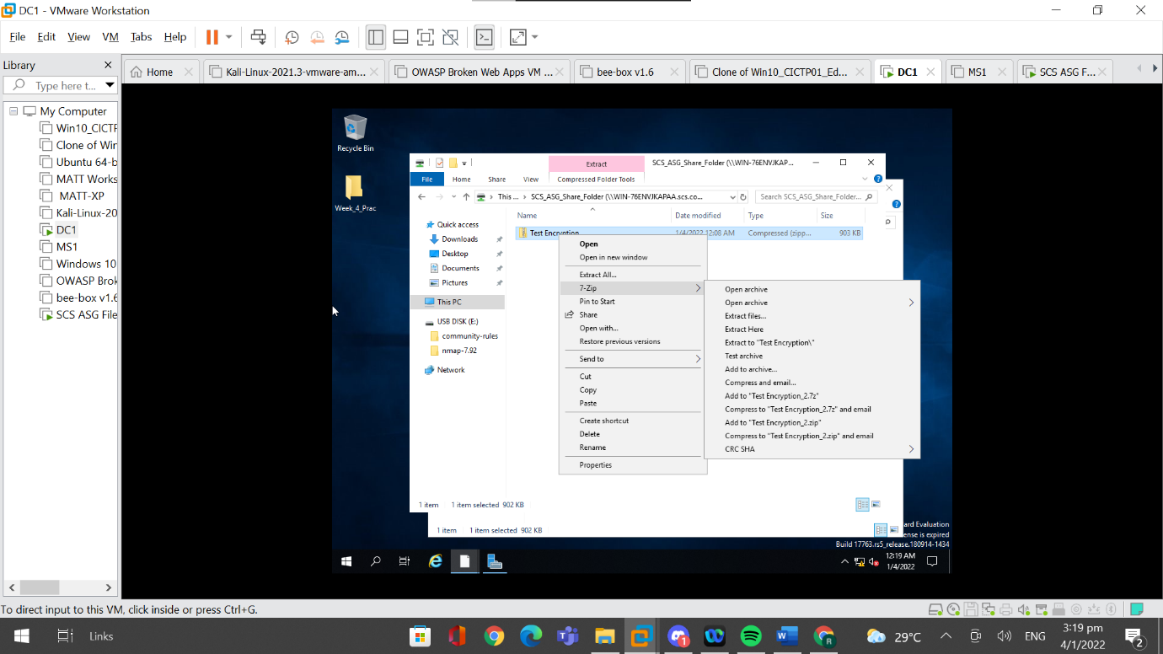

After clicking on “Extract Files”, a pop-up will appear that is requesting for the password of the encrypted folder. In order to access the contents of the encrypted folder, the password for the encrypted file has to be entered.

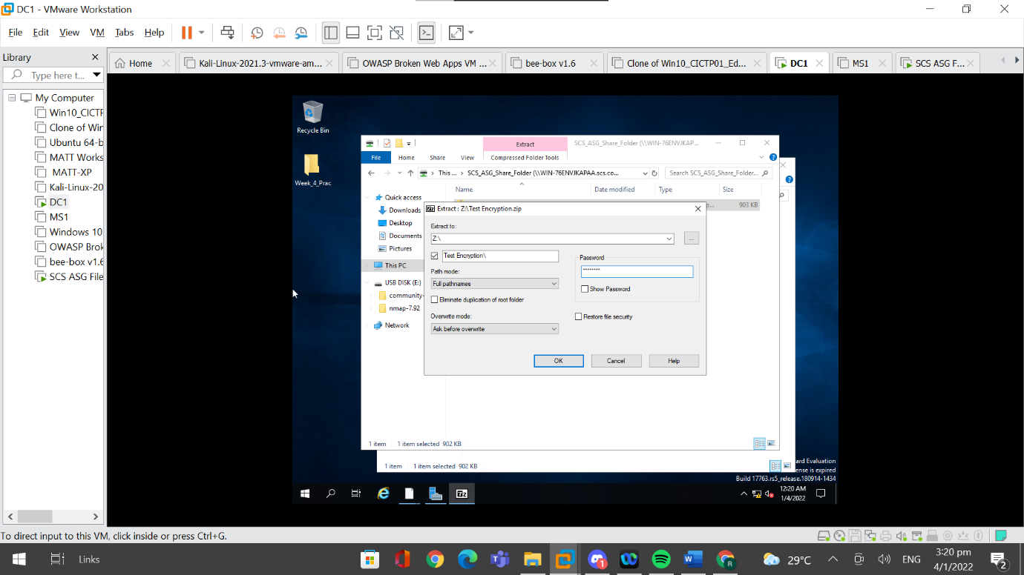

If the password was entered correctly, the files in the encrypted folder will be extracted and the contents can be accessed.

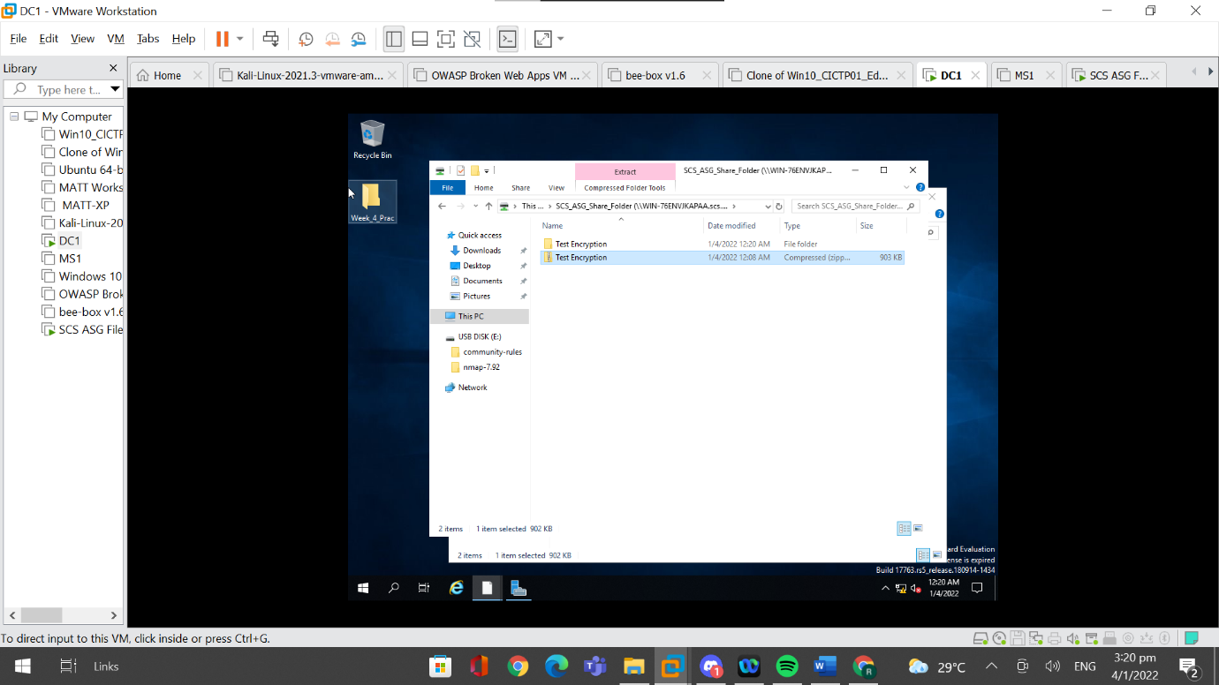

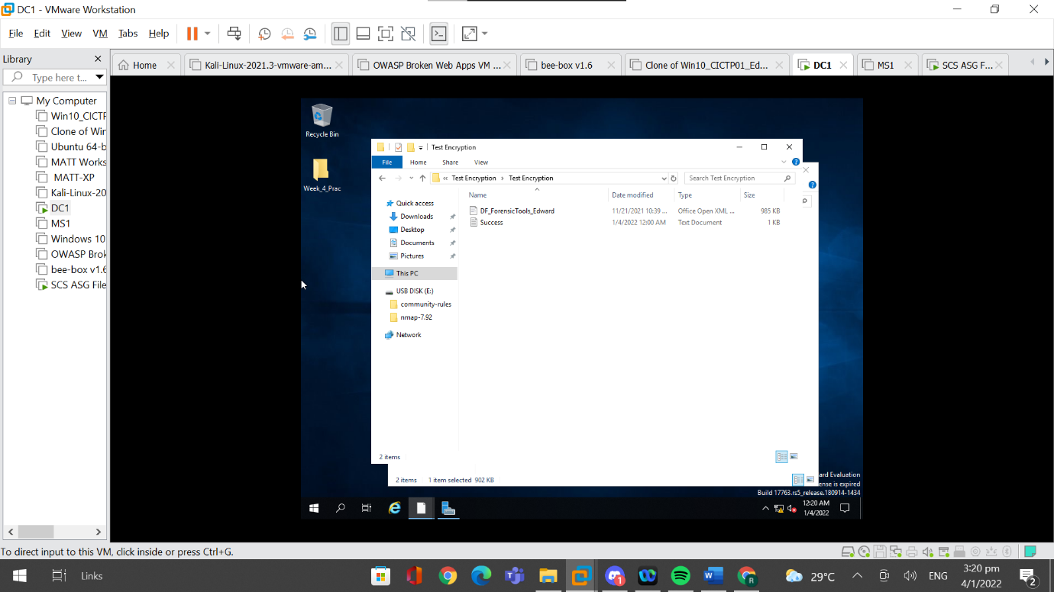

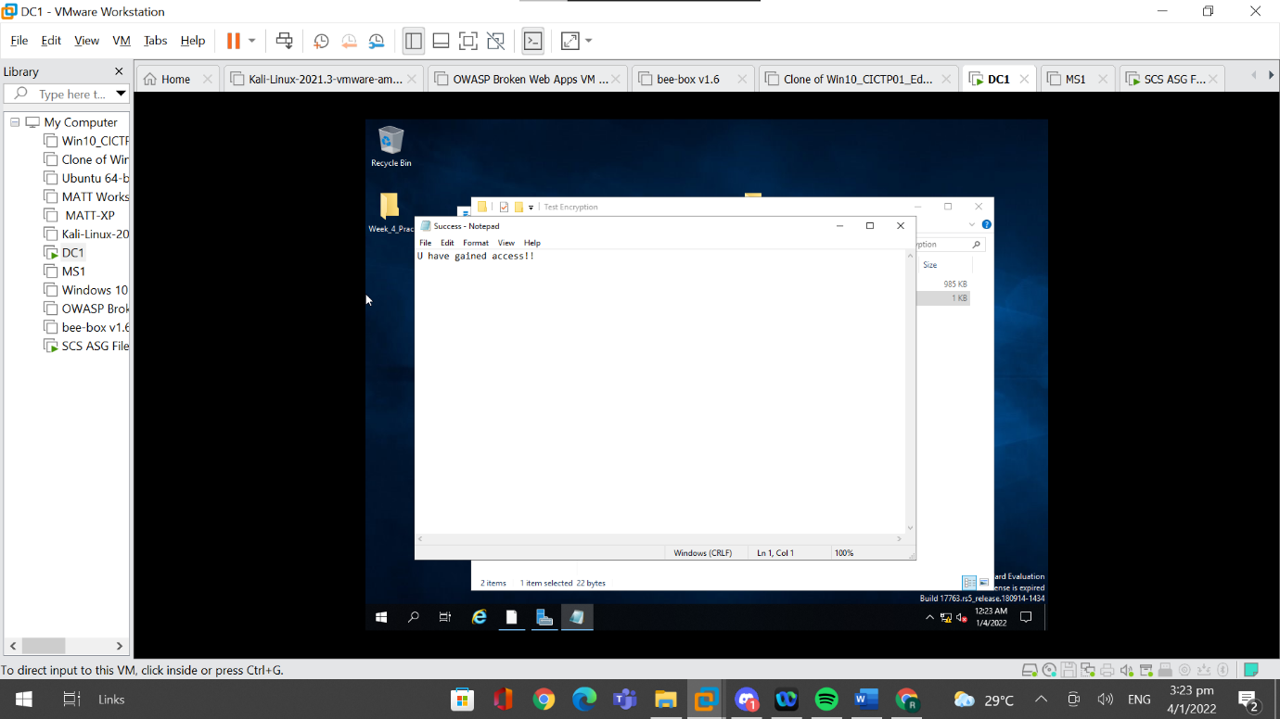

If the password was entered wrongly, a pop up will appear indicating that the wrong password was used and that there were errors decrypting the encrypted folder.

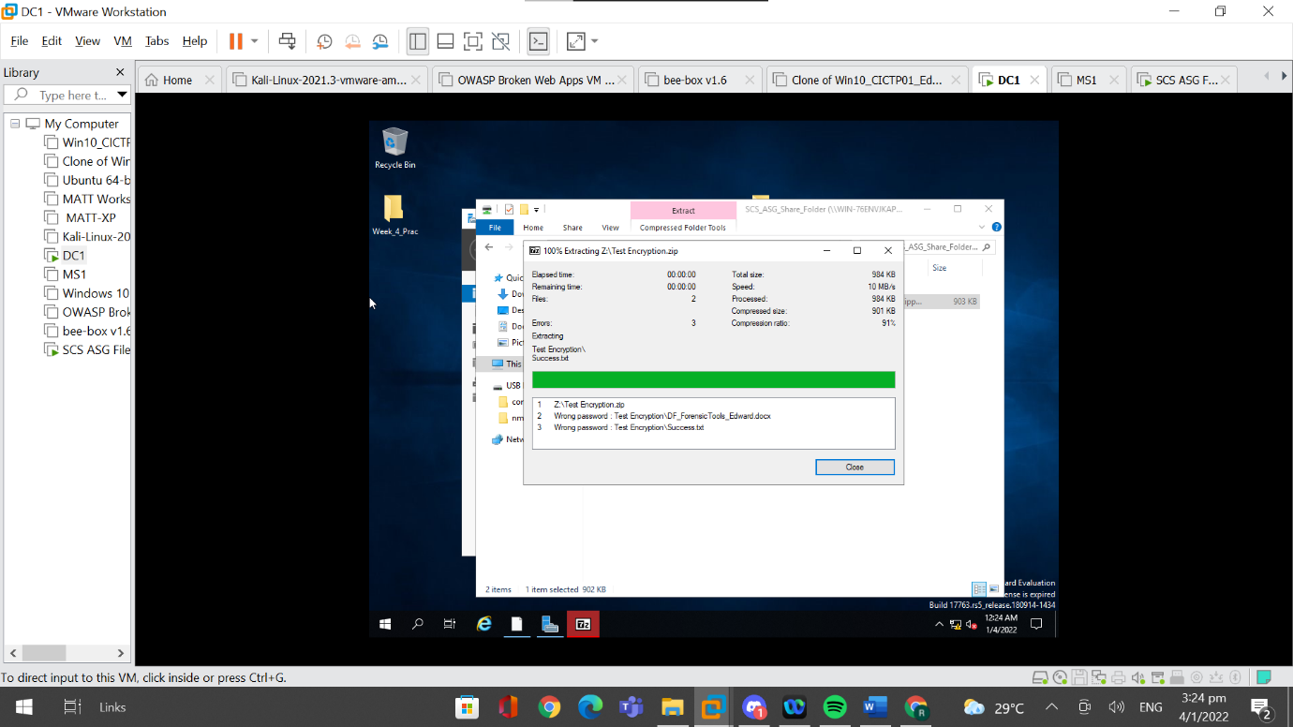

However, after closing the popup, the folder was still extracted and the names of the files can still be seen

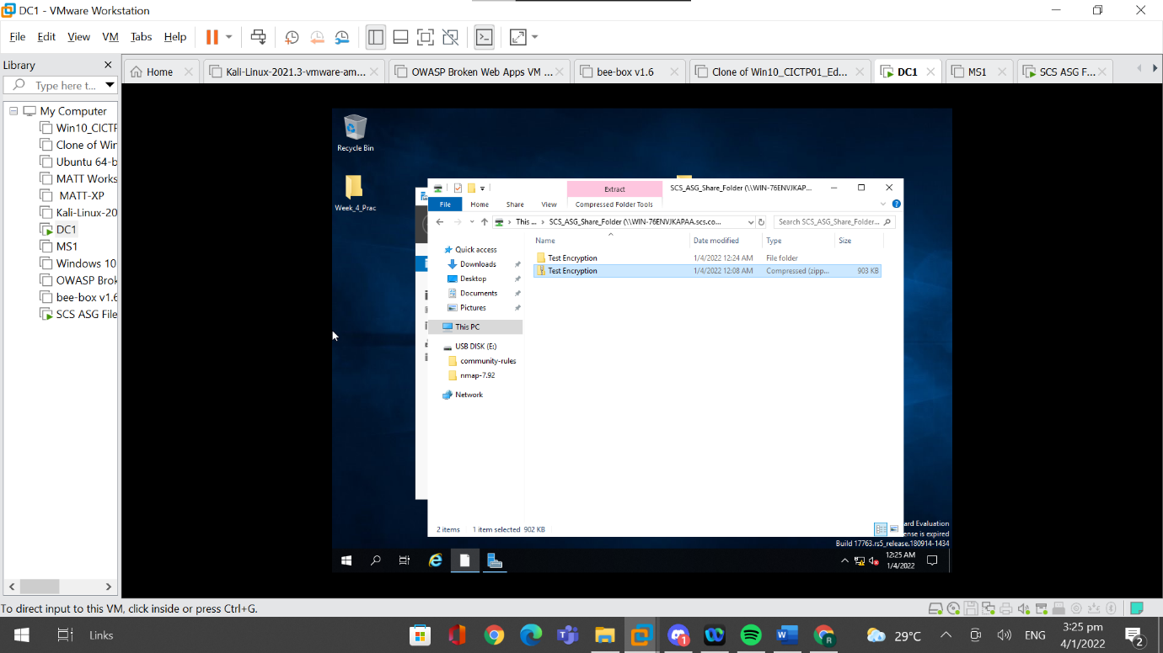

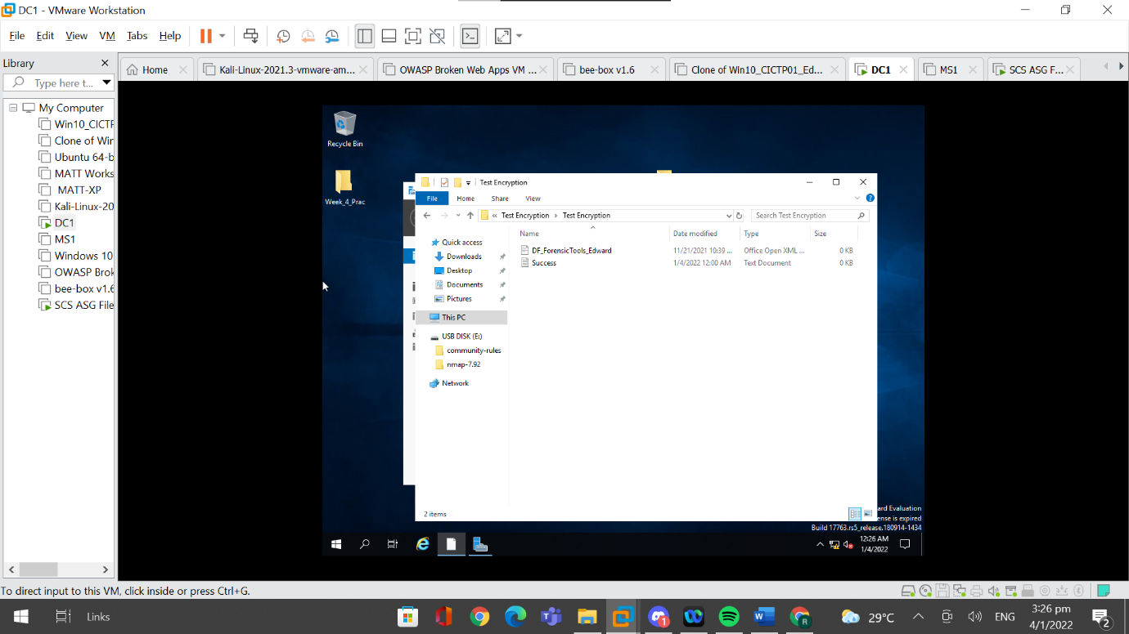

However, when I view the contents of the file, nothing will be shown and thus no data will be lost.

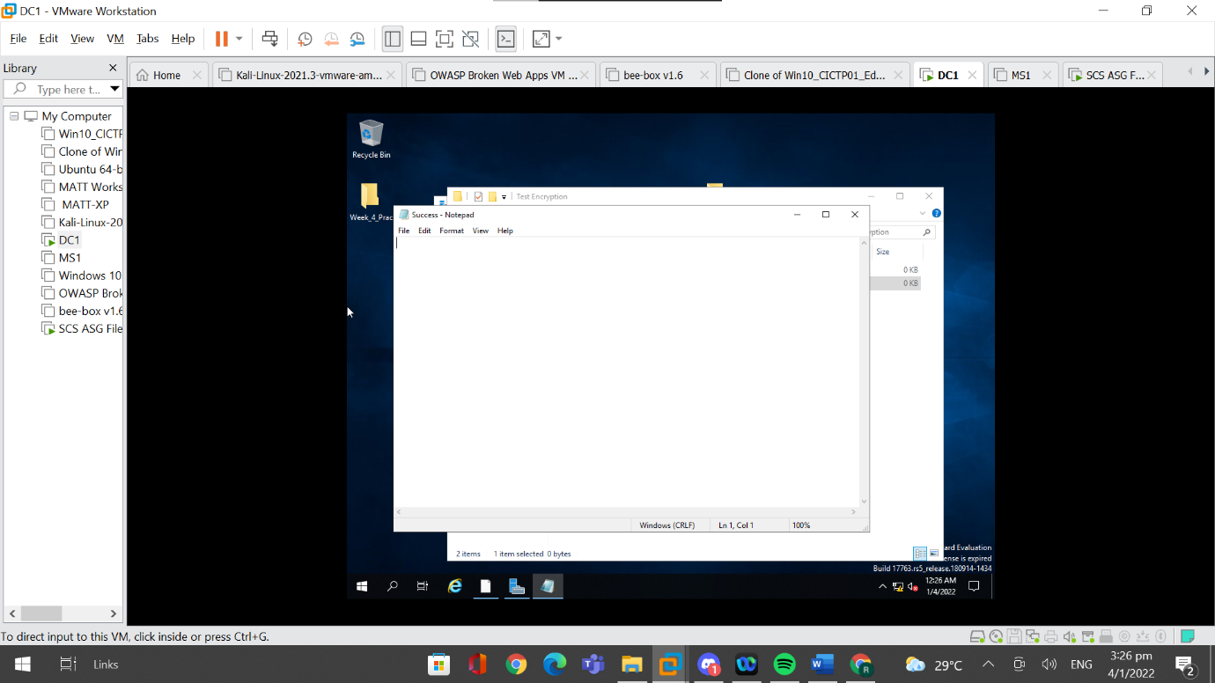

## 4.7 Configure Access Control List

An access control list is extremely essential in hardening the shared folder. It allows administrators to control which users can access certain files. It defines permissions for users belonging to different roles, allowing for the implementation of the least-privileges principle which is a security measure in which a user is only granted the minimal permissions required to complete their required and authorised tasks. This helps to ensure that users are not granted permissions that they do not require, preventing them from accessing unauthorised information or performing unauthorised actions.

### 4.7.1 Configure Access Control List

In order to configure an access control list, I first have to create multiple users in the active domain and use access permissions to control which account can access the shared folder.

I have to use the domain controller, “DC1” to add users and groups.

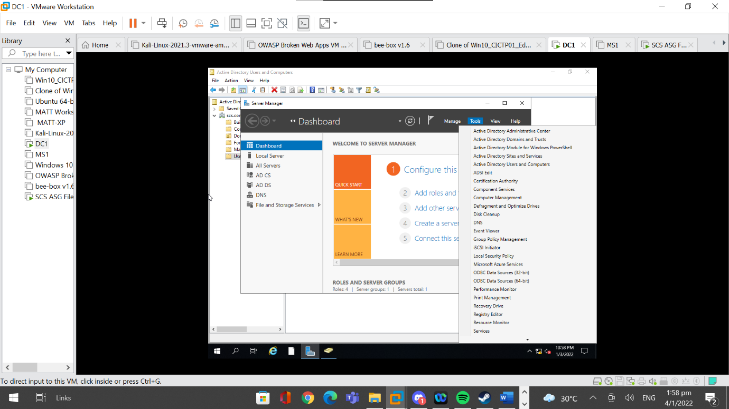

In order to create new users, I first went to “Active Directory Users and Computers”.

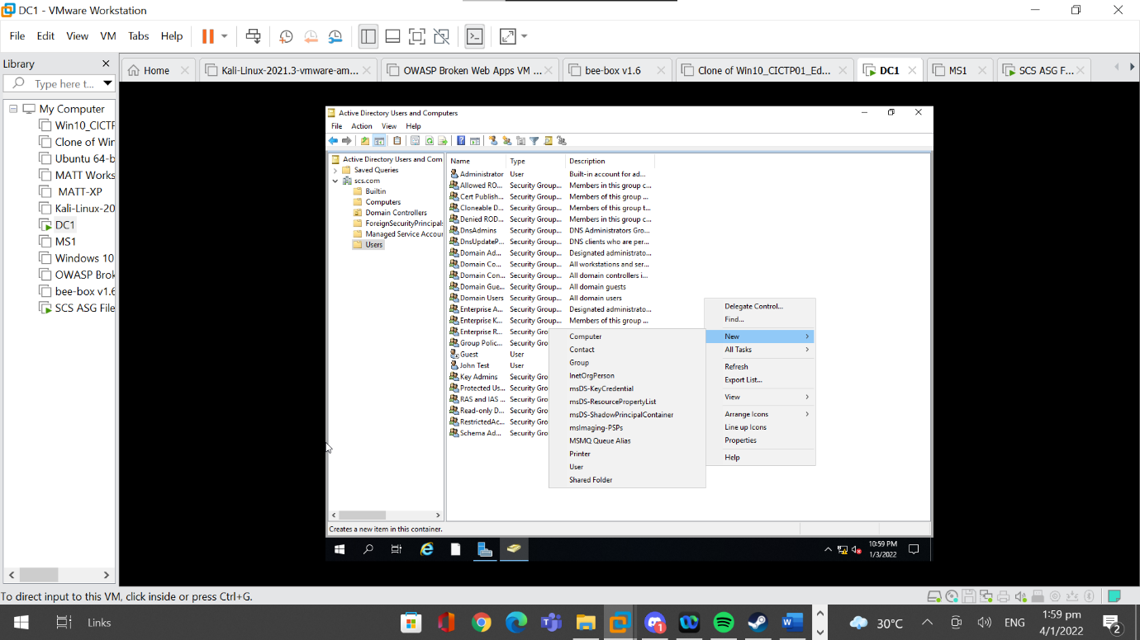

Then, I went to the subfolder, “Users”, right-clicked on an empty spot and clicked on “New” and clicked on “User”.

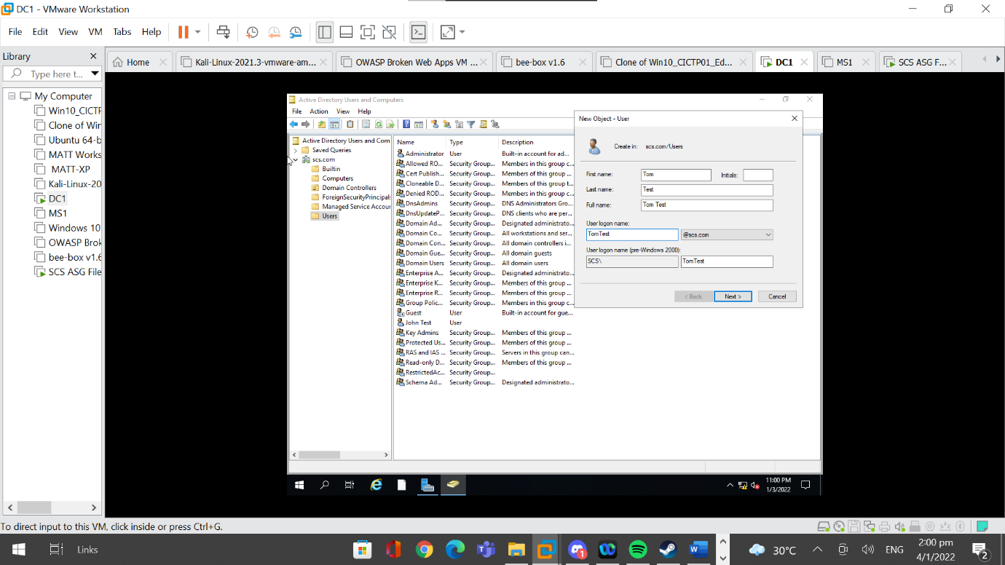

Next, I have to specify the details of the new user to be created such as first name, last name and logon name. After adding the details of the user, I clicked on “Next” to move on to the next segment.

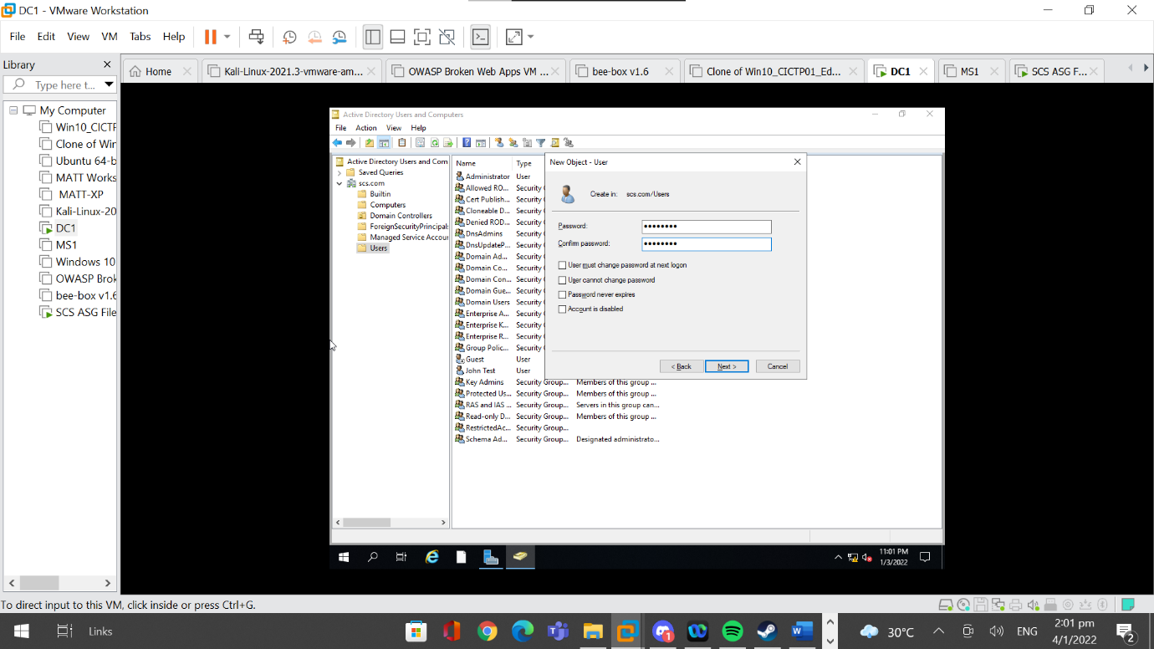

In the next segment, I have to fill in the password information of the user. In a real-life situation, “User must change password at next login” should be ticked for security reasons. However, since this is for testing purposes, I unticked it for convenience. After setting up the password, I clicked on “Next” to move on.

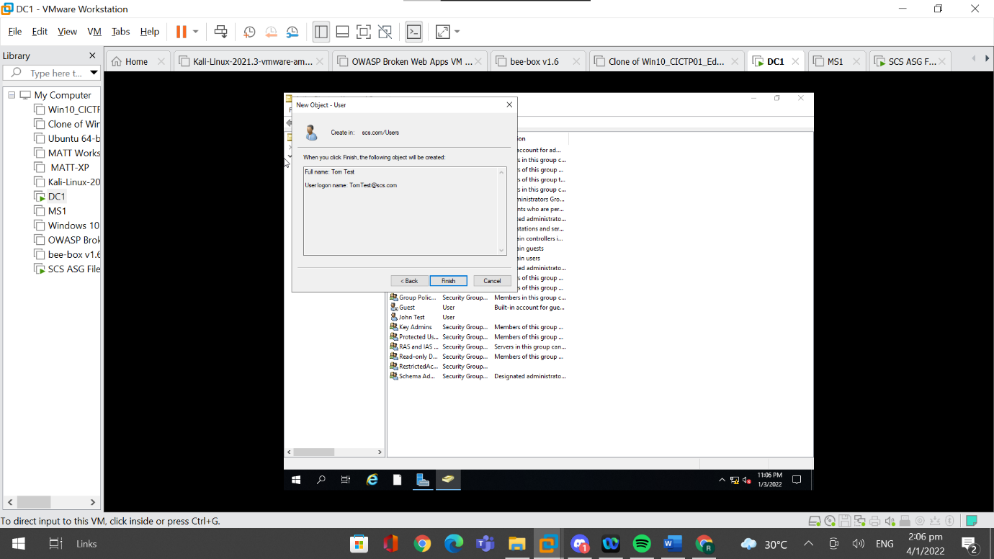

I verified the details of the user and clicked on “Finish” if everything is correct. I created another user, “John Test” as well.

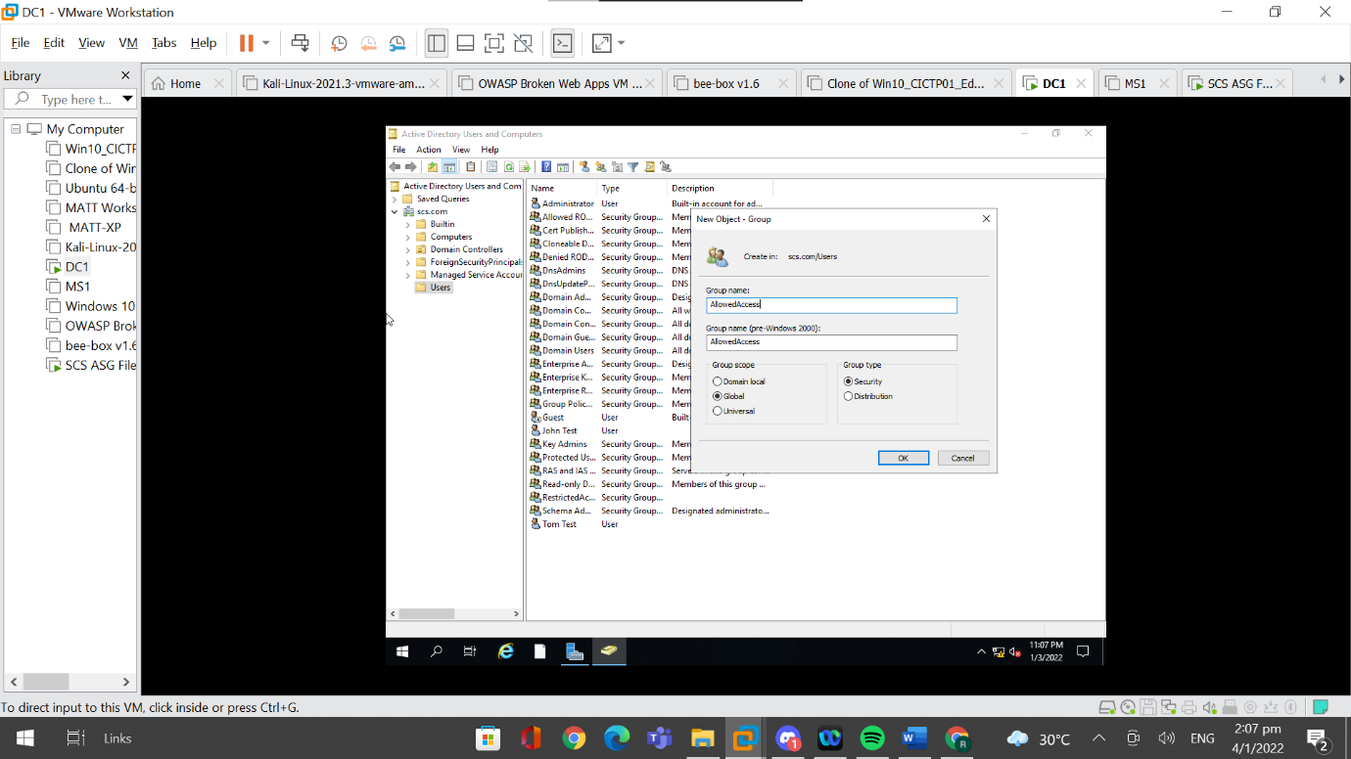

After creating both users, I also created groups. I created two groups, “RestrictedAccounts” and “AllowedAccounts”. Both of these groups have a global scope and a security group type. These groups have a global scope and a security group type because the groups consist of users that belong to the local domain and because permissions need to be assigned to these groups.

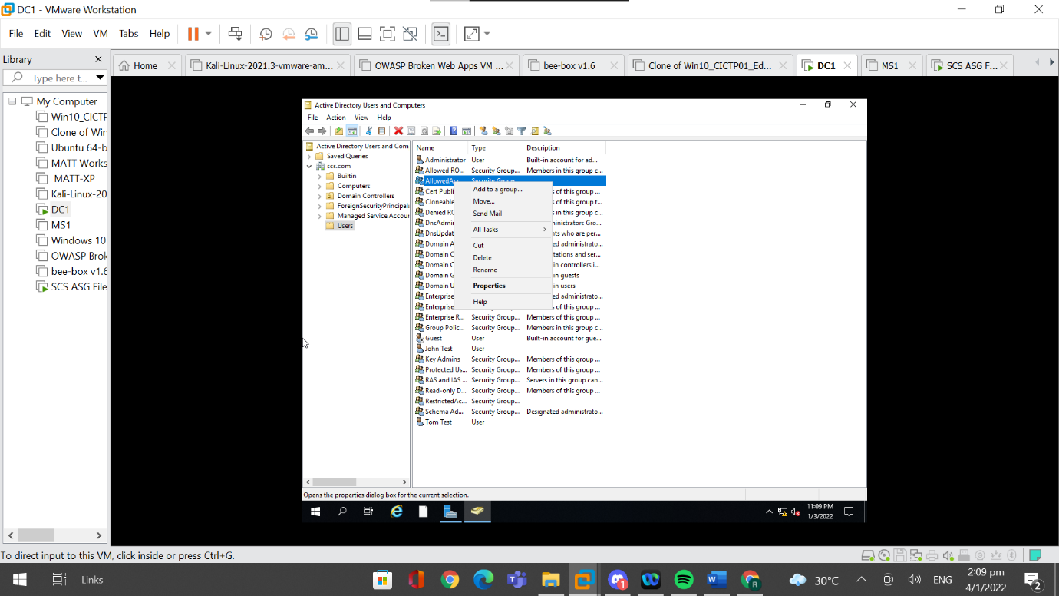

After creating the groups, I have to add the users to the group which can be done by right clicking on the group created and going to “Properties”.

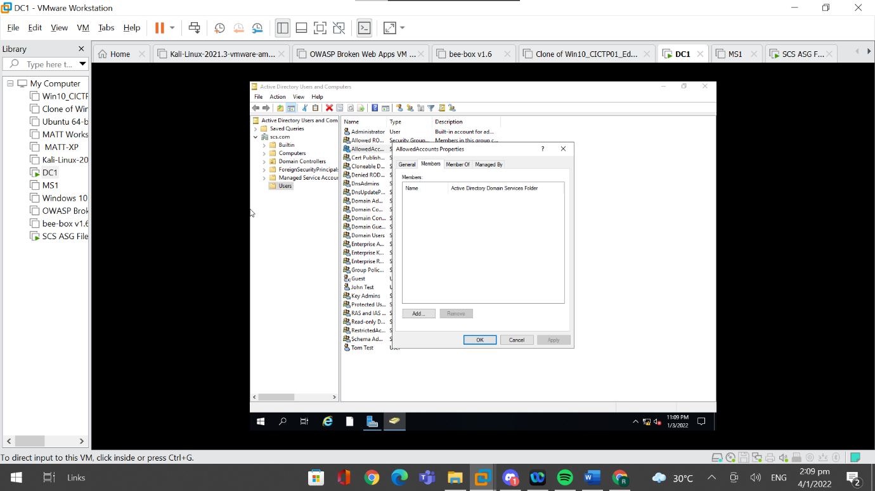

Then, I have to go to the sub header, “Members” and click on “Add”.

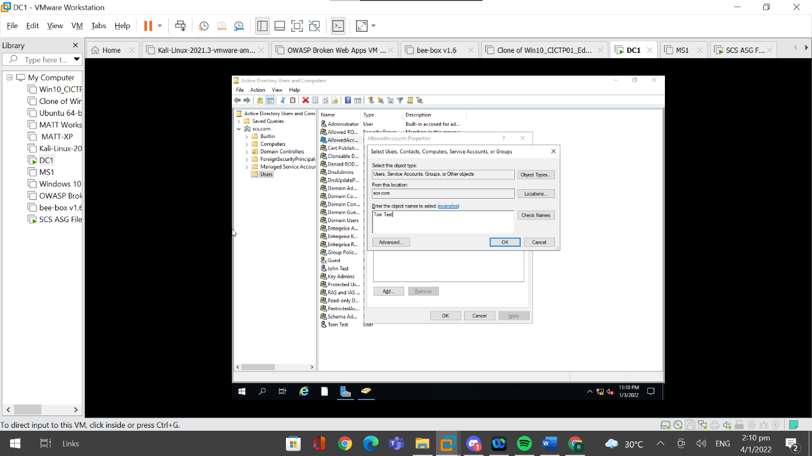

A popup will appear, and I have to add the names of the users that are supposed to be assigned to the group. I added the created user, “Tom Test” and clicked on Ok.

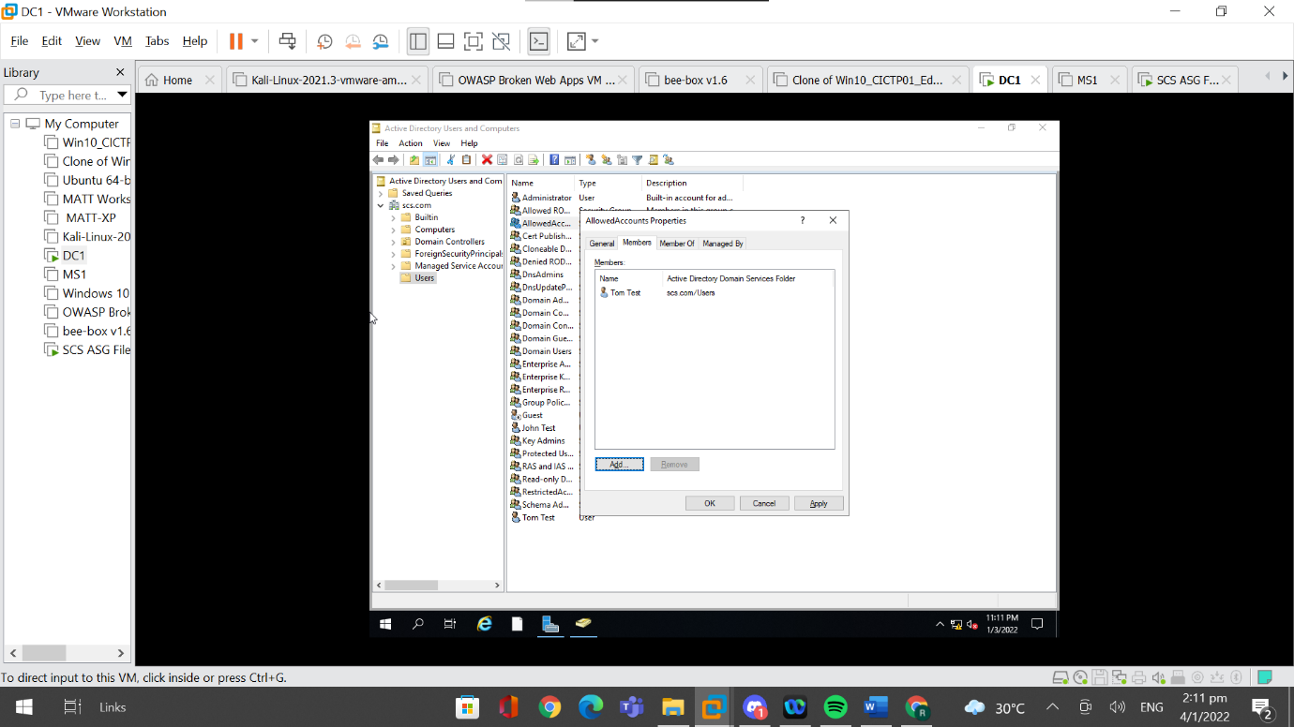

After adding the user, I clicked on “Apply” and “OK”. “Tom Test” is a member of “AllowedAccounts”, and “John Test” is a member of “RestrictedAccounts”.

Now, I have to adjust the shared folder permissions using the File server.

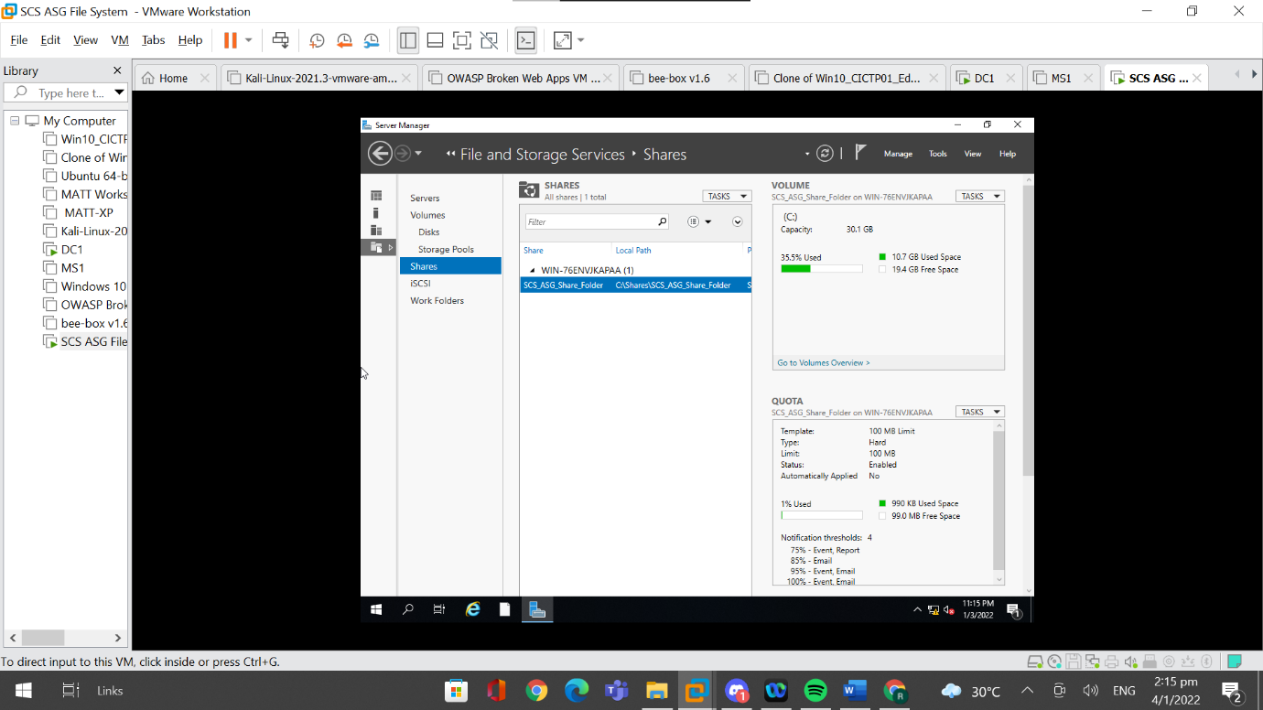

I first went to “File and Storage Services”, went to “Shares” and located the created shared folder.

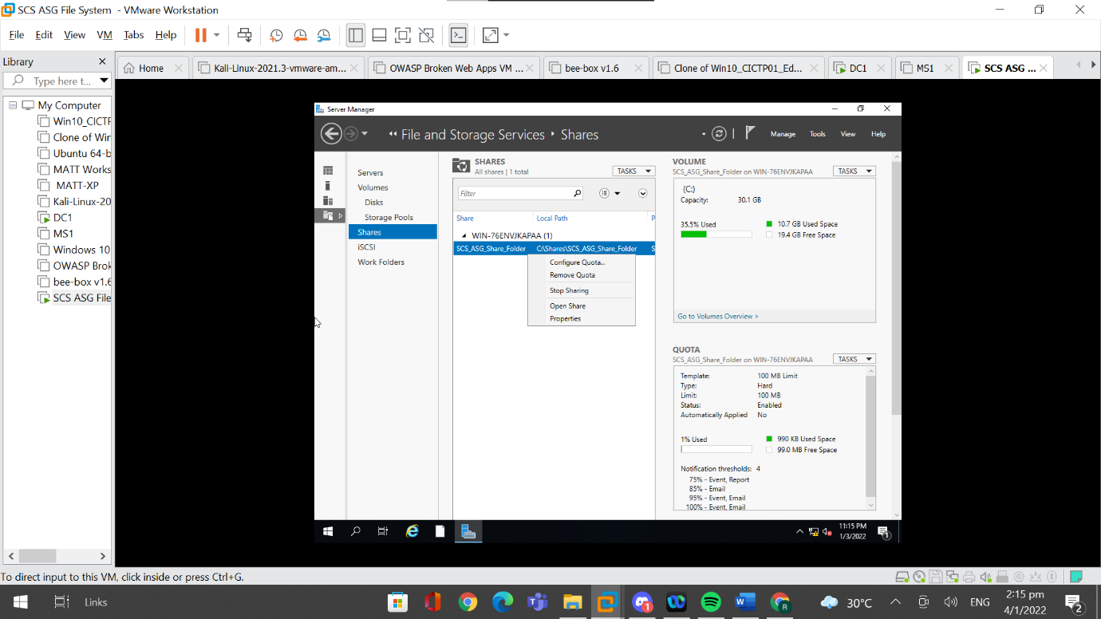

Then, I right clicked on the shared folder and went to properties.

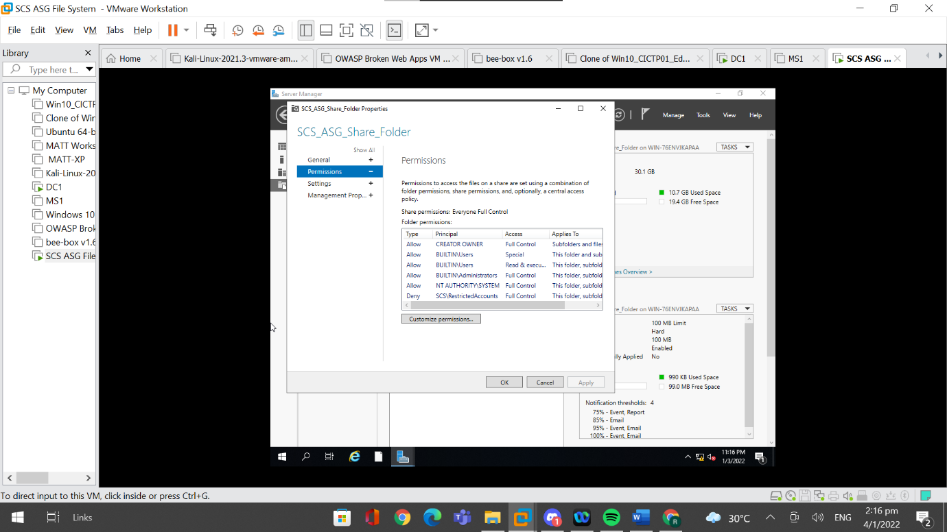

I then adjusted the permissions by going to “Permissions” and then going to “Customize permissions”.

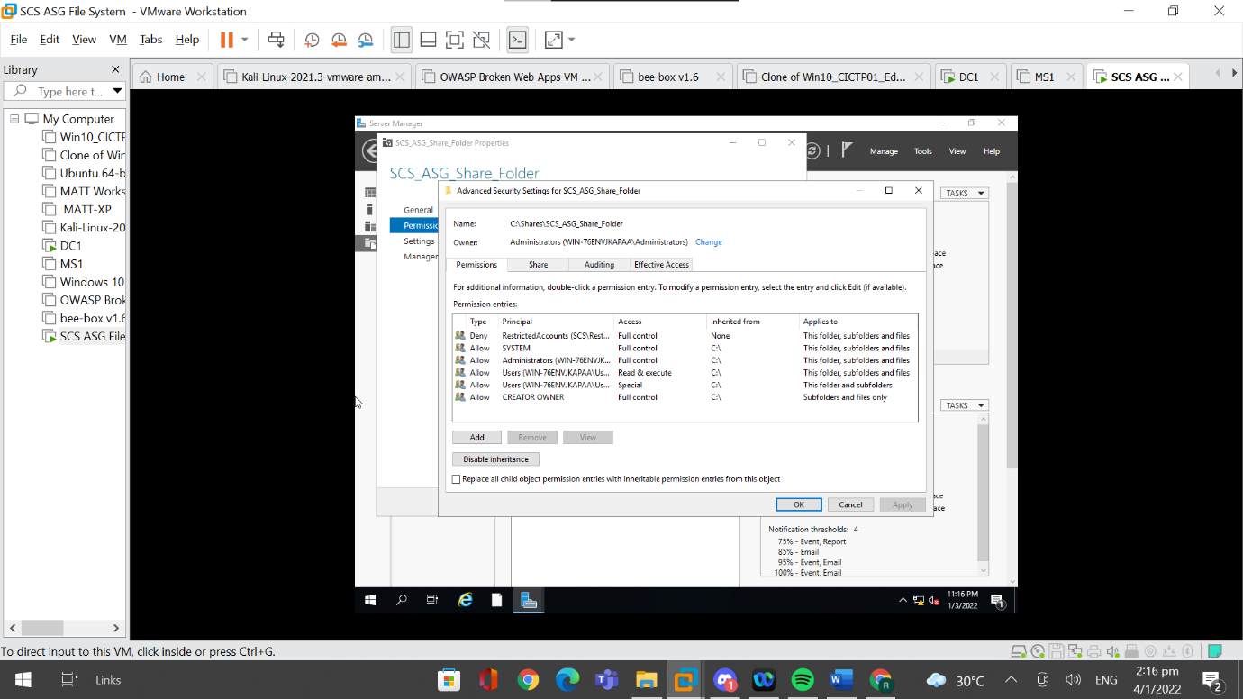

I clicked on “Add” to add permissions to the shared folder.

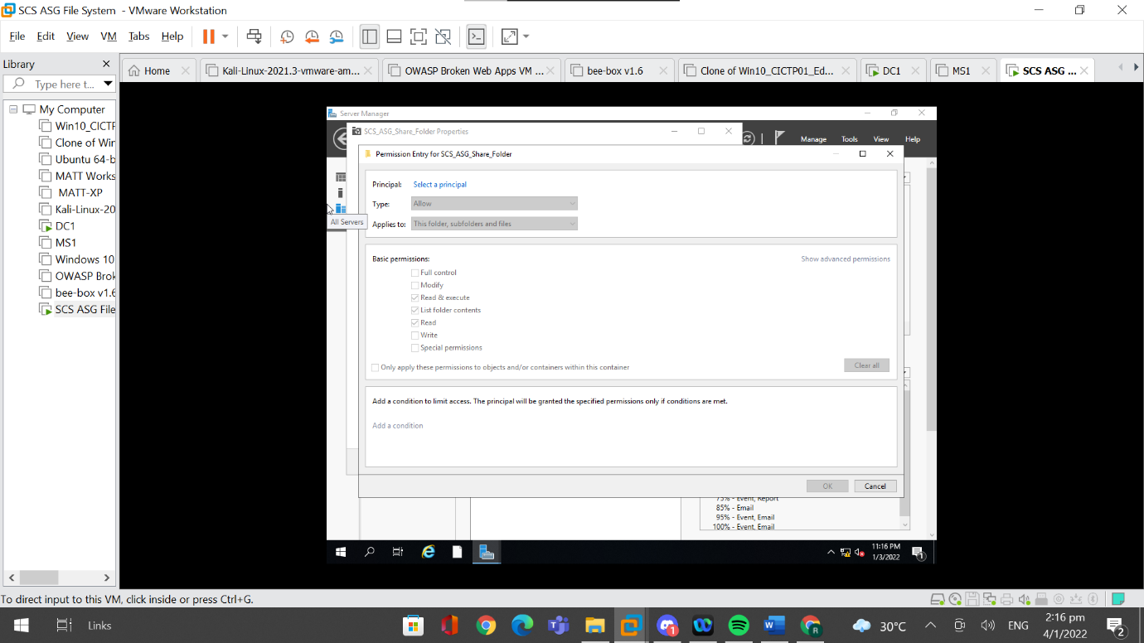

Afterwards, I clicked on “Select a principal”.

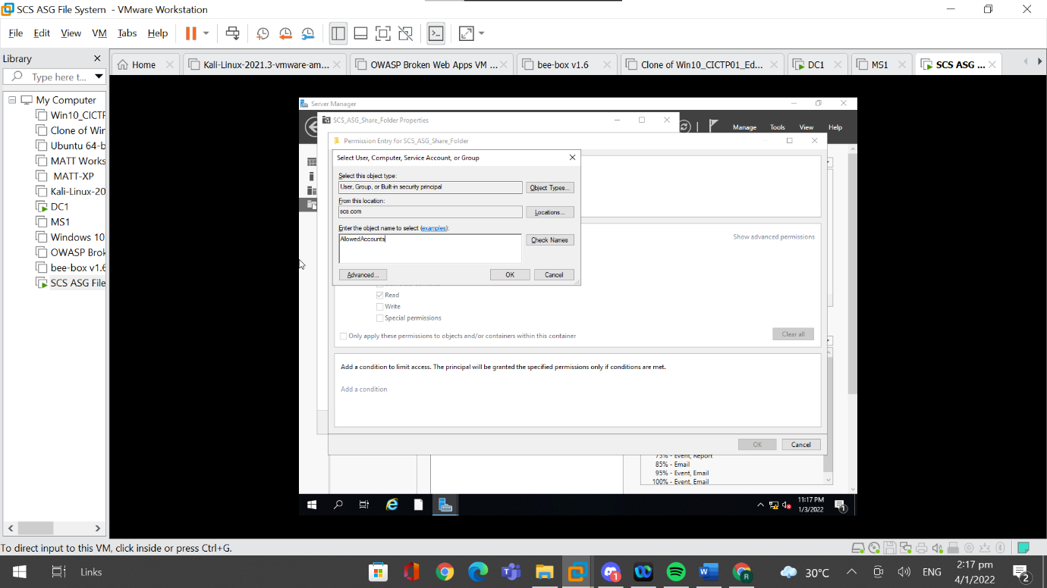

Then, I entered the group name previously created and clicked on OK.

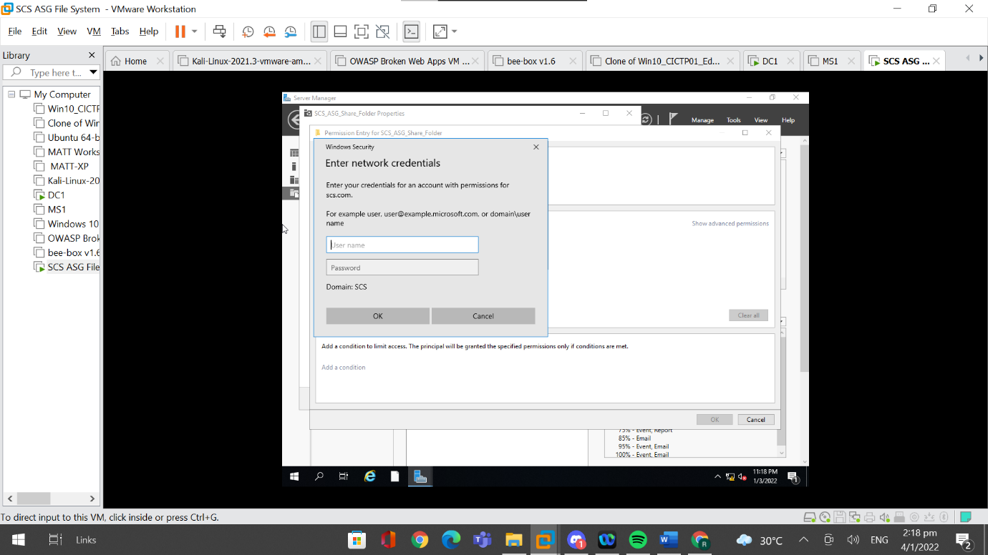

Windows Security will pop up and I had to fill it up with the administrator account information.

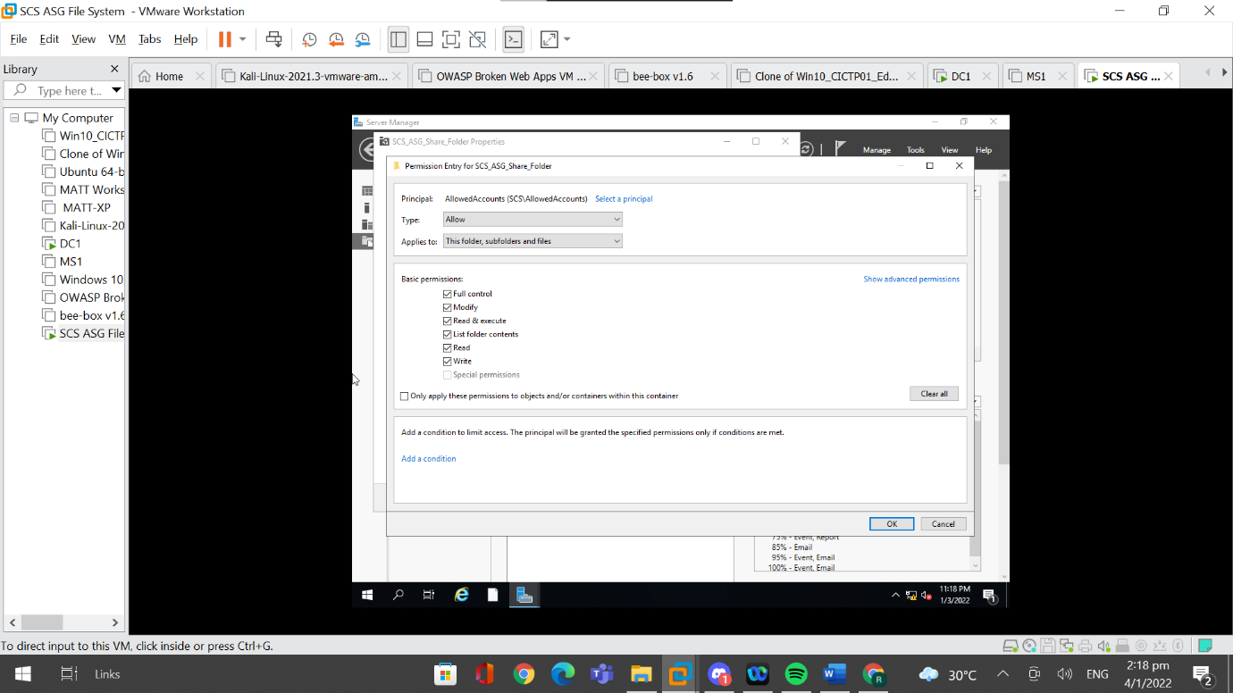

Then I set the type to “Allow” and let this permission be applicable to “This folder, subfolders and files”. I then set the basic permissions, which in this case, was set to Full control, and clicked on “Ok”.

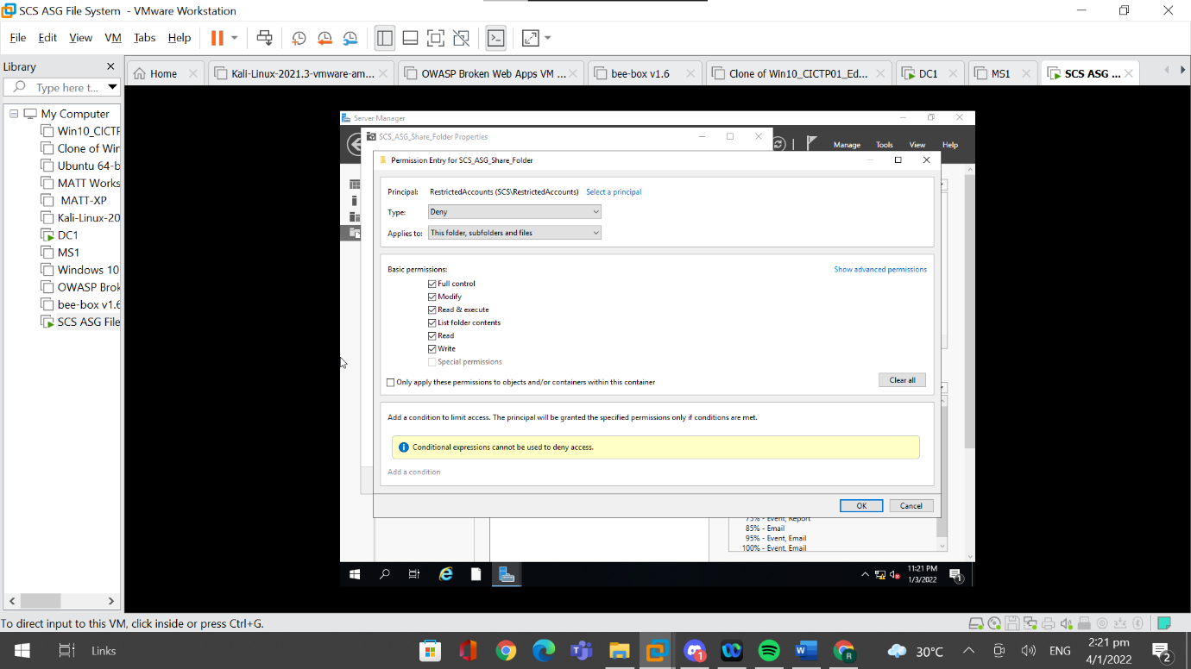

For the other group, “RestrictedAccounts”. The type is set to “Deny” and everything else is set to be the same.

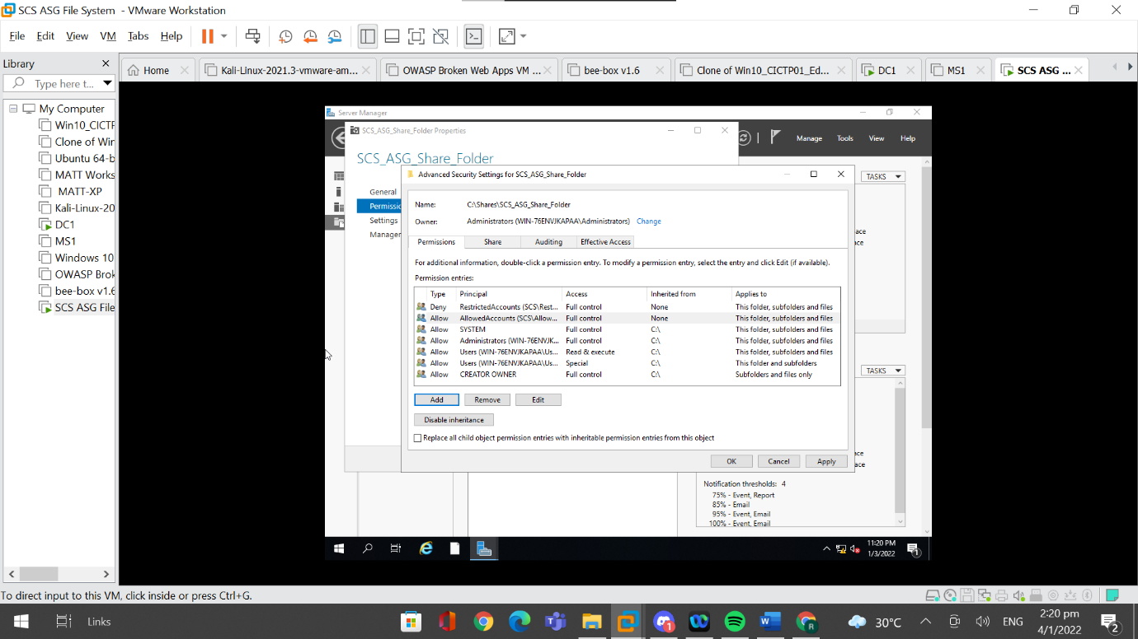

After I added both RestrictedAccounts and AllowedAccounts, I clicked on “Apply” and “Ok”.

### 4.7.2 Testing Access with Created Users

When trying to log in using the user, “John Test”, I received an error stating that “Windows cannot access” the shared folder.

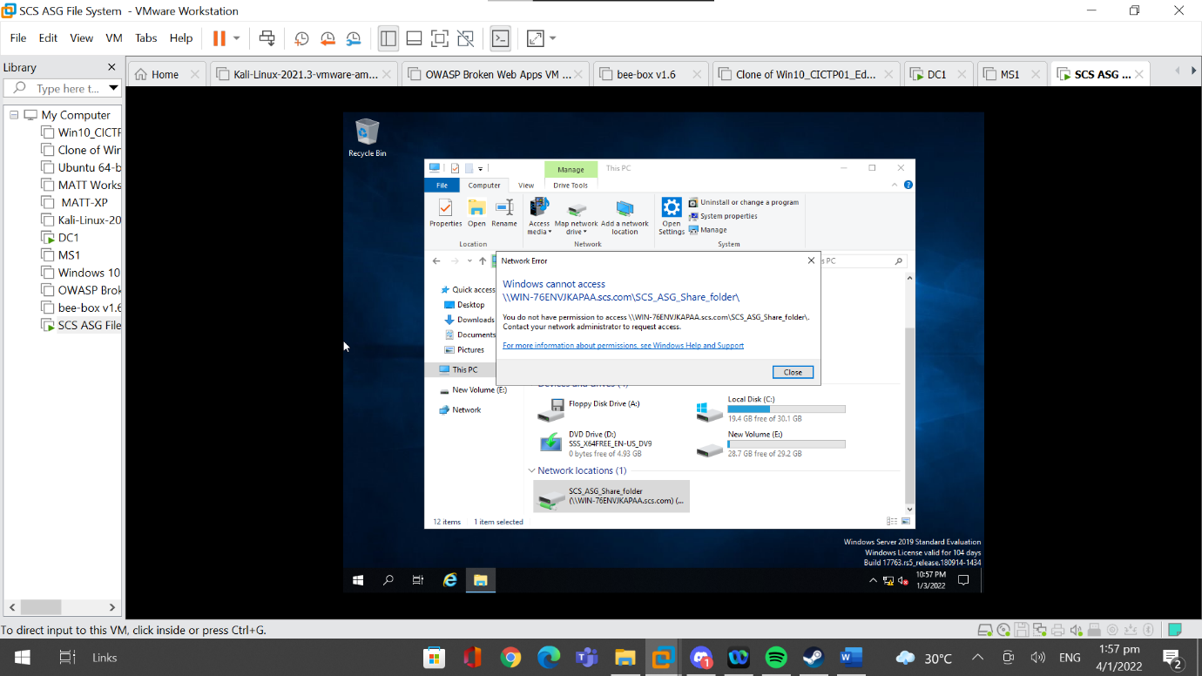

When trying to log in using the user, “Tom Test”, I was able to access the shared folder and its contents. From these two tests, I am able to see that the access control list configured on the file server was correct and is working properly.

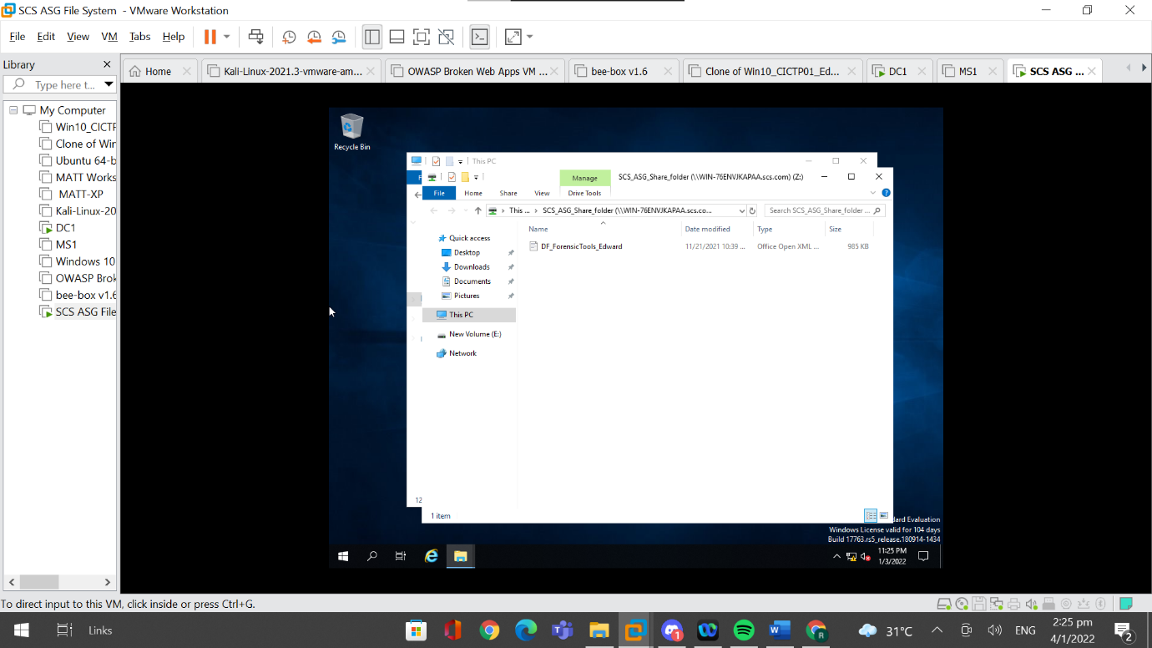

## 4.8 Server Backup

Server Backup is very important to implement on the file server because it acts as a fail safe. It backs up the file server and ensures that data is not lost. In the event of emergencies, having back ups can ensure that data is stored and protected. This can also be useful in times where data stored is corrupted. It can also be used to restore operations of the organisation immediately, resulting in less downtime.

### 4.8.1 Server Backup Implementation

In order to set up server backup, I have to first go to “Server Manager” and go to “Add Roles and Features”.

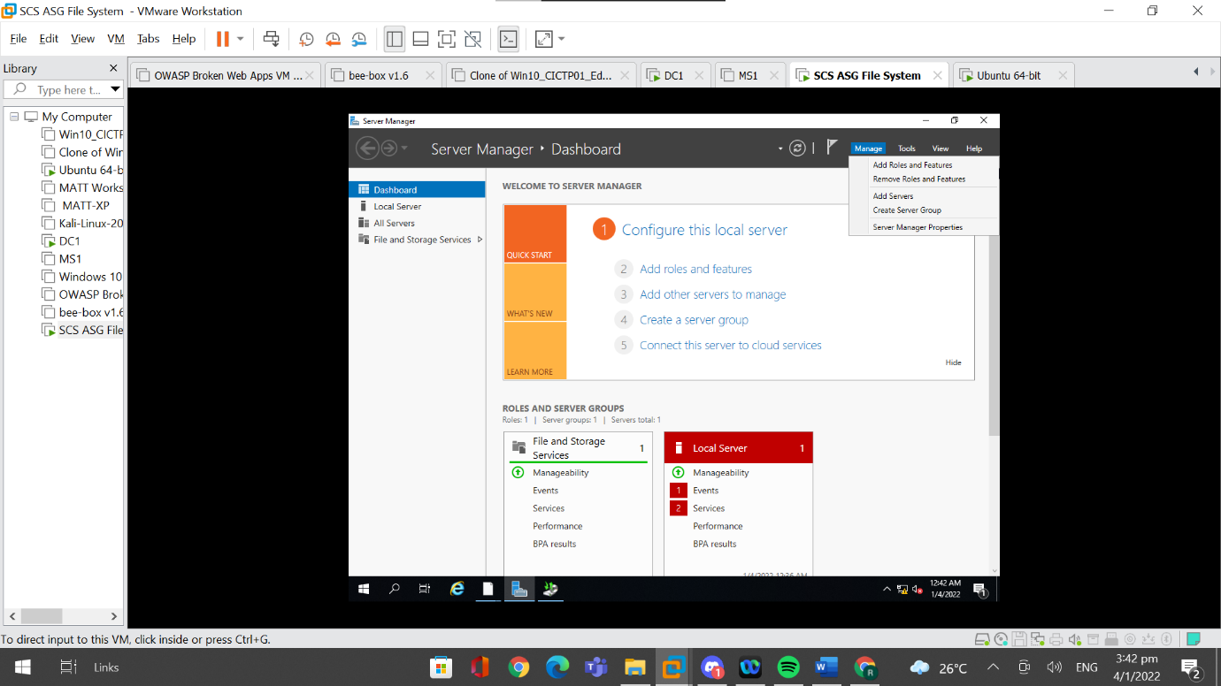

I then had to go to “Features”, tick “Windows Server Backup” and click on “Next”.

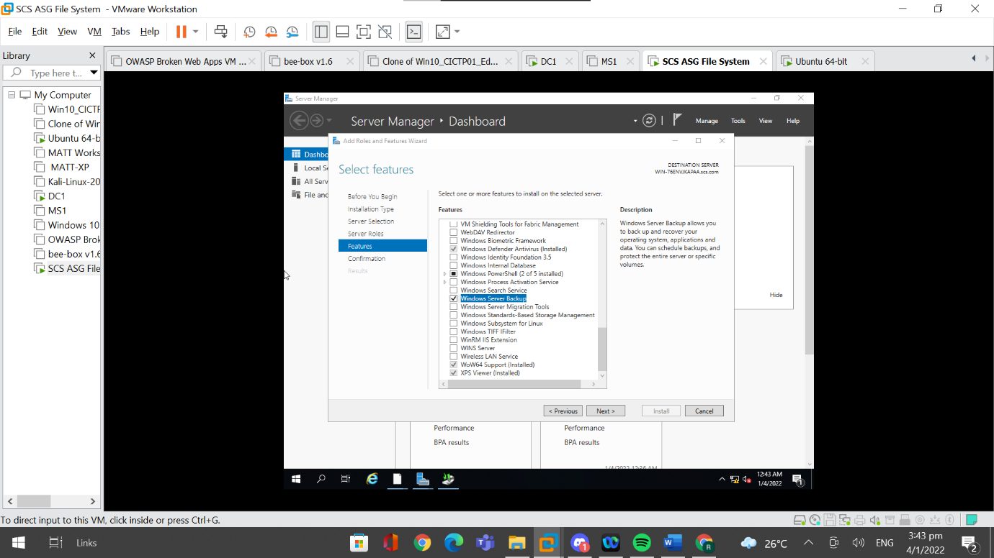

I installed the previously selected feature by clicking on “Install”.

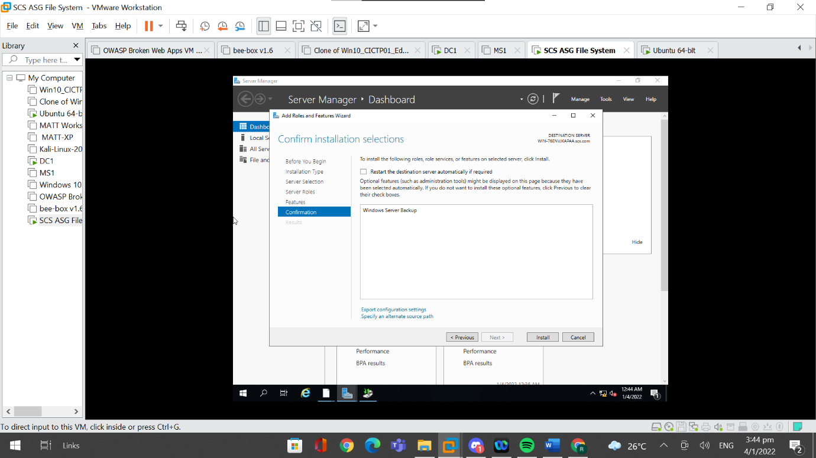

After the installation was completed, I then closed the popup window.

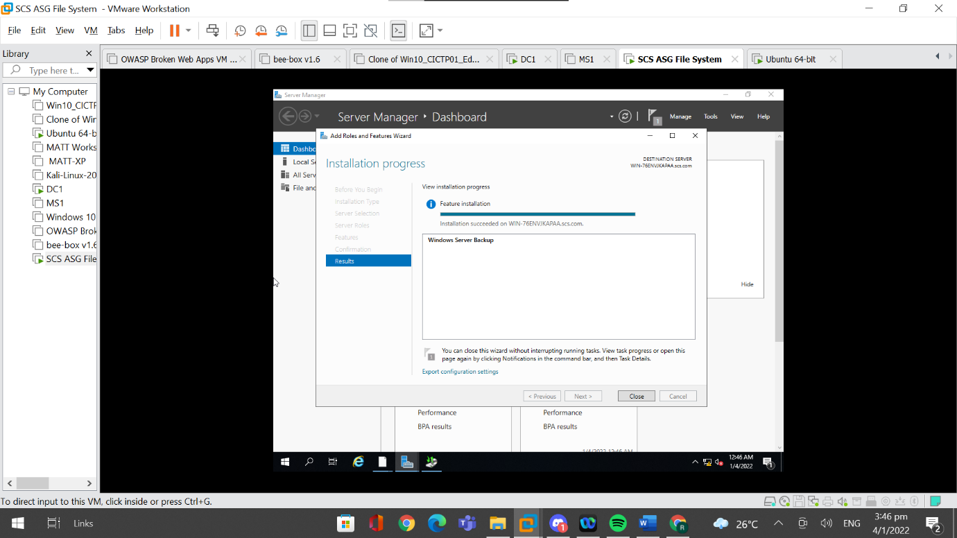

Next, I went to “Tools” and to “Windows Server Backup”.

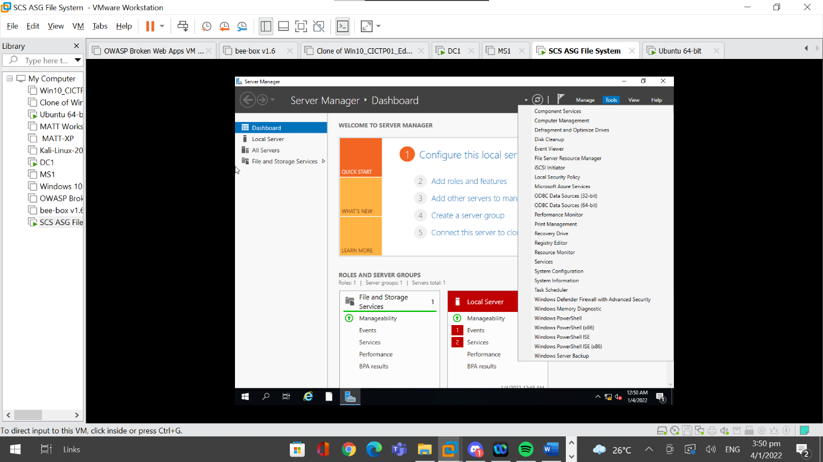

The Windows Server Backup application will open, and I can see the last local backup that was made. Since this is the first time installing this feature, the contents of the last local backup will be null. I then went to “Local Backup” to create my first local backup of the file server.

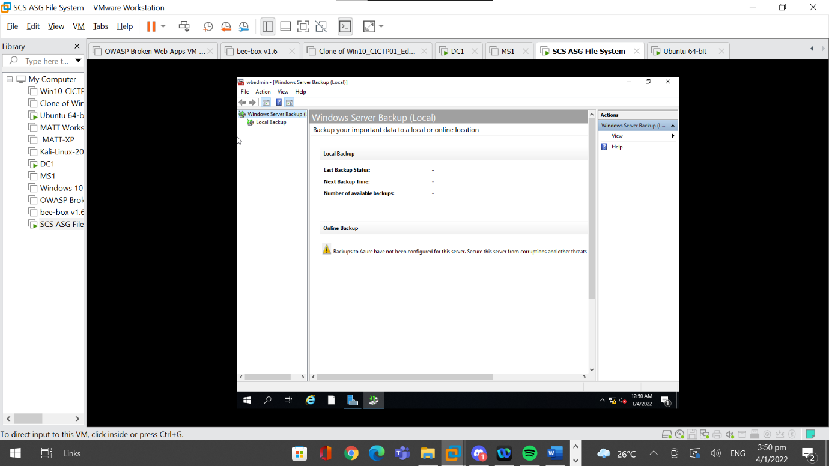

In order to create a local backup, I have to click on “Backup Once”

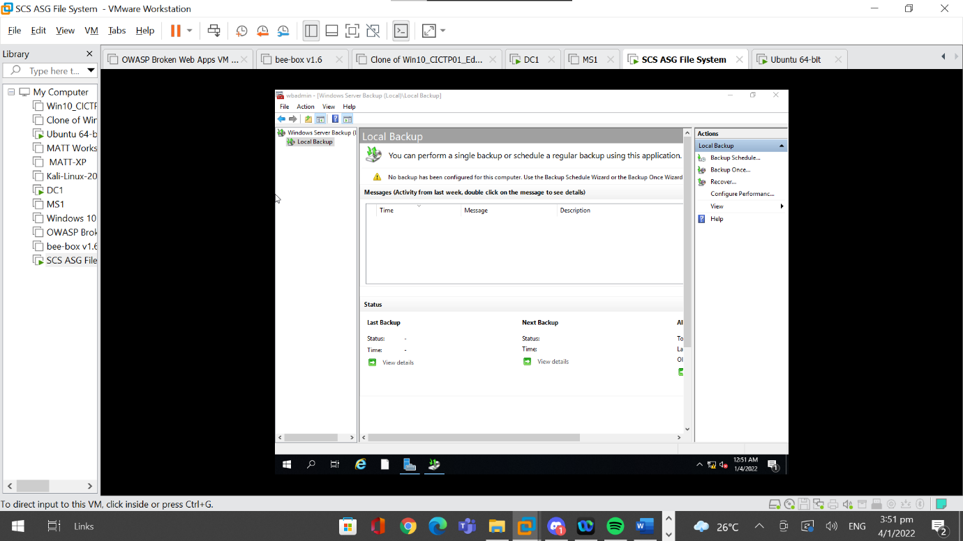

A popup will appear, and the backup option will be left on default as this is the first back up to be made. I then click on “Next” to continue.

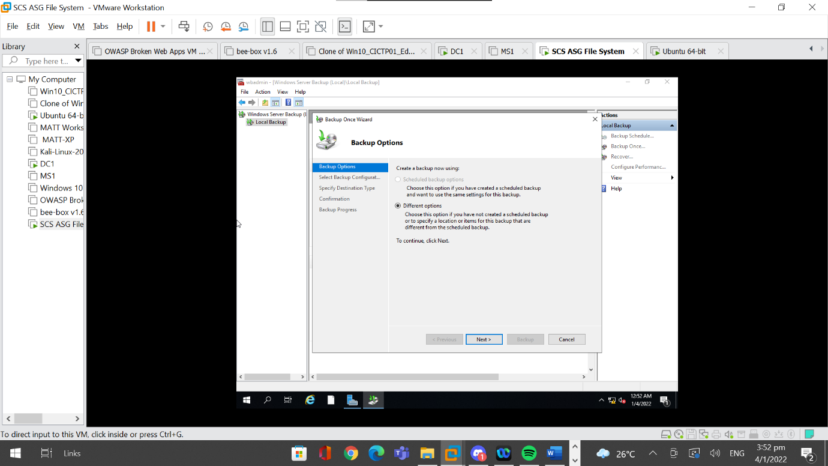

For the first option, I decided to choose to back up the shared folder only because the shared folder is the most important resource on the file server and thus only this folder needs to be backed up. Choosing custom files to backup also saves space since less space will be taken up for each back up. Thus to choose which specific files to back up, I had to click on “Custom” and go to “Next”.

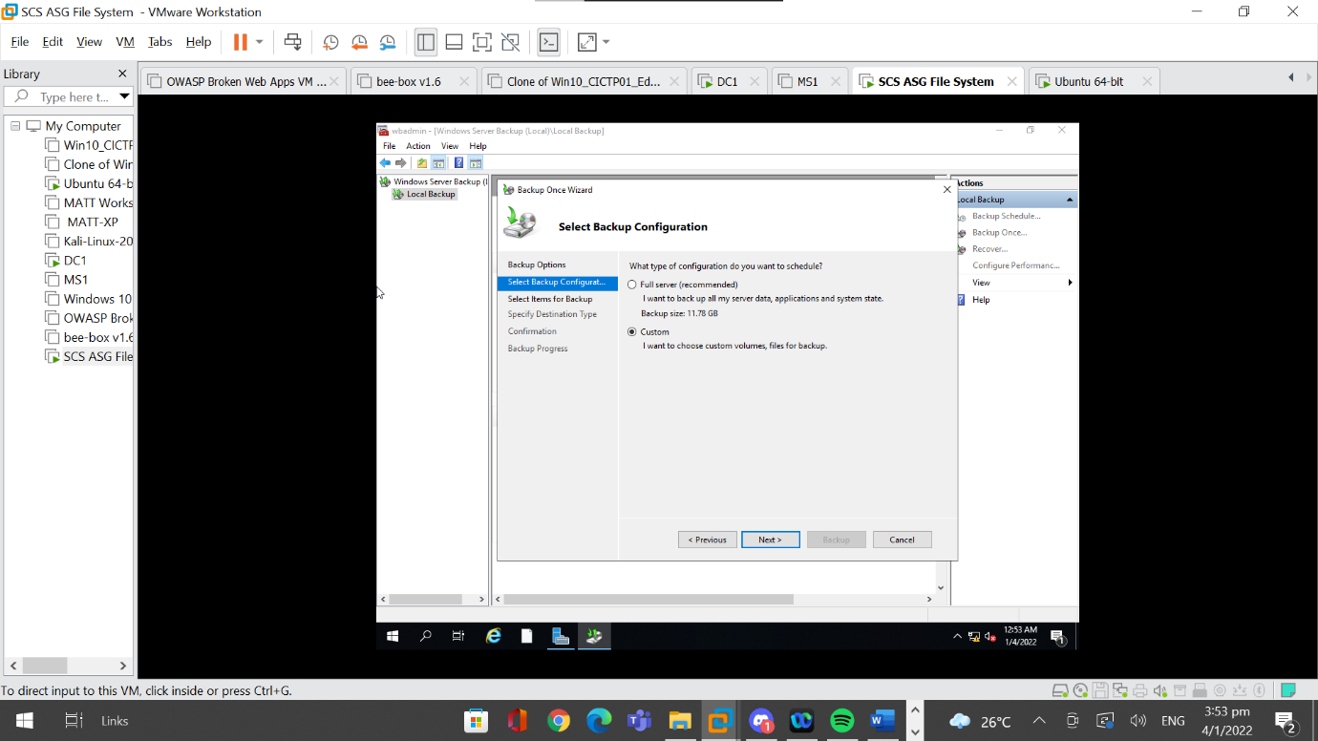

For the second option, I clicked “Add Items” and added the shared folder to the selected items.

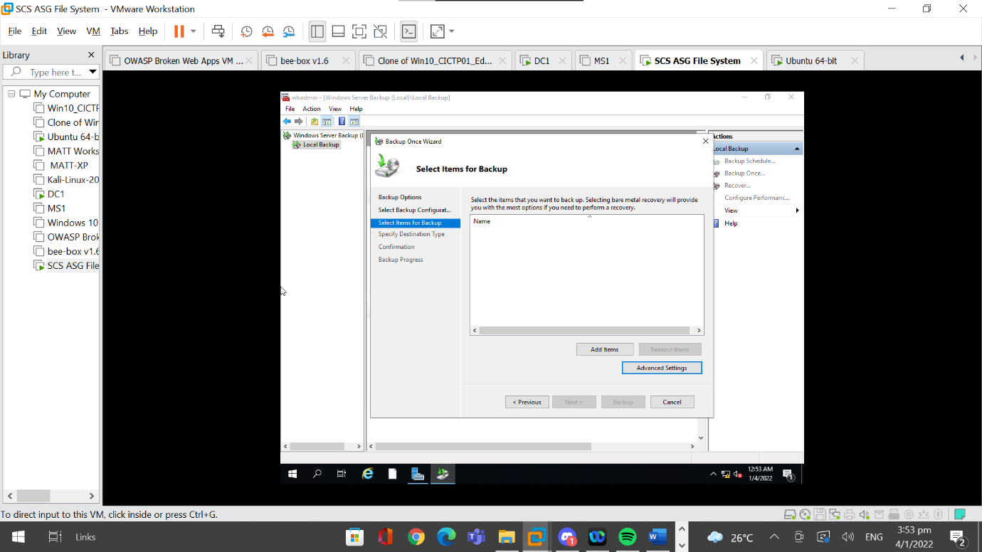

For the third option, I verified that the folder chosen is the correct one before moving to the next option.

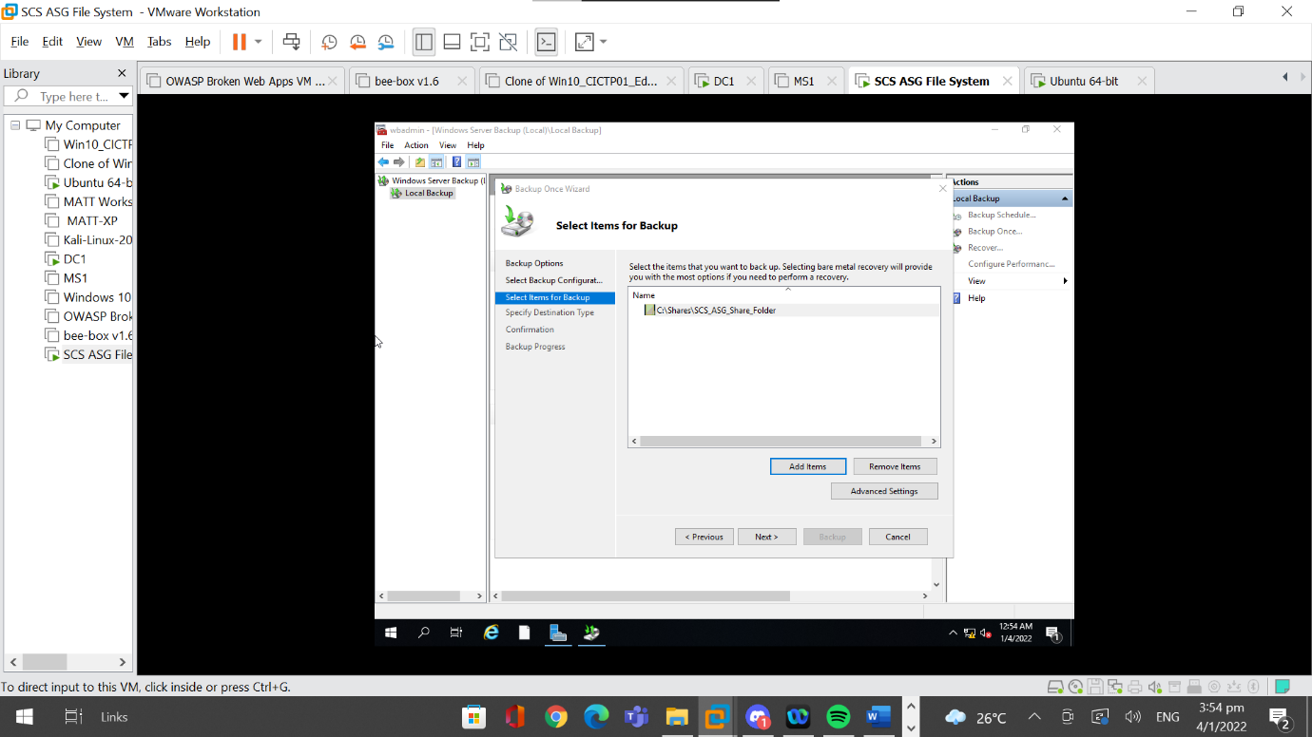

I then went into “Advanced Settings”, then to “VSS Settings” and set it to “VSS full Backup”. “VSS full Backup” was chosen because no other software is being used to backup the shared folder. Then I clicked on “OK” once the settings are configured.

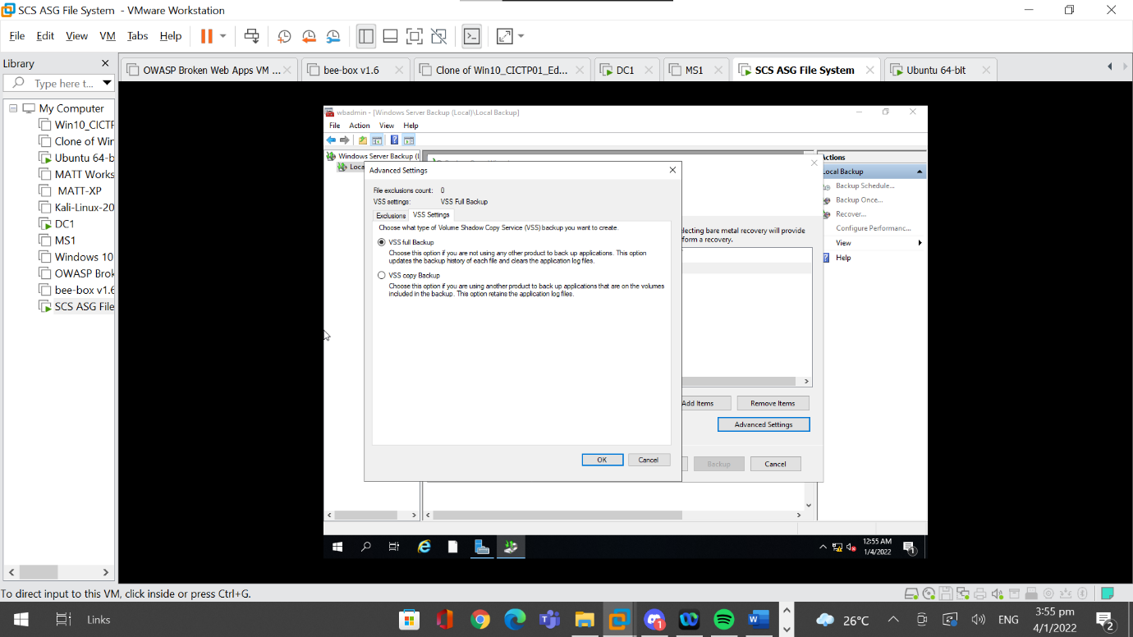

For the fourth option, I selected “Local Drive” and went to “Next”.

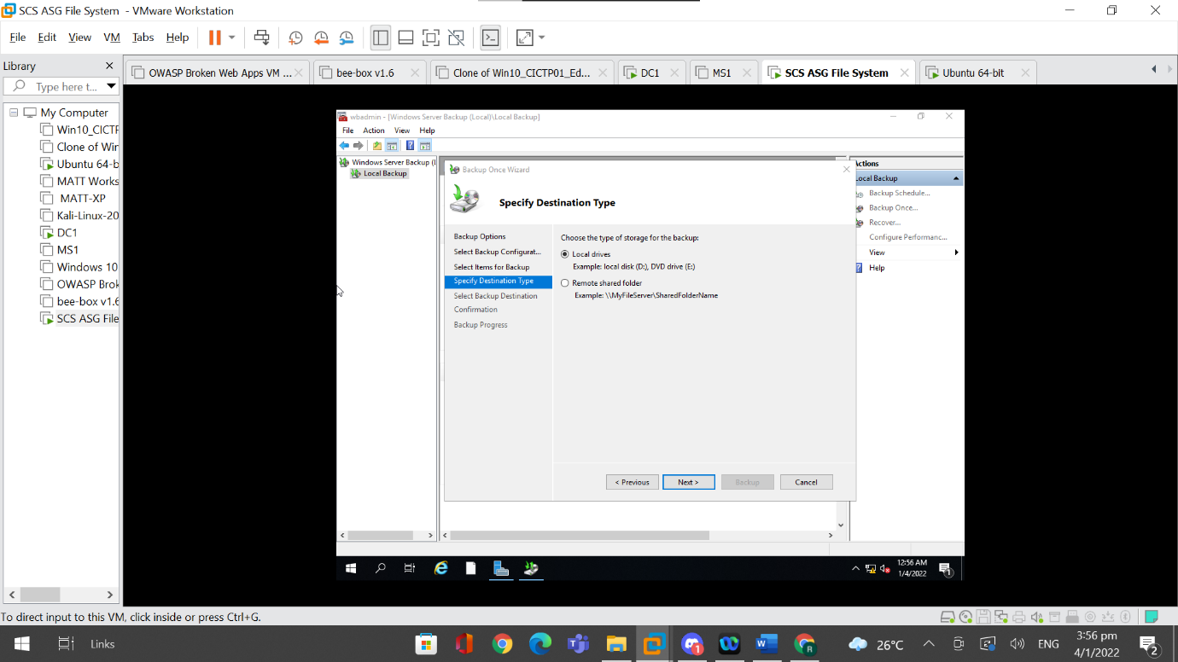

For the fifth option, I selected a drive location to save the backup to. I then clicked on “Next” to move on to the next option.

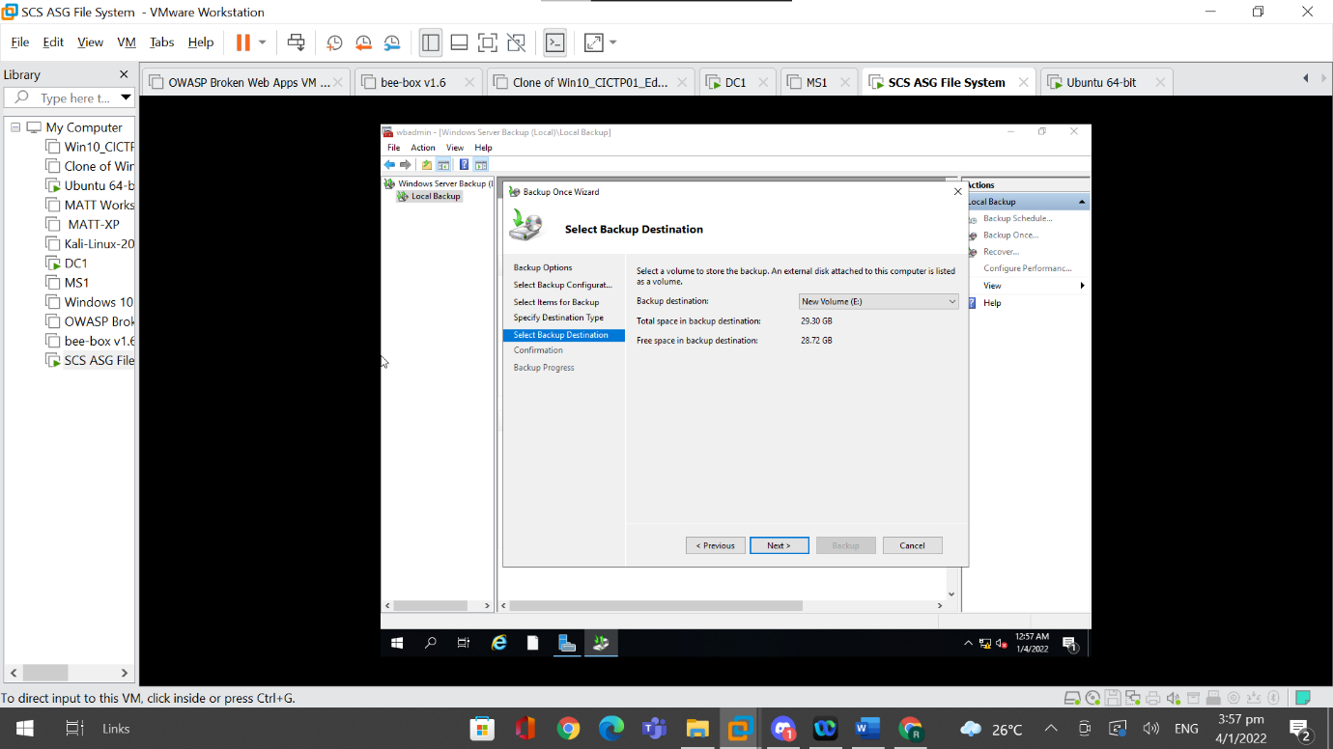

For the next option, I confirmed the backup configuration and once everything is correct, I clicked on “Backup”.

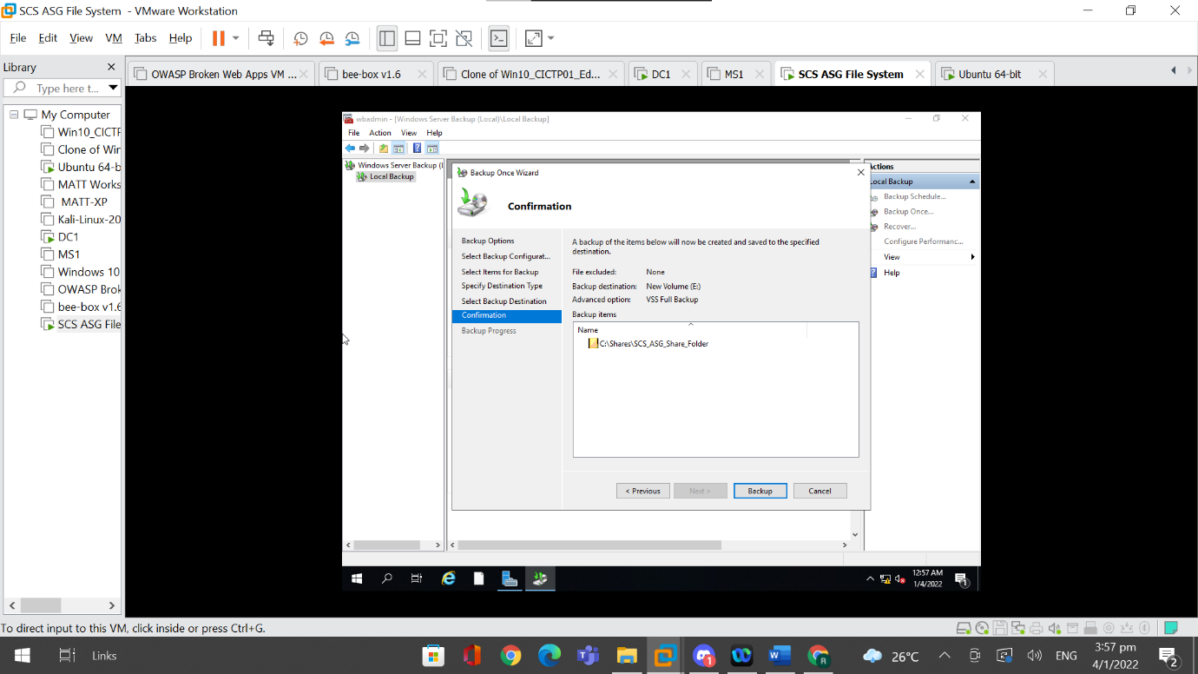

Once the backup shows that it is completed, I then clicked on “Close.”

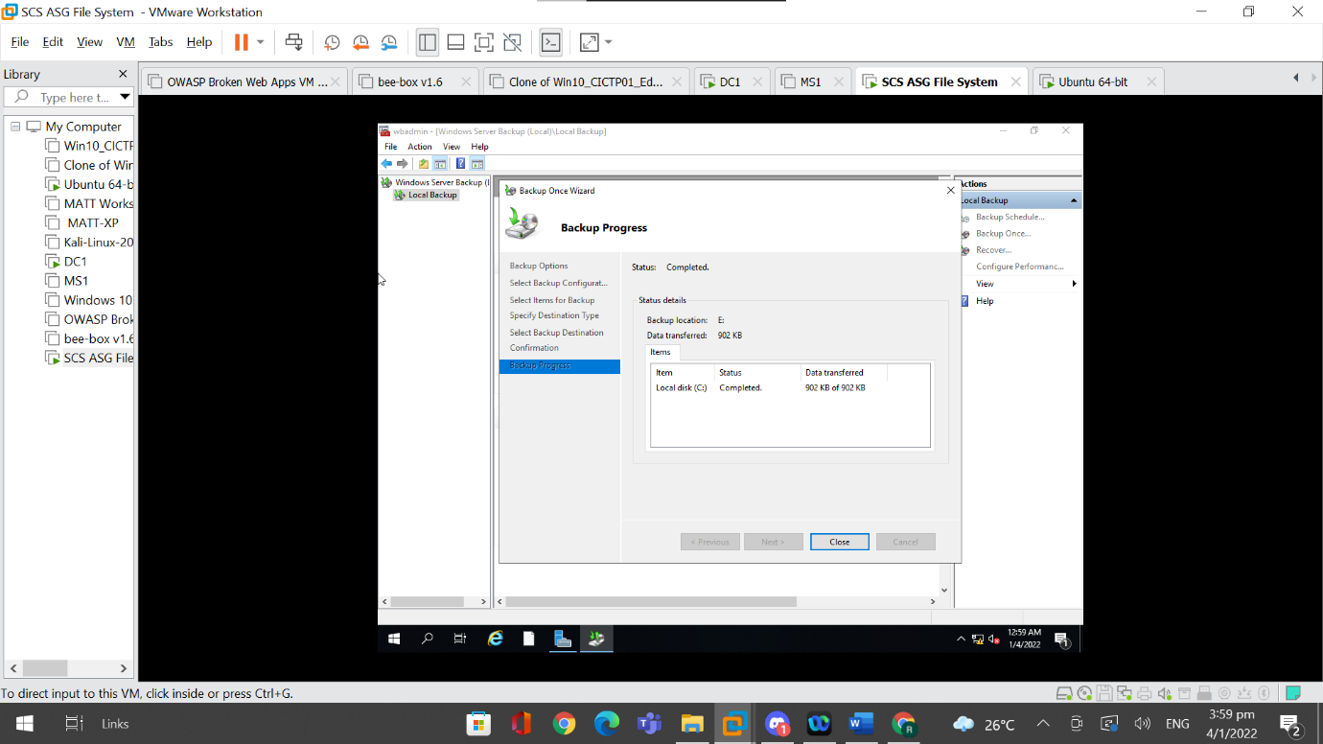

### 4.8.2 Testing Server Backup

In Windows Server Backup Application, I can see the history of backups made and this confirms with the fact that the server backup made previously was successful.

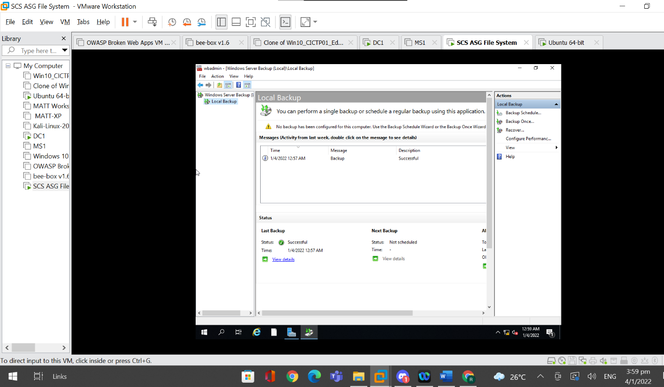

In the E: Drive, it also shows the Windows Image Backup folder that contains the backup that was made, which implies that the backup of the server was saved and the implementation of the server backup is working as intended.

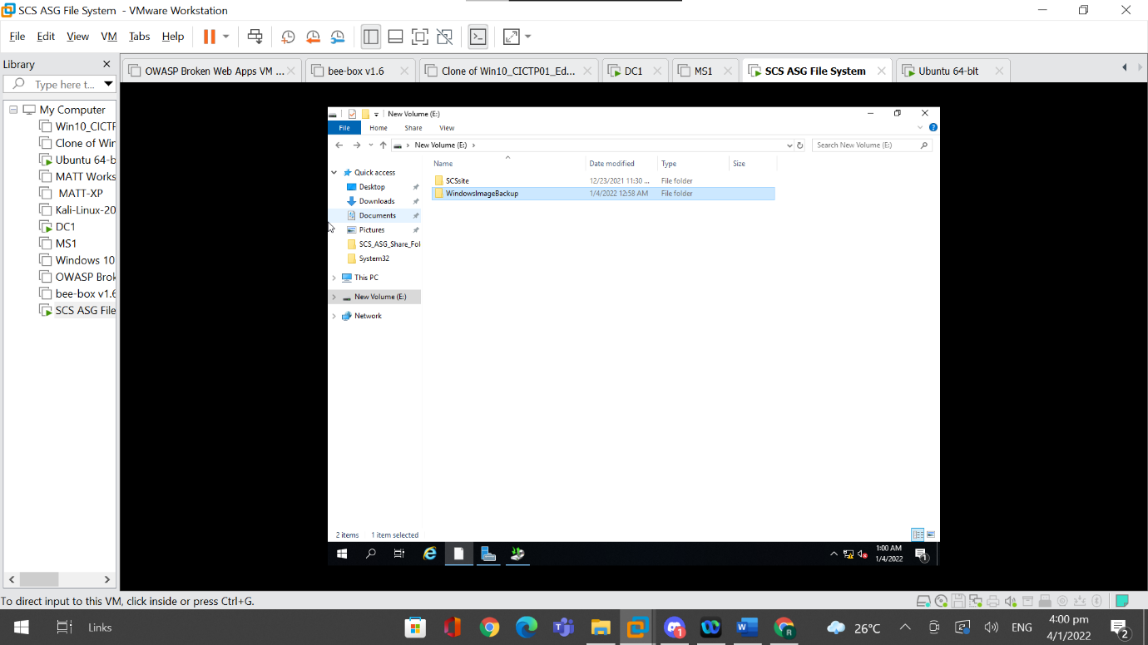

## 4.9 Account Lockout Policy

Implementing an account lockout policy is important because it prevents attackers from conducting attacks such as brute forcing on the account. This can slow down the password-guessing attacks and can also be used as a method to protect weak passwords from getting cracked.

### 4.9.1 Implementation of Account Lockout Policy

In order to configure the account lockout policy, I needed to first open “Group Policy Management Editor”. Then I navigated to “Policies”, “Windows Settings”, “Security Settings” and “Account Lockout Policy”.

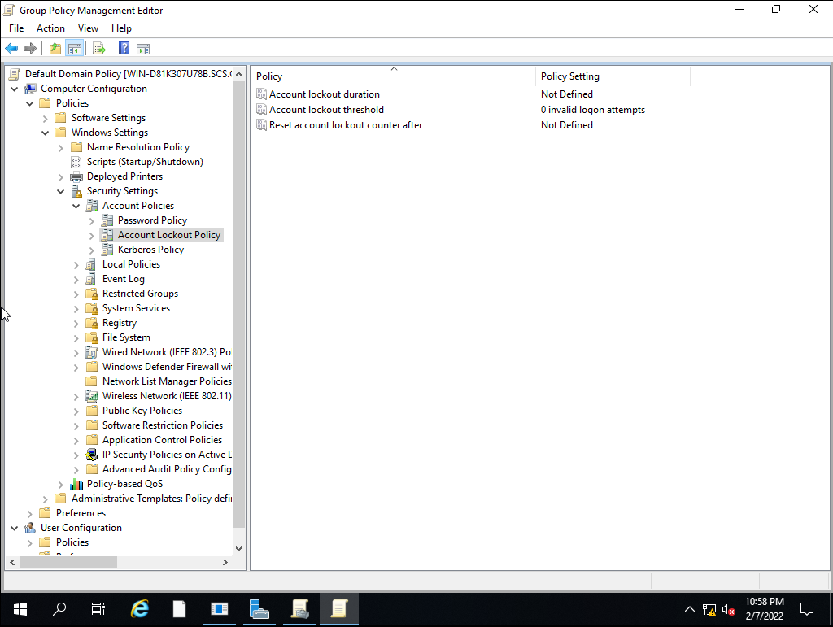

Then I double-clicked “Account lockout duration” and the properties of this policy popped up. I ticked the box to “Define this policy setting” and specified the account to be locked out for 30 minutes.

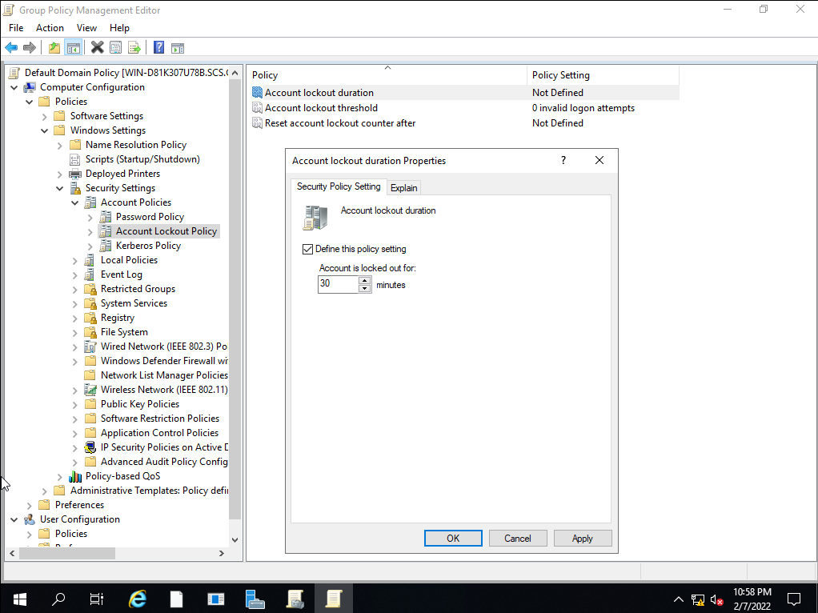

When I clicked on “OK”, another pop up appeared, suggesting changes to be made to the other policies. It recommended that I change the “Account lockout threshold” policy to 5 invalid logon attempts and “Reset account lockout counter after” to be 30 minutes long.

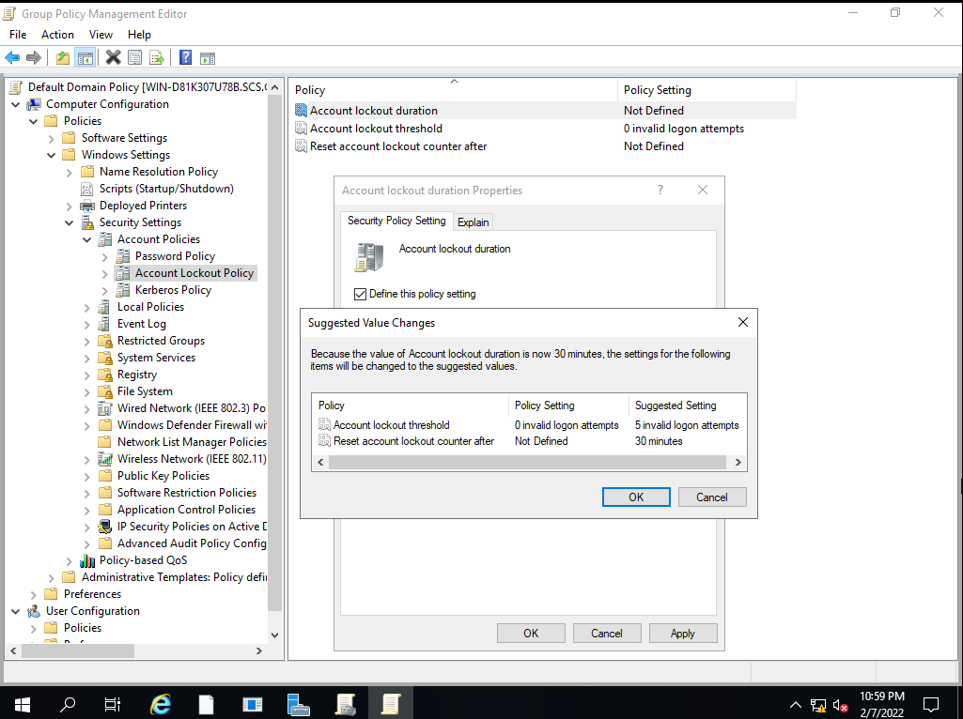

I accepted the suggested value changes by clicking “OK” and confirmed the policy settings that were modified.

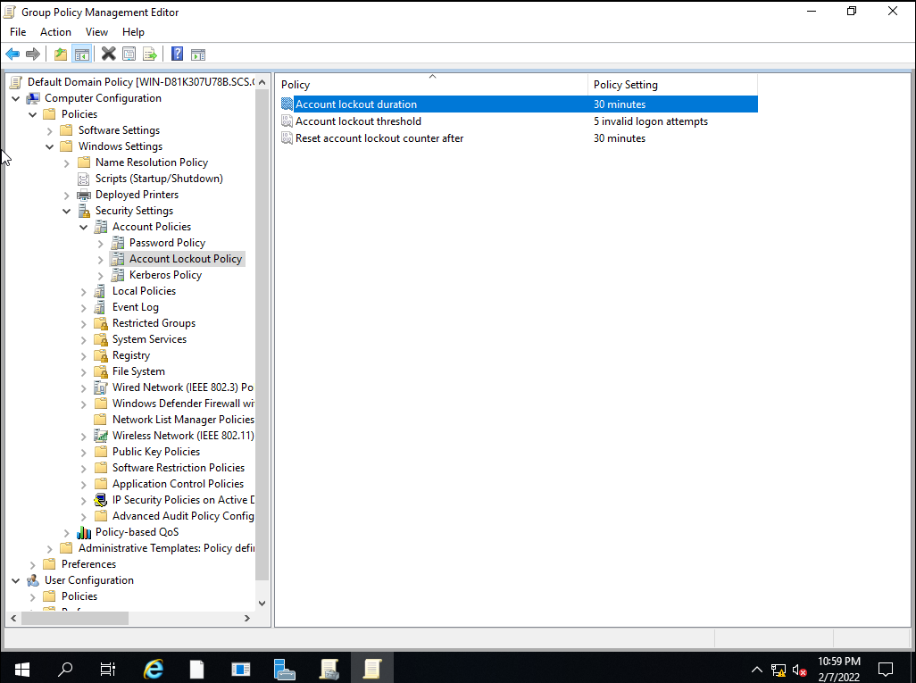

### 4.9.2 Testing of Account lockout Policy

After trying to log in for five times, we tried for the sixth time and got displayed with this error message stating, “The referenced account is currently locked out and may not be logged on to”. Even typing in the correct password will not allow me to log in.

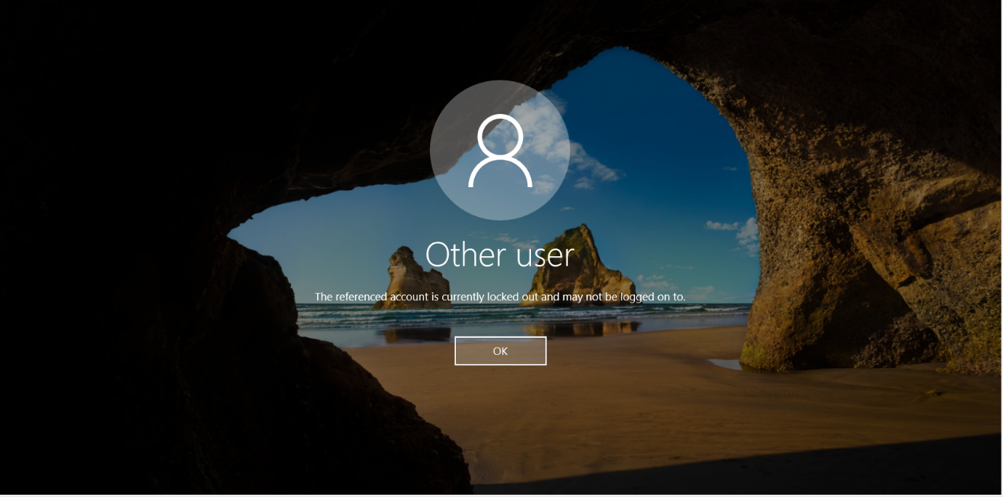

## 4.10 Logging

Logging is important to enable on the shared folder so as to monitor the activities that are occurring on the shared folder. Logging tells administrators information such as the account name and the action the user did. This can be used for non-repudiation which allows administrators to see which users are responsible for what actions. It provides a greater understanding of what is happening in the shared folder so that administrators can have a better view of the activities in the shared folder. It also shows whether there are any errors in the shared folder as well as any warnings to take note of.

### 4.10.1 Implementation of Logging on Shared Folder

In order to enable auditing of the shared folder, I must first enable a certain policy by going to “Local Group Policy Editor”. I then navigated to “Computer Configuration”, “Windows Settings”, “Security Settings”, “Local Policies” and “Audit Policy”.

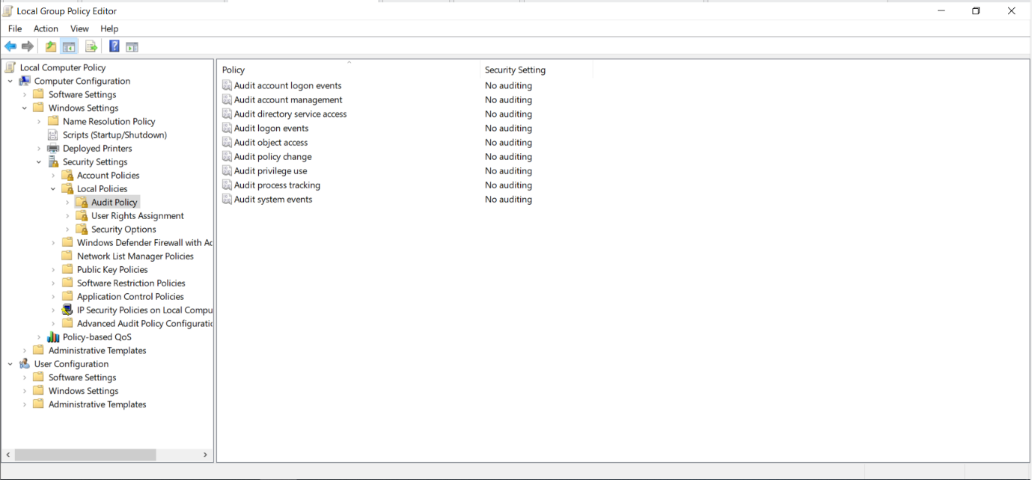

I then double-clicked on the fifth policy, “Audit object access” to open its properties. I then ticked both boxes present in the properties to enable the audit of both success and failure attempts. I then clicked “Apply” and “OK” to apply the changes.

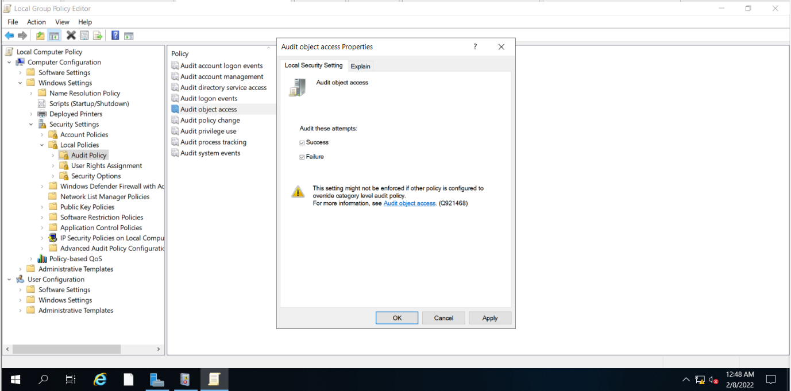

Next, I had to enable auditing on the shared folder. I went to the properties of the shared folder and went to the “Security” tab.

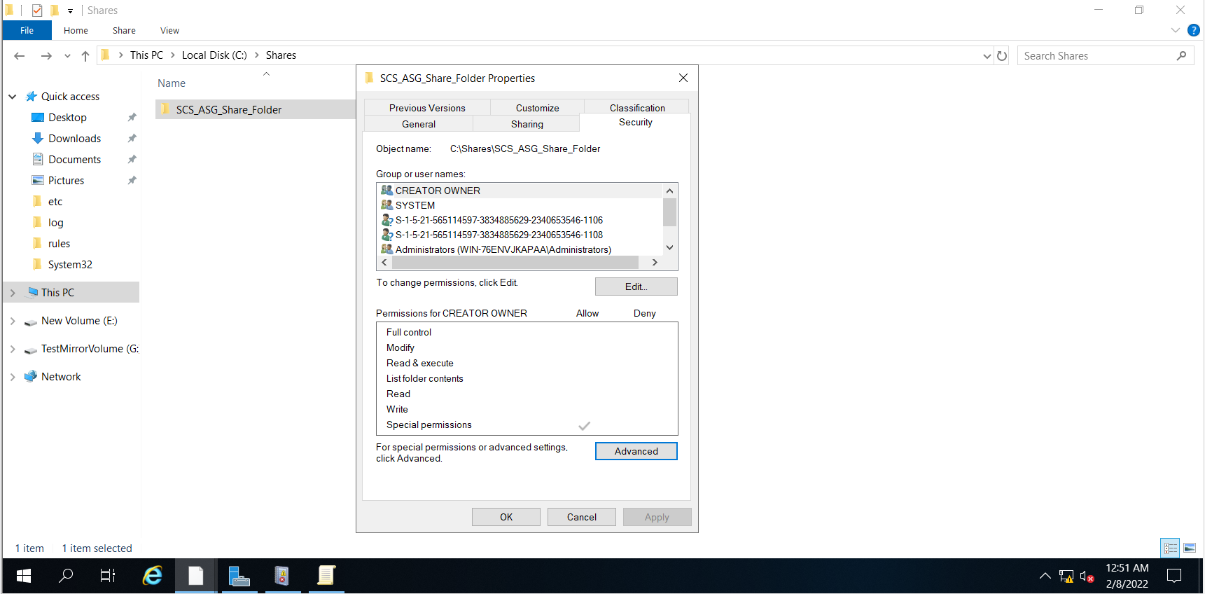

I clicked on “Advanced” and went to the advanced settings. Afterwards, I went to the “Auditing” tab and clicked on “Add”.

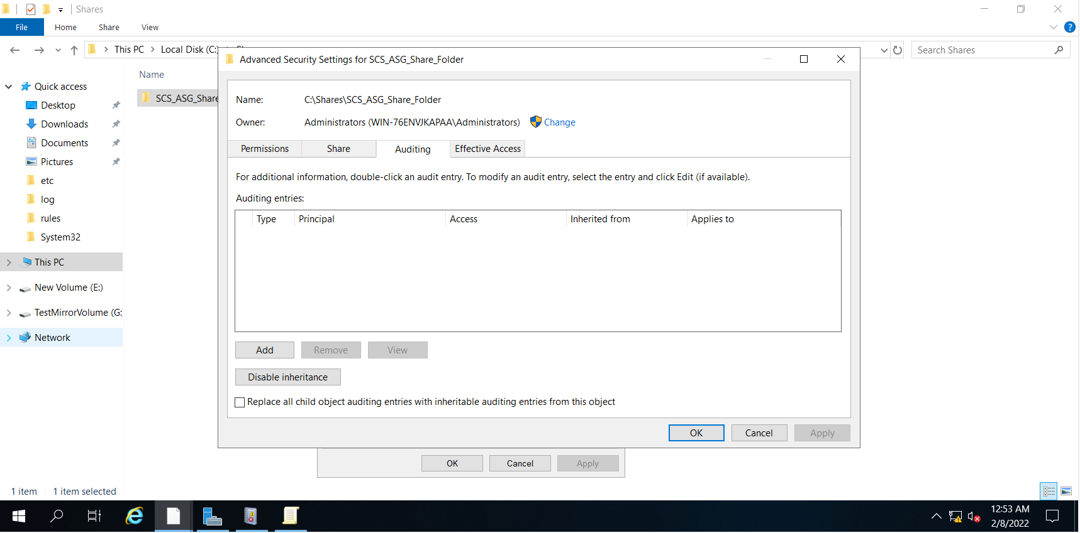

When adding an auditing entry for the shared folder, I selected the principal to be “Everyone” and the type to be “All”. This is because I want to see everyone’s actions in the shared folder and all failures and successful attempts in the folder. I also set the audit to apply to “This folder, subfolders and files” so that every item in the shared folder would be audited. For “Basic permissions”, I enabled everything to ensure that every action will be audited. After ensuring everything is configured correctly, I clicked on “OK” to finalise the audit entry.

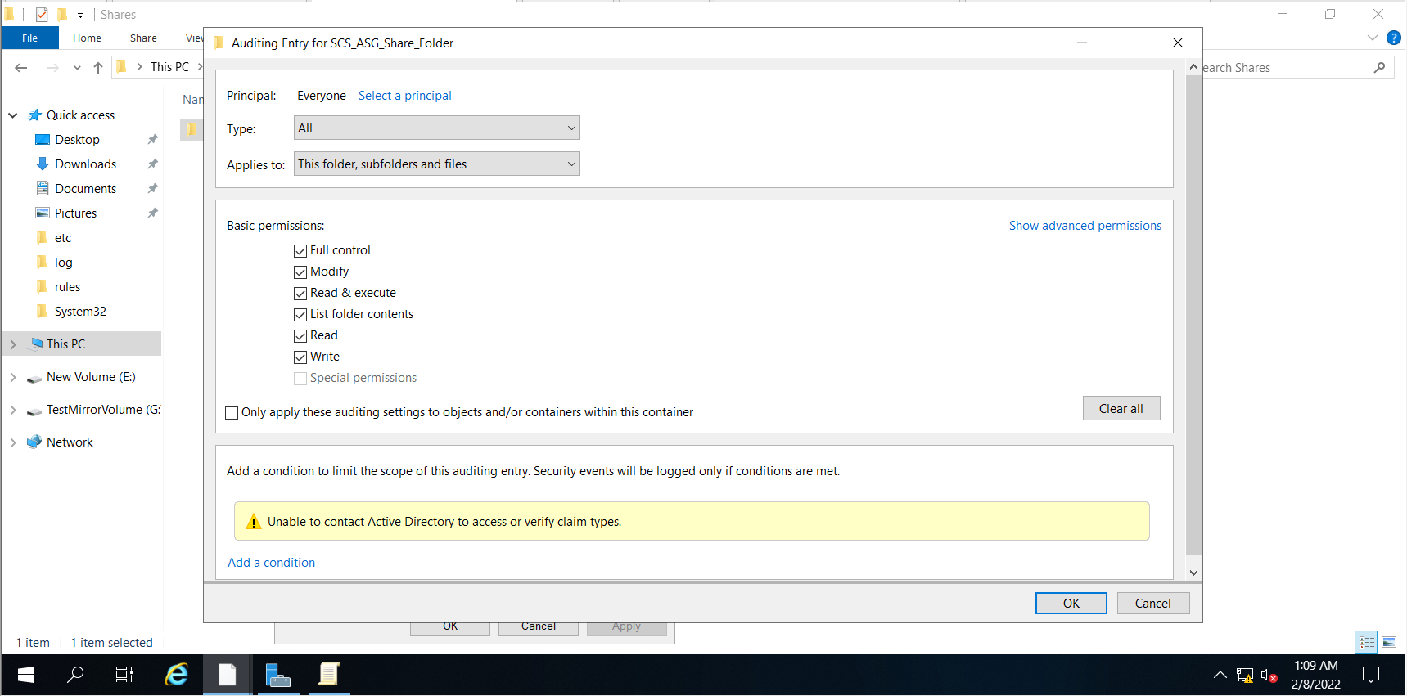

After clicking “OK”, I can see the auditing entry has been successfully added and I can click on “OK” to close the settings page.

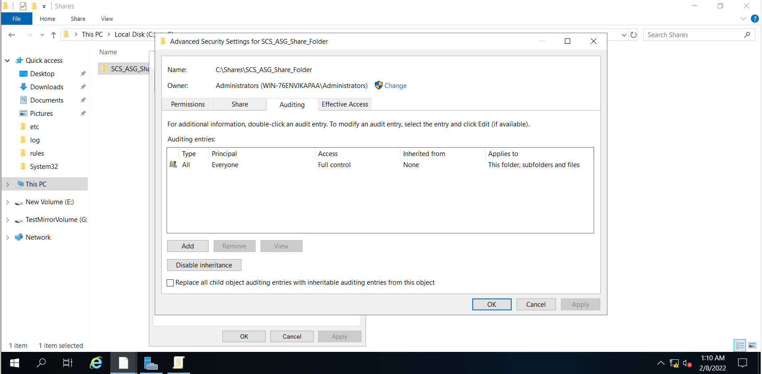

### 4.10.2 Testing of Implemented Logging

#### 4.10.2.1 Accessing Network Shared Object

I first tested whether logs were produced when a network shared object was accessed. As there are a large amount of security logs, it was quite hard to find the exact log that showed this. Thus, I researched online and found that the event ID for accessing a network shared object is 5140. I then filtered the event logs based on the event ID to see if the event has been logged. Based on the screenshots below, the audit was a success, and we can see the account that accessed the shared folder, “SCS_ASG_Share_Folder”.

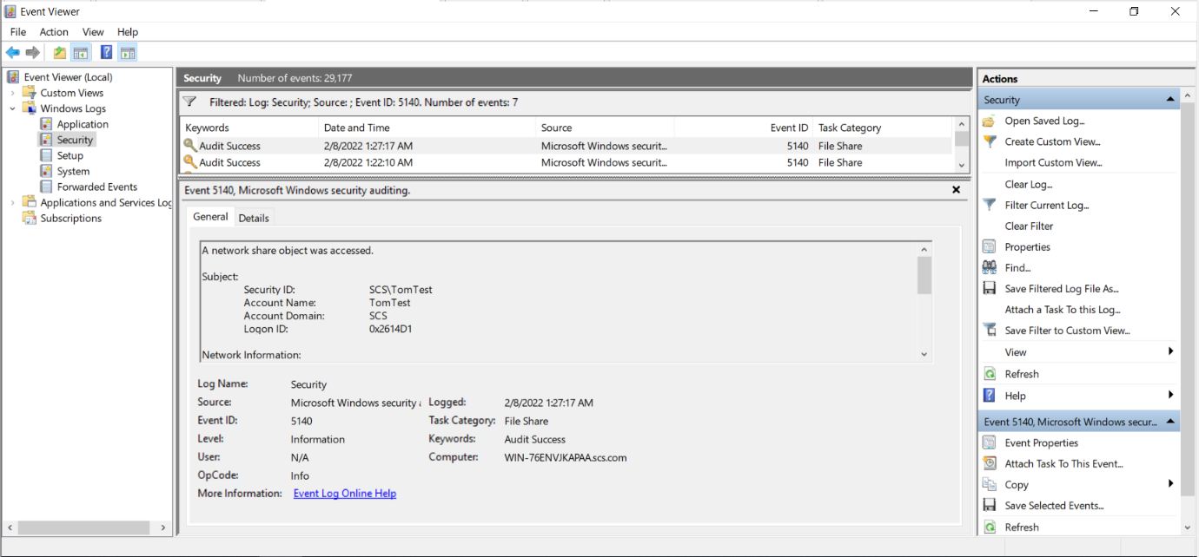

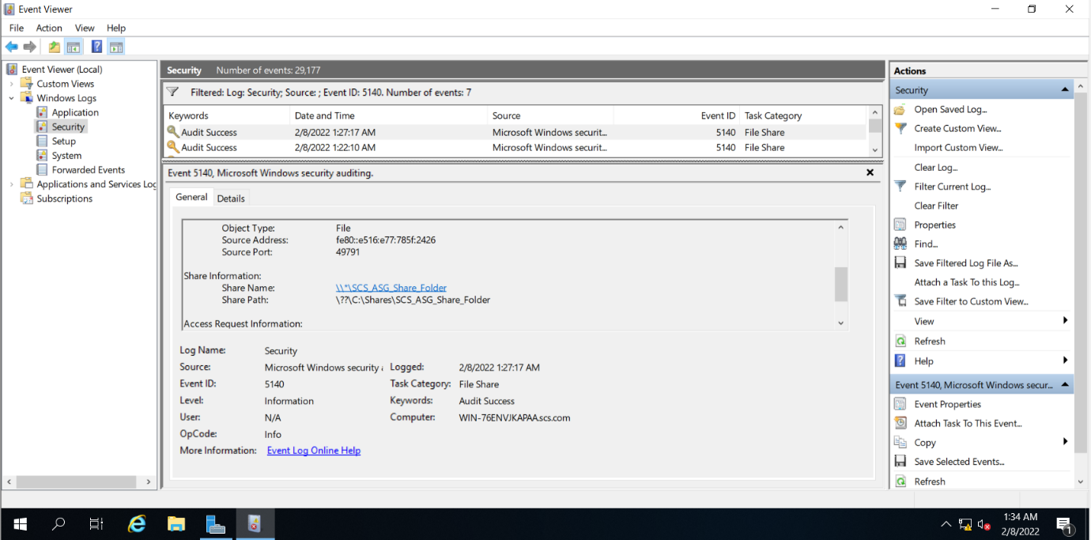

#### 4.10.2.2 Opening of File in Shared Folder

I then experimented to see if the logs for opening a file would be tracked. Once again, I searched for the event ID that corresponds to the event. The file auditing event that is related to opening a file is identified to be “A handle to an object was requested” and it has an event ID of 4656. I filtered the output to be events belonging to event ID of 4656 and could identify the account name reading the contents of the shared folder.

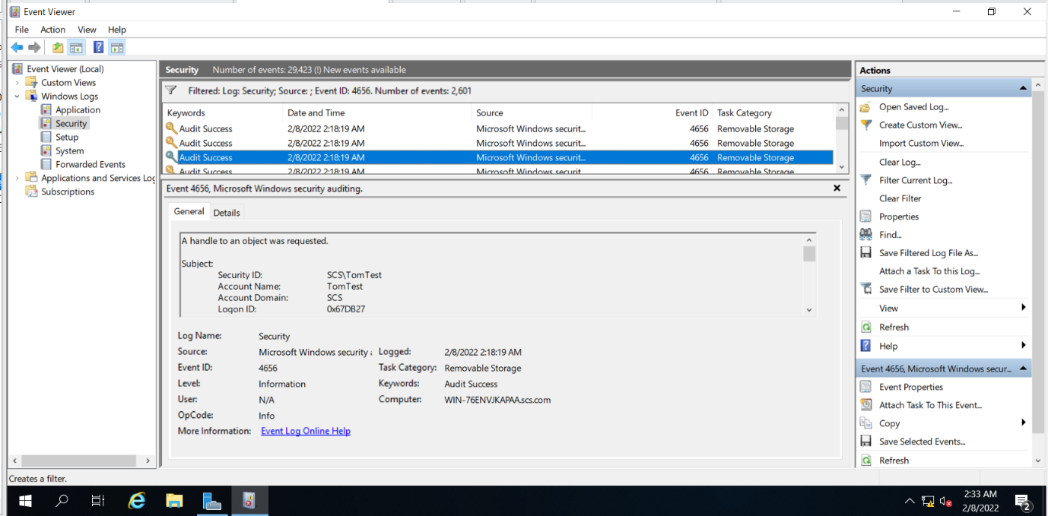

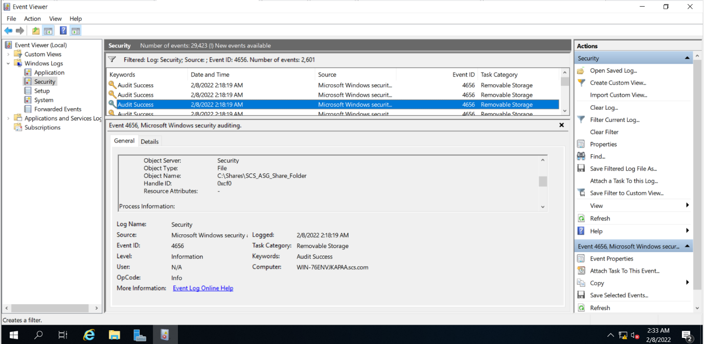

#### 4.10.2.3 Deleting of File in Shared Folder

I then tested whether logs for deleting a file in the shared folder would be detected. I first searched for the event ID of accessing an object in a file system, which is 4663. I then filtered out the event logs to display events with the ID of 4663. As there were still many logs belonging to 4663, I searched for a string that matches with “Delete” and it brought me to the event shown below.

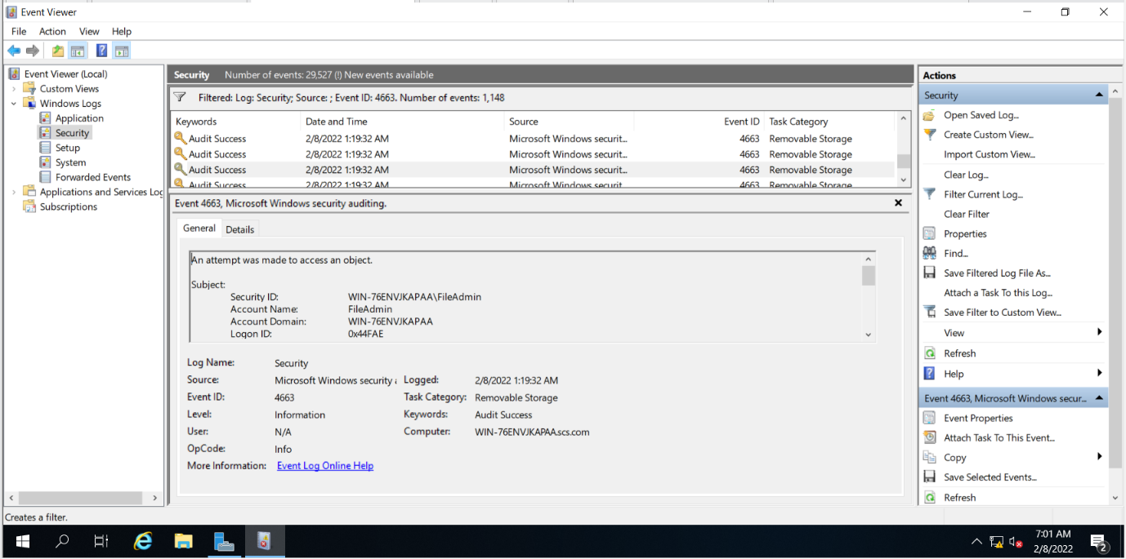

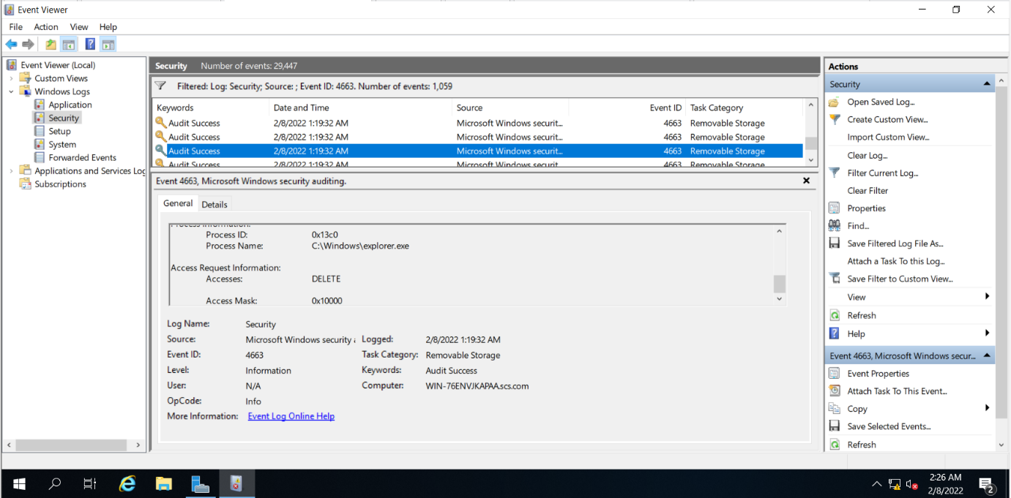

#### 4.10.2.4 Modification of File in Shared Folder

Next, I checked to see if logs for modifying files are tracked. I used the previous event ID, 4663 to filter the events. In the event below, I can see the account who accessed a specific file, “test_renamed.txt” which implies that this file has been modified.

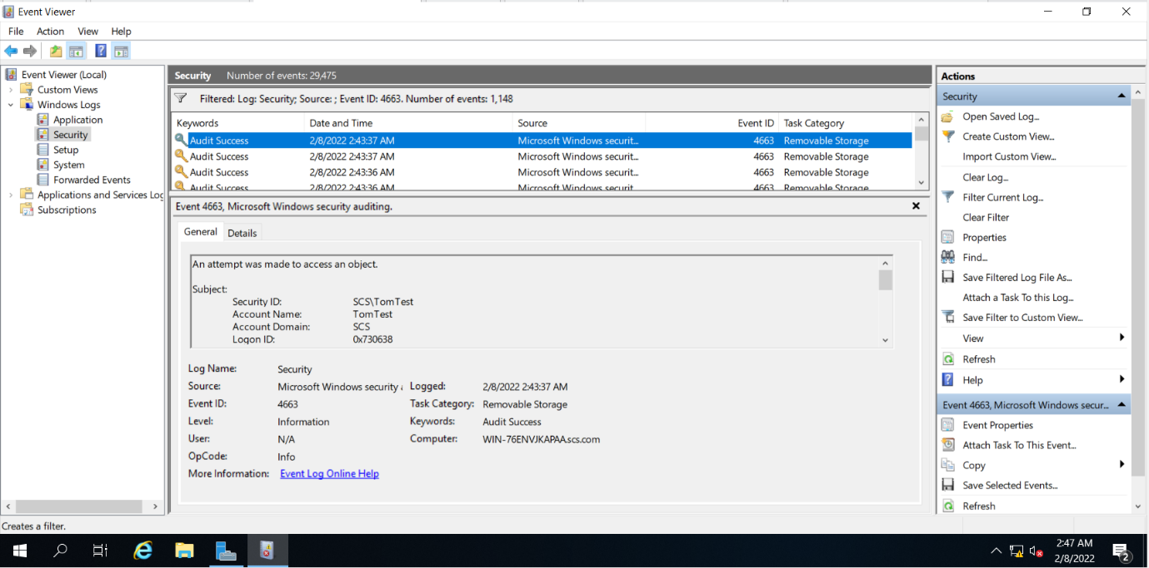

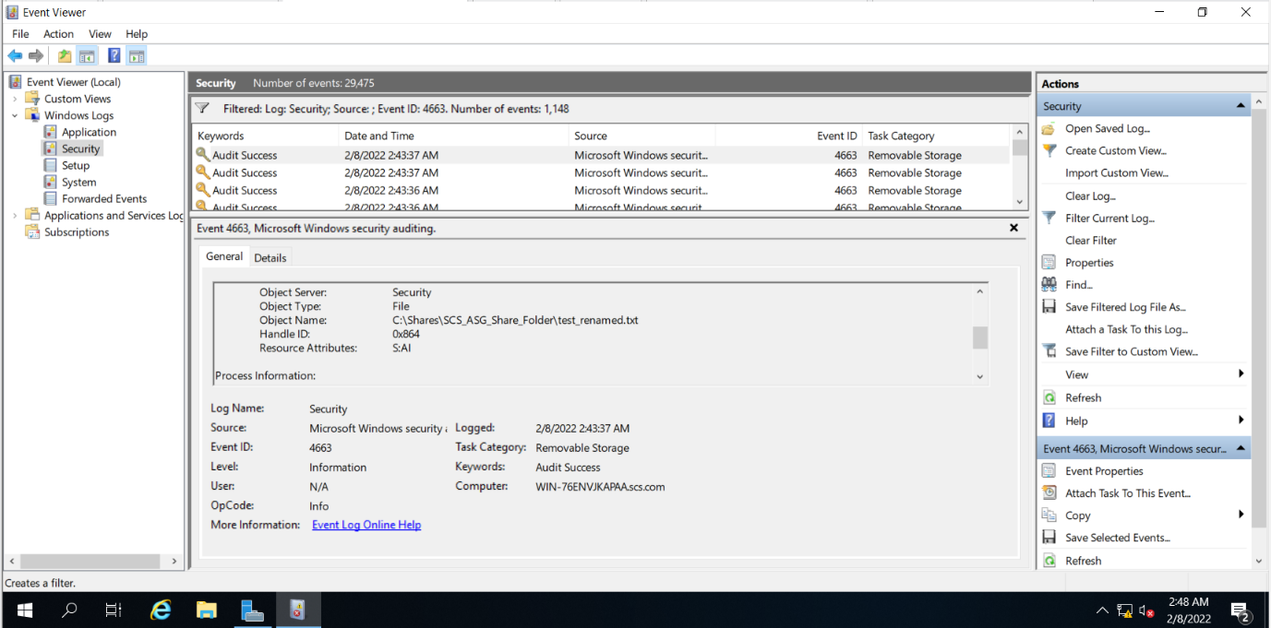

#### 4.10.2.5 Closing of File in Shared Folder

Lastly, I checked to see if logs for closing files were generated. Similar to the other events, I searched for the event ID related to this event online. The file auditing event that I found that related to this is “The handle to an object was closed” and it has an event ID of 4658. I filtered out the logs based on this event ID, and the logs showed me the account that closed the handle and the handle ID which was closed. Using this handle ID, I then searched for the object with the handle ID in the event that belongs to “accessing an object in a file system”. In the screenshots provided, we can see that TomTest, closed a handle and when the handle ID was searched, the object related to the handle ID was the shared folder. This means that this particular event represents the closing of the file made from the account “TomTest”.

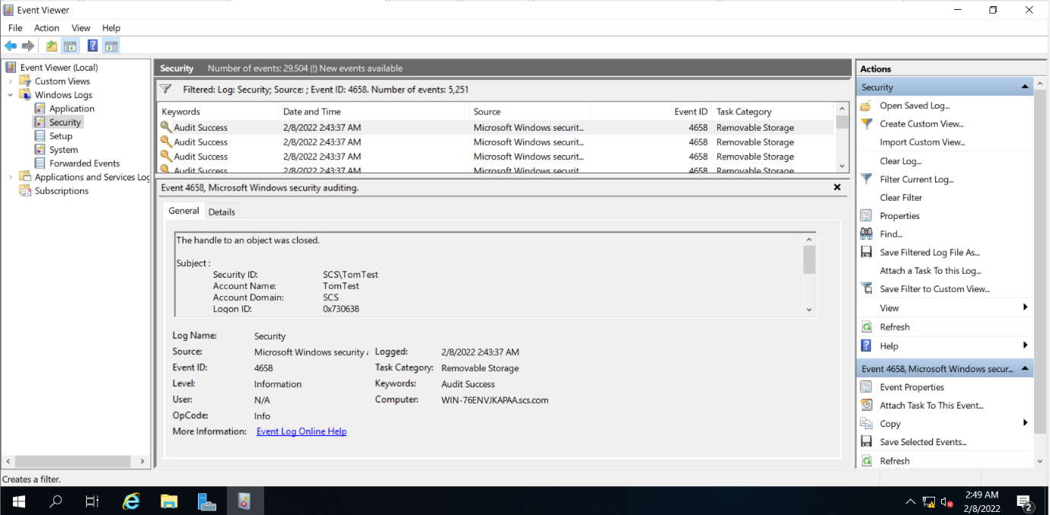

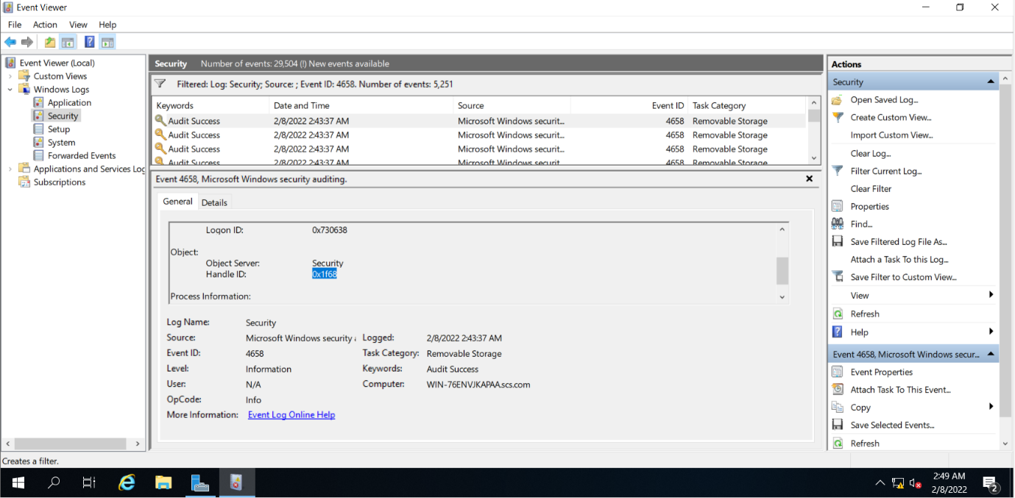

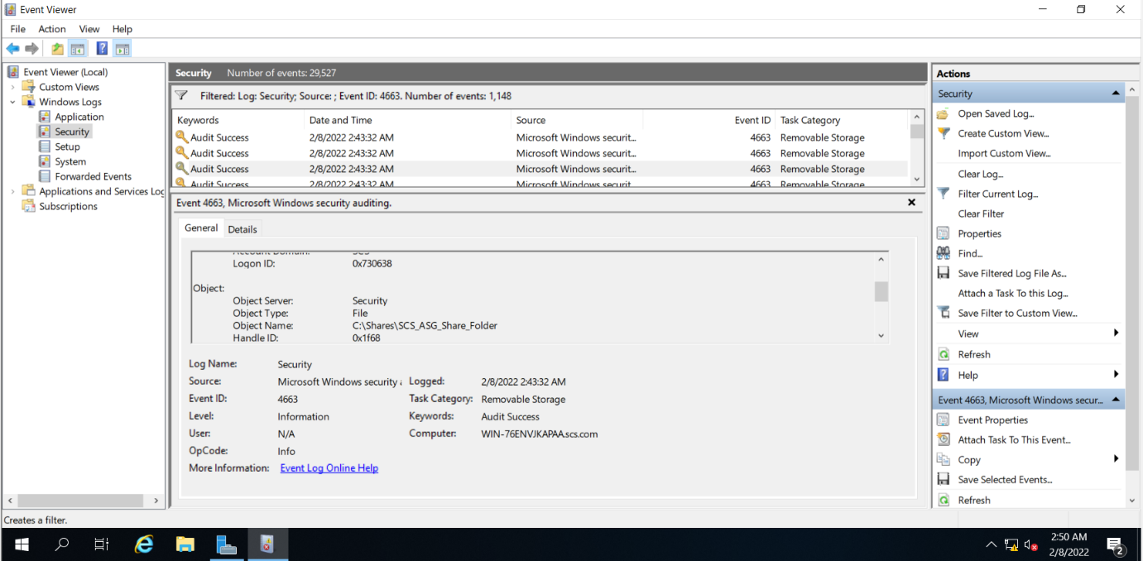

## 4.11 Ensuring OS is the latest version

Ensuring the operating system is the latest version is a good practice to have. Software updates are important because it repairs vulnerabilities and bugs that have been identified. It helps patch security flaws which prevents attackers from exploiting the operating system. In order to ensure that the Windows operating system is up to date, I searched “Windows Update” in settings and clicked on “Check for updates”. If it is stated that “No updates available”, it means the operating system is at the latest version.

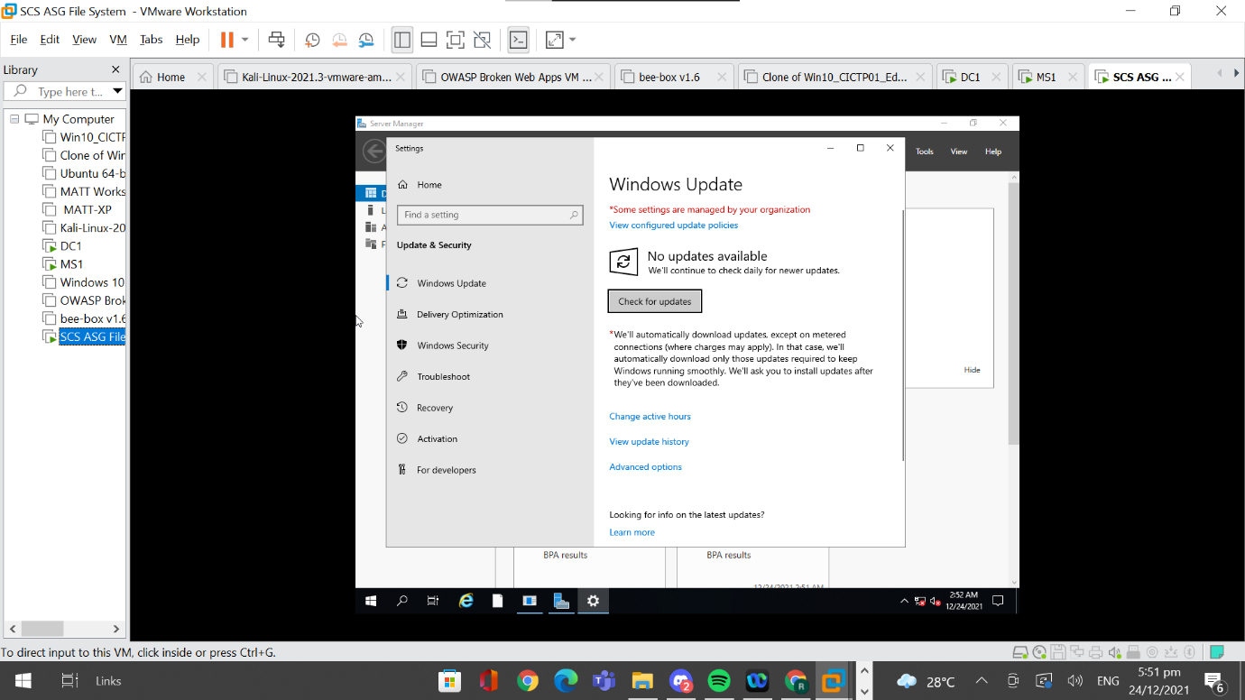

## 4.12 Changing of Default User Account Names and Passwords

Ensuring that the default user account names such as “Administrator” and “Guest” are changed is a good practice to have. Changing default passwords also must be done to ensure that attackers cannot easily guess or crack the password. By changing the default user account names and default password, it lengthens the time taken for attackers to brute force and crack the credentials as they have to brute force both the username and password. Having a unique username and strong password is the most basic step to protecting the account and is a step that should not be neglected.

### 4.12.1 Implementing Change of Default User Account Names and Passwords

In order to change the default user account names and passwords, I had to go to “Tools” on server manager and to “Computer Management”.

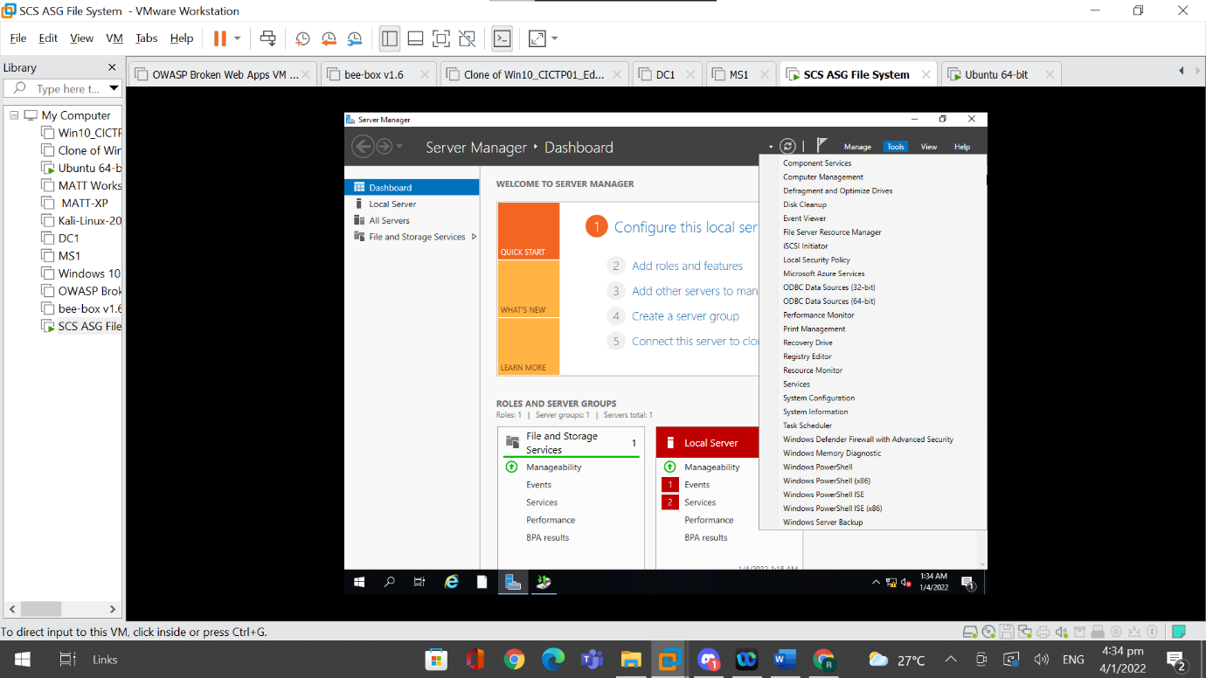

I then navigated to “Local Users” to “Groups” and to “Users”.

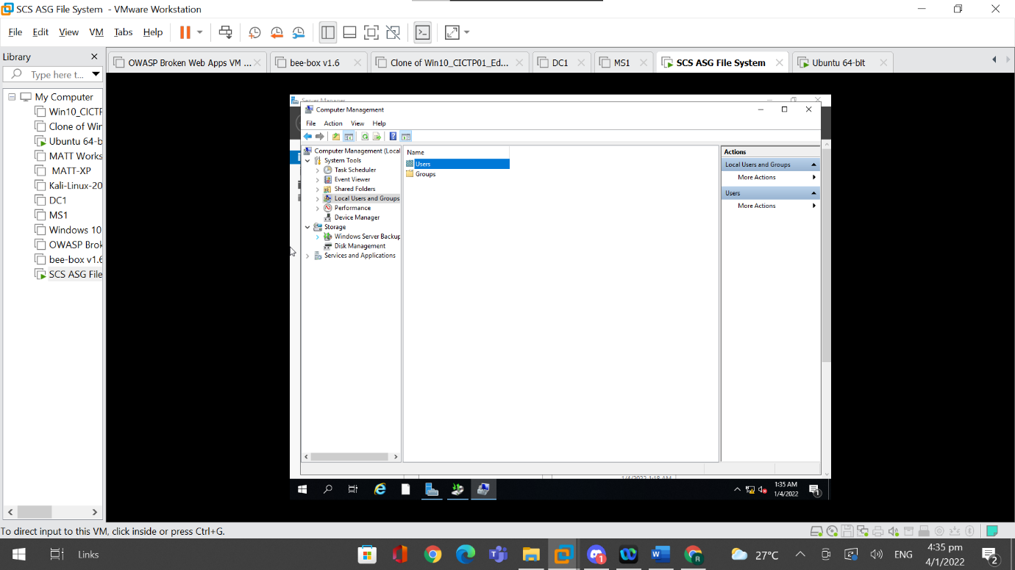

I went to the default accounts such as “Administrator” and “Guest”, right clicked them and renamed them.

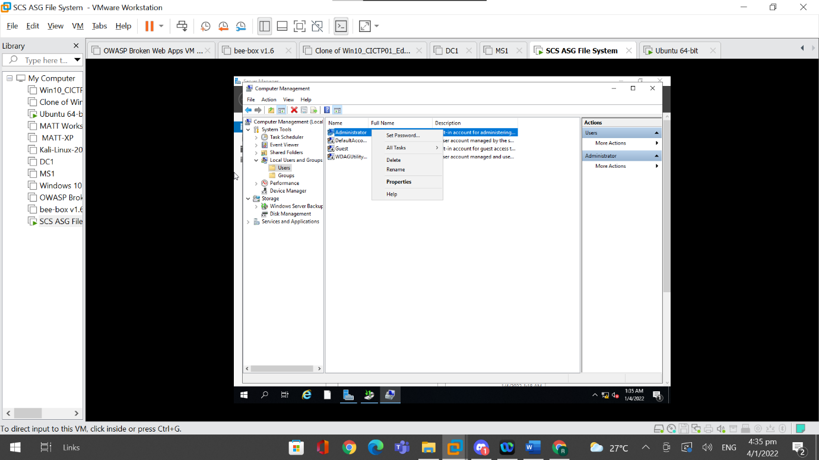

In this case, “Administrator” has been renamed to “FileAdmin” and “Guest” has been renamed to “FileGuest”.

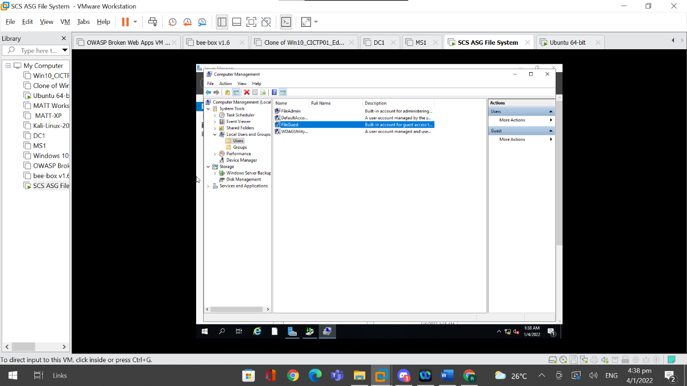

After renaming the default accounts, I then changed the default passwords of these accounts by clicking on “Set Password”.

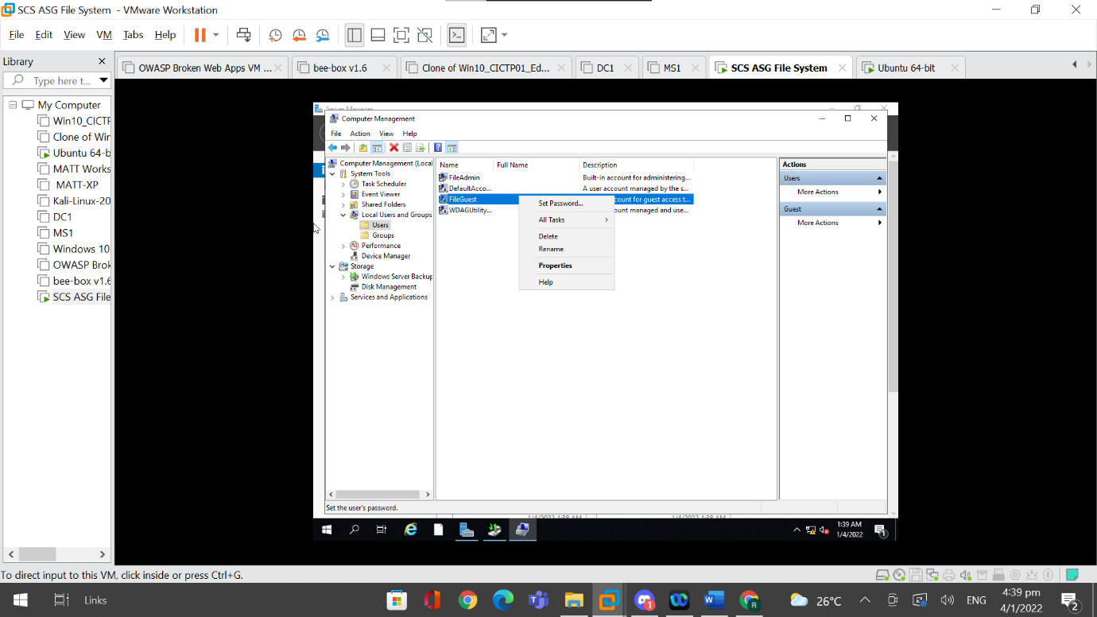

This pop up will appear and I had to click on “Proceed”.

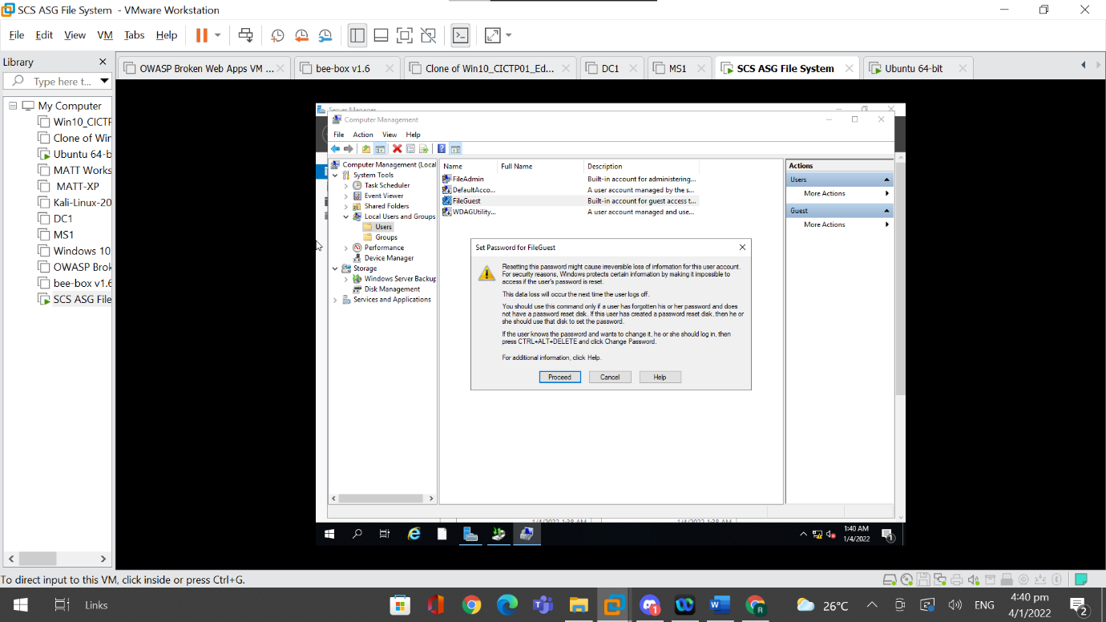

I Set the password for the default account and clicked on “OK” after doing so.

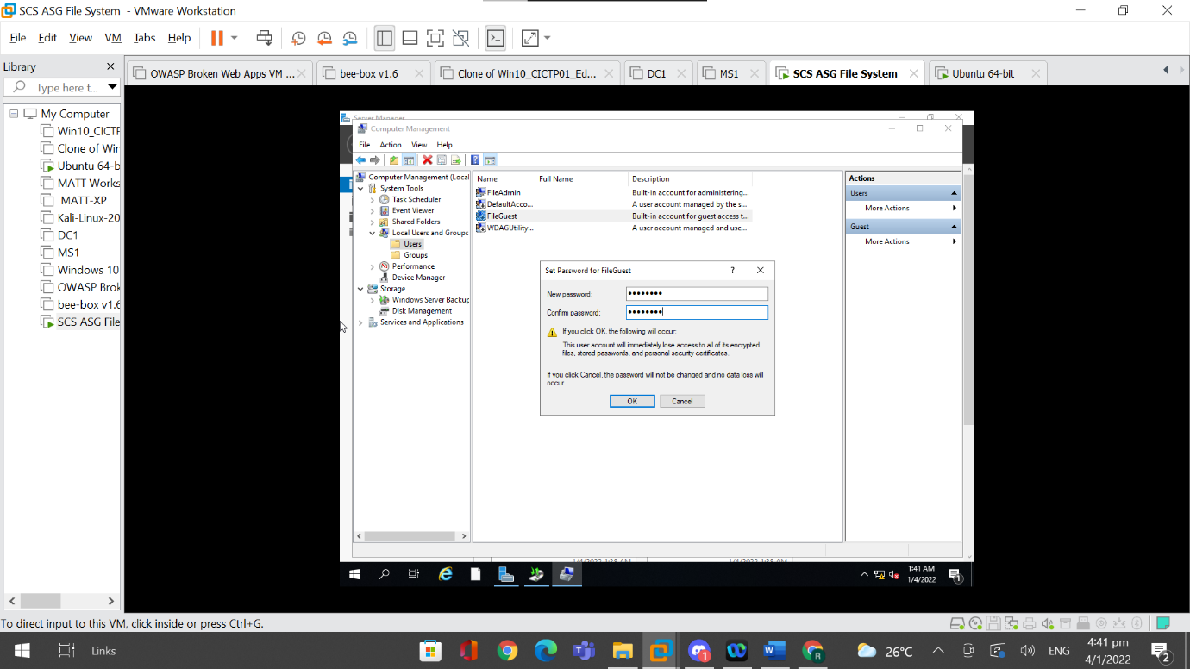

I then received a pop up stating that “The password has been set”.

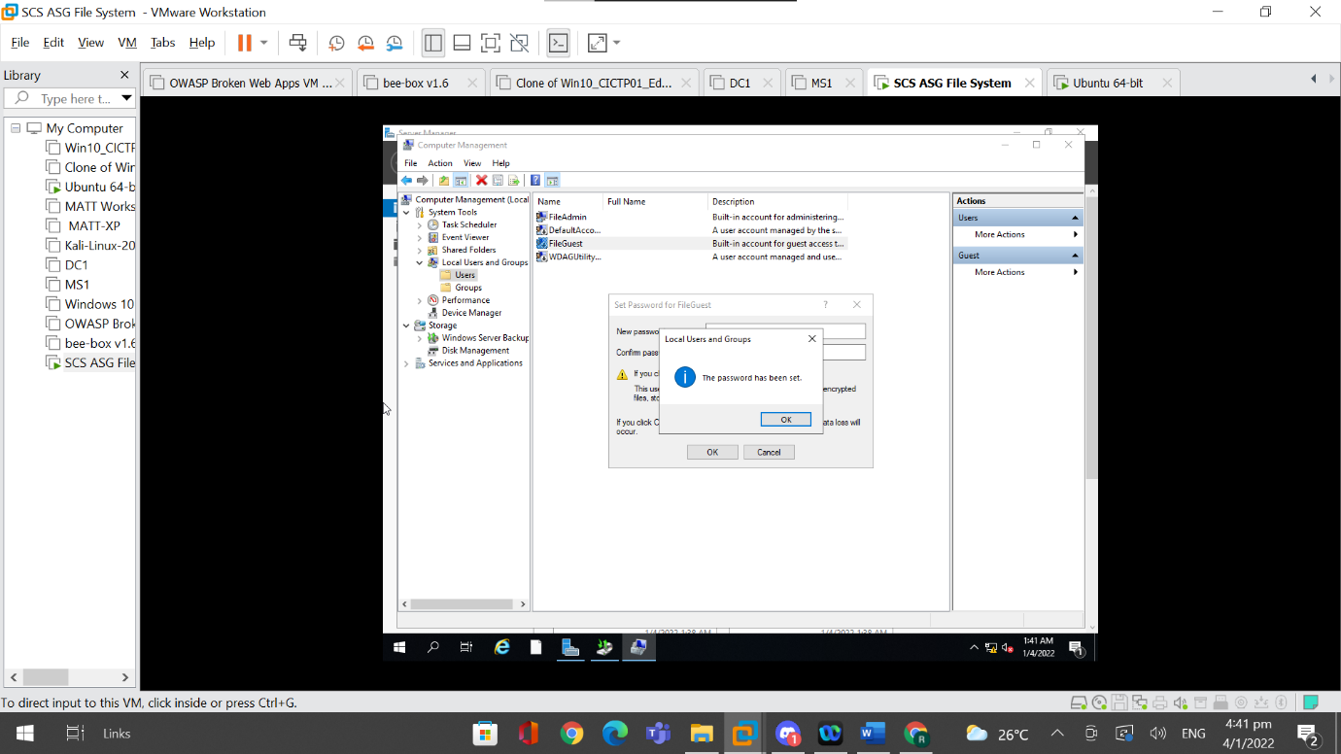

### 4.12.2 Testing of Changed Default Name

I logged out of the file server and restarted the system to see if the name of the account will be different. When I was greeted with the login page, I can see that the default name of “Administrator” has been changed to “FileAdmin” which means the implementation was a success.

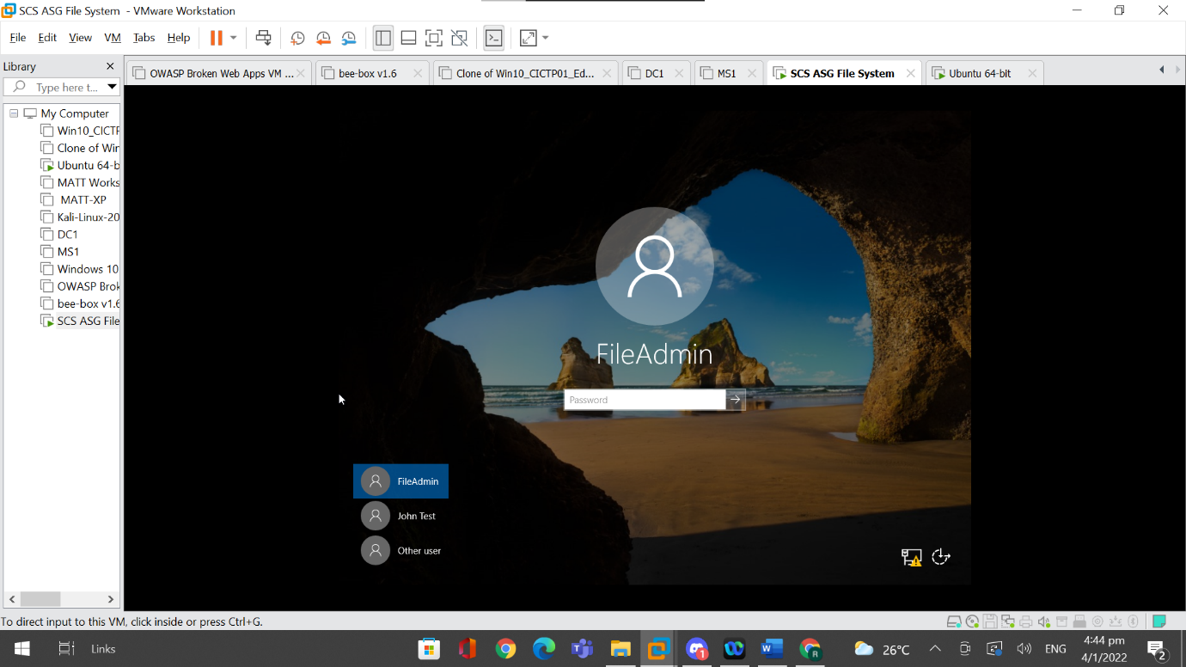

# 5. Conclusion

All in all, security is very important and needs to be maintained on the Windows Operating System. In this assignment, I managed to set up a file server using the Windows Operating System and successfully used a large number of tools available online to harden the server. I managed to talk about 10 features that can be used to harden the file server. These features are configuring a quota limit on the file, configuring file screens templates to use on the file, configuring antivirus software, configuring host-based firewalls to filter traffic, installing host-based IPS/IDS to monitor traffic, setting up full-disk encryption to prevent unauthorised access, configuring an access control list to control access to the shared folder, setting up a server back to ensure data is not loss, implementing a lockout policy to prevent attacks such as brute forcing, implementing logging so that actions in the shared folder can be accounted for. There are also good practices that I have mentioned so as to ensure that the server is at its maximum security. I mentioned three good practices and they are firstly to remove unnecessary services and role to reduce the attack surface, secondly to ensure that the operating system is at the latest version at all times to reduce vulnerabilities, and thirdly is the changing of default account usernames and passwords so as to prevent attackers from gaining unauthorised access. The table belows also explains about the recommended guidelines for each feature.

|  |  |  |
| --- | --- | --- |
| Feature | Tool Used | Recommended Guidelines |
| Quota Limit | File Resource Server Manager | Ensure that the limit is not too small as that will affect how many documents can be stored. Attackers may not be able to upload malicious applications but can still render the shared folder useless by making full use of the available space. |
| File Screens | File Resource Server Manager | Ensure that unneeded file extensions are blocked and that only extensions that are used by the companies such as .doc files should be enabled. |
| AntiVirus Software | Windows AntiVirus | Ensure that it is on and all settings for the windows antivirus are enabled and that no threats have been found |
| Host-based Firewall | Windows Firewall | Ensure that it is on and specify the apps and features that should be allowed through the firewall. The apps and features that are not needed should be denied access. Ensure regular checking of the firewall logs |
| Host-based IPS/IDS | Snort | Ensure that the rules have been configured correctly so that malicious networks can be logged and be blocked accurately. Ensure that the logs are also checked regularly. |
| Encryption | Bitlocker and 7-zip | Use complicated but easy to remember passwords. Ensure that the recovery key for bitlocker can be accessed and not lost. |
| Access Control List | Active Directory | Ensure that proper permissions have been put in place and that only appropriate groups have access to the folder |
| Server Backup | Windows Server Backup | Ensure that the server is backed up regularly and that the backup files are properly secure |
| Account Lockout Policy | Group Policy Management Editor | Ensure that a maximum number of login attempts are set and that the lockout duration specified should be an appropriate length where it is neither too short nor too long. |
| Logging | Local Group Policy Editor | Ensure that logs are checked and monitored regularly |
| Remove Unnecessary Services | Server Manager | Ensure that only the features and roles that are needed are installed |
| Ensuring Operating System is Latest Version | Windows Update Settings | Ensure that are no updates available to confirm that the operating system is the latest version |
| Changing of Default Usernames and Passwords | Computer Management  (Server Manager) | Ensure that passwords are complicated and cannot be found in the dictionary. Usernames should also be different from the default username given. |